Resource Sharing User Group Meeting Agenda
Wednesday, February 16th, 2022
Chair: Joan Miller
- Updates
  - Joan Miller is our new chair. Welcome Joan!
  - PSB Refresh happened Sunday, February 13th
  - Ex Libris moving away from monthly releases to quarterly ‘feature’ releases starting June 2022.
    - Bugs and fixes will continue to release monthly.
  - February Release Notes (Feb 6th) https://knowledge.exlibrisgroup.com/Alma/Release_Notes/2022/Alma_2022_Release_Notes?mon=202202BASE
    - Enhancements to Alma Documentation
      - How-to documentation
      - Workflow diagrams
      - Reorganization of the Resource Management, Fulfillment, and Acquisitions sections
      - Over 55 new glossary terms
      - Over 200 links to training videos embedded
      - http://exl-edu.com/01_Alma/Online_Help/
    - Fulfillment Library Independence
      - Enables more independence of multiple libraries under 1 Alma institution
        - Full Fulfillment Independence Model
        - Partial Fulfillment Independence Model
      - Webinar on Fulfillment Library Independence
      - https://www.youtube.com/watch?v=IQH6M2zaRWA
    - Job Category added as input parameter for Borrowing Fulfillment Unit RS Rules

  - Reminder: Please double check Borrowing Requests for complete information. Include ISBN, LCCN, or OCLC if possible

  - March Sneak Preview
    - Expanding Loan Due Date Beyond Patron Expiry
    - Prevent Unintended Message Confirmations
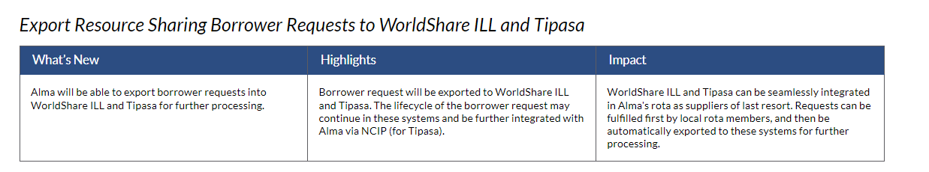
    - Worldshare and Tipasa Integration!
- Library Updates

- New ILL reports available in ODIN consortia folder. Please delete MNPALS reports.
  - 2022 IPEDS Dashboard includes 2 ILL reports as well

- Anything else you would like to discuss or address?

- Next meeting is scheduled for Wednesday, April 27th at 9am CST

