Retrieving Circulation History for an item
In SimplyReports go to the Items / Item history reports tab:
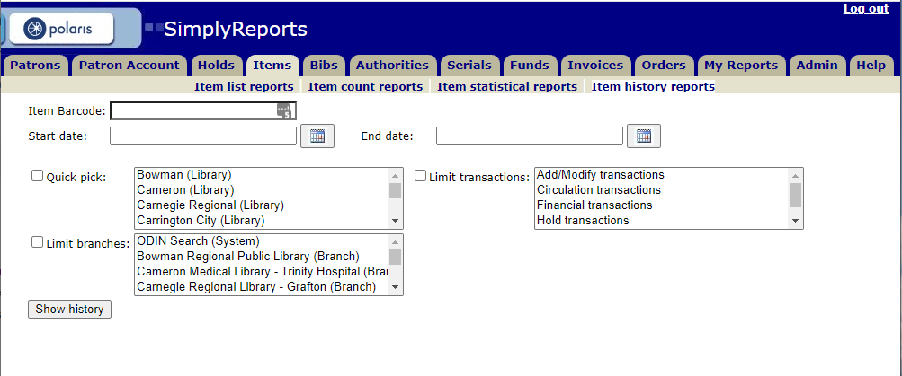

Enter Item Barcode and dates which you want the history. You can further limit by library and type of transactions if needed but if you want all the item information for that time period those options may be left unchecked.
Note: The dates cannot encompass more than 95 days due to patron privacy considerations. If you need a longer time span, you may have to do multiple runs.
When you click on Show History, it may take several seconds to retrieve the information. You will get two sections – Item information and Results. The Item Information contains details for this item such as title, call number, material type, last activity, etc.
Next is the option to export to Excel or Word if needed.
Then you have the Results table. This will include the transaction date, transacting organization (especially useful for items that are loaned through other libraries), transaction type, etc.
In the example below, the Terminator. Dark fate DVD was checked out to the first patron on 3/11/21 who had placed it on hold. An email reminder was sent out 3/17/21 and the item was checked back in on 3/20/21. A different patron checked out the item on 3/29/21.

