How to Make the Format Icon (aka TOM) Display Correctly in the PAC

Note: Before changing the fixed fields in a bibliographic record in Polaris, make sure you have the correct record describing the material you have in hand. Do not change a bibliographic record from format to another. For example, do not change a record for a videocassette to a DVD.
Example: This bibliographic record is describing a DVD, but the PAC display shows a book
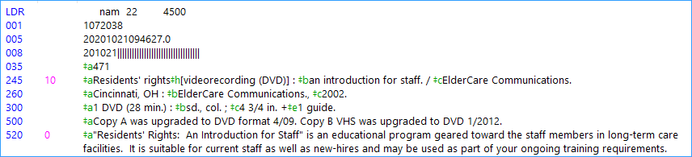
In Polaris Documentation there is a chart that describes the fixed fields necessary to make different format icons appear in the PAC.
For a DVD, you need three elements:
- Leader 06 = g
- 007 00 = v, 01 = d, 04 = v
- 008 33 = v
Polaris’s cataloging has work forms to guide you in entering these codes into the correct field positions.
- Double click on the blue LDR tag in the record to open the work form
- Change the Type of record (06) from a – Language material to g- Projected medium and click OK
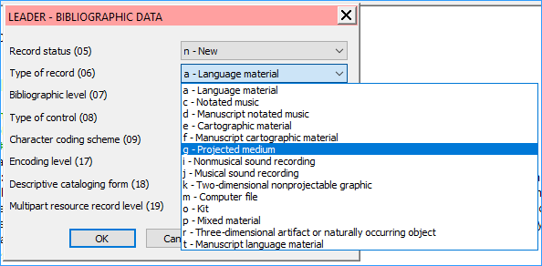
- This record does not have a 007 field. Insert a line after 005 field and type in 007. Now double-click on the 007 to open the work form.
- The first box asks for the category of material. Use the drop-down to select v – videorecording, click OK.
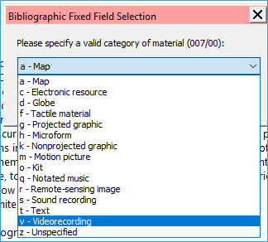
- For the 007 field we need to make sure Specific material designation 01 is d – videodisc, and Videorecording format is v – DVD, click OK.
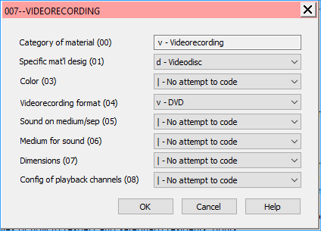
- Double-click on the 008 tag to open the work form. For the 008 we need to make sure the Type of visual material (33) is set to v – Videorecording. Click OK.
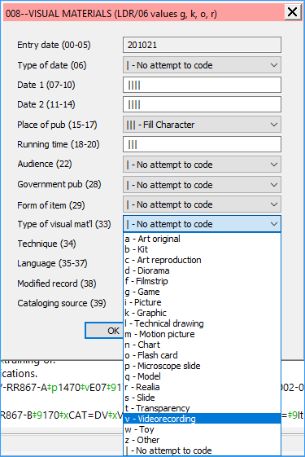
- Save the record. Now we can verify that the PAC display is what we want. In the blue bar on the left side of the window, click on the library symbol:
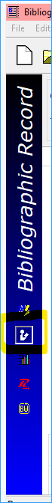
- The PAC display will appear in the window. The icon for the TOM (type of material) will appear to be a DVD.

Leap
You can also edit the fixed fields in a MARC record in Leap.
- Click the check box next to the field you want to update, and click the button Edit Tag.
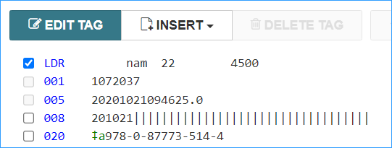
- The work form appears. Just edit it like in the example above and click OK.
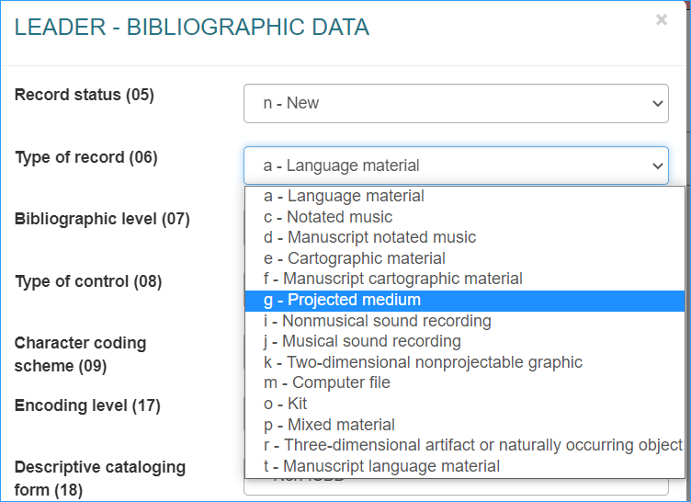
- To add the 007 field, click on the Insert button. It has options to insert missing fixed fields as well as a data field. Click on the 007 Control Field.
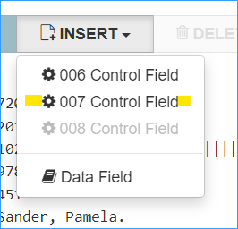
- A work form appears. Select the category of material.
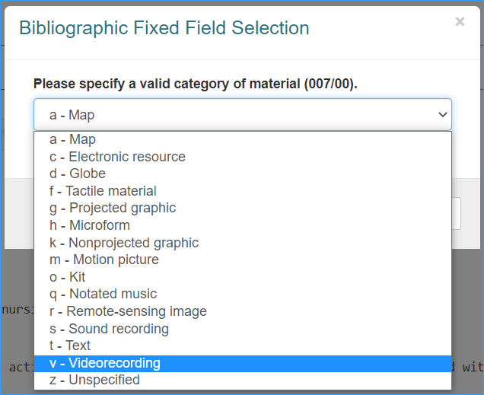
- Fill in the rest of the 007 as in the instructions above.
- Click the check box for tag 008 and edit it like the example above and click OK.
- Save the record.
- To quickly view the record in the PAC, click the Links menu, and select PAC.

