How to Add a Portfolio to a Bibliographic Record

- Find your record in Alma. In this example, I am using a record from the Network Zone. Remember when searching the Network Zone to use an “All Titles” search.
- Click the “Edit” button to open the record in the metadata editor:
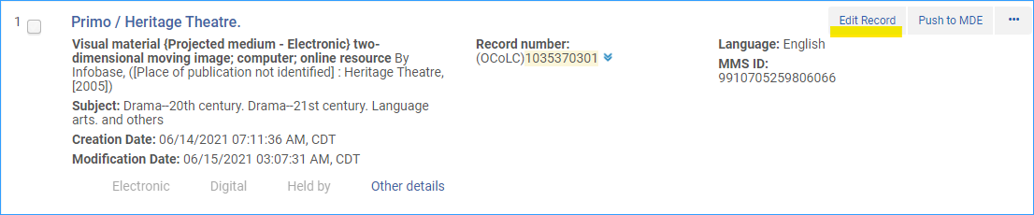
- Click on the menu link +Add Inventory and then click on Add Portfolio.
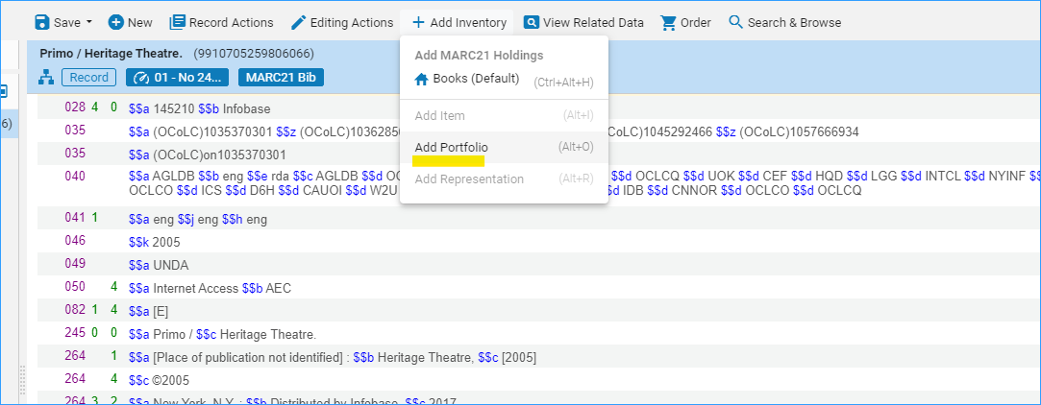
- A form opens where you can add information to the Portfolio. The top box contains title information. It is okay to just leave as is. If you feel like the title needs to be updated, you can do that with the “Create new title” button and fill in new information.
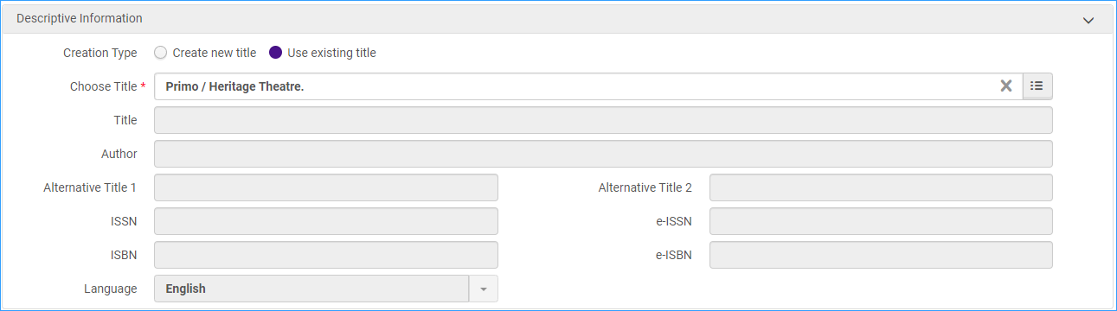
- The next box is “General Information” this is where you make sure you add the collection information for the portfolio. If the portfolio is standalone, you can leave it blank. For this example, the portfolio is part of the Films on Demand collection. Click “Part of an electronic collection.” Use the Electronic Collection search box to find the correct collection. It will automatically fill in the service information.
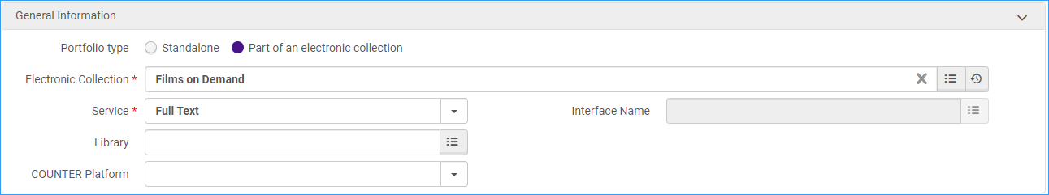
- The next box is “Coverage Information” you would fill in information here about date coverage for an electronic journal.
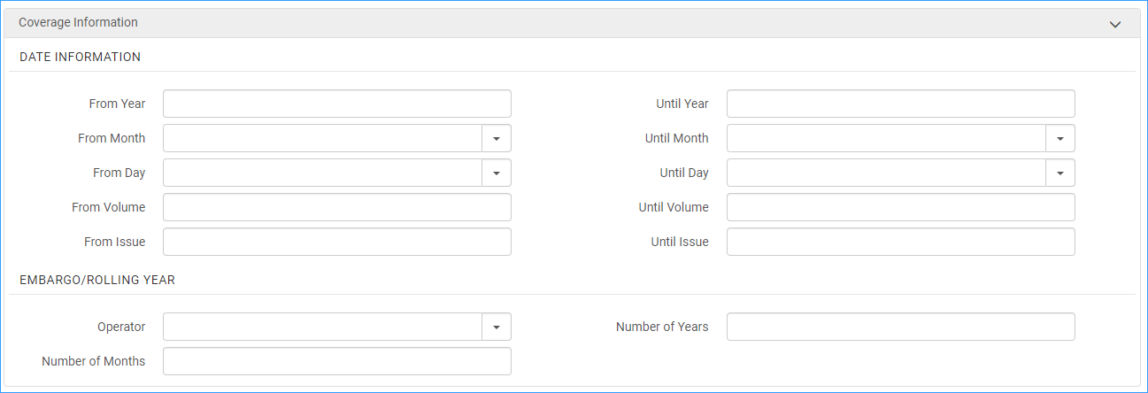
- “Inventory and Linking Information” is next-
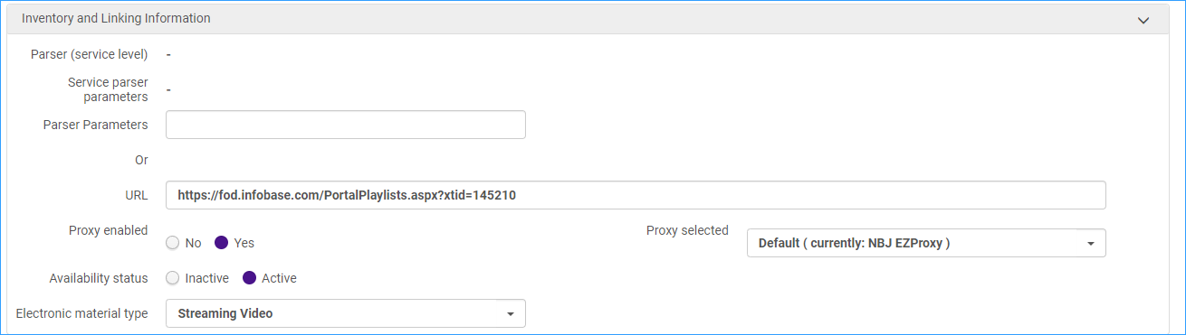
  - Parser parameters- you can add them here if the portfolio’s parser is different from the electronic collection.
  - If the portfolio has a URL enter it in the URL field.
  - Proxy information- you can add them here (i.e. for each portfolio) or you may set it up in the service in the electronic collection. When the proxy is set up in the service of the collection, the settings in the portfolio are: Proxy enabled No and leave selected proxy blank.
Proxy is set up in Collection Service | Proxy is not set up in Collection Service or Portfolio is Standalone
Set proxy enabled: No  Proxy selected: leave blank | Set proxy enabled: Yes  Proxy selected: select default proxy
  - Select the Electronic material type- Book, Streaming video, etc.

- The last box is for notes. A public note will appear in Primo VE. For our example, we will leave them blank.
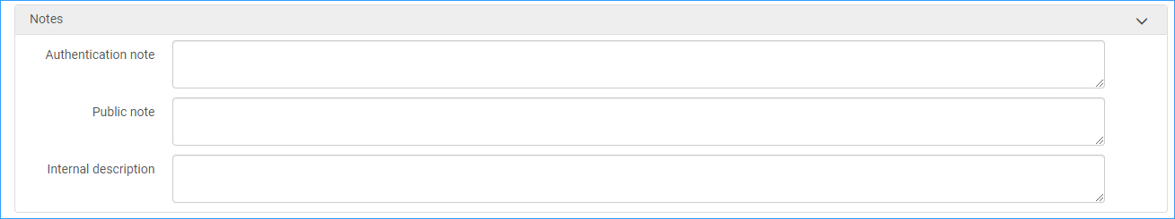
- Click “Save and Done” to return to the metadata editor.
- Click Save and Release record to release the record from the metadata editor.
