Setting up EBSCOhost electronic resources with the new (2022) link resolver settings

- Add the customer ID and OPID to the electronic collection service for ALL EBSCOhost databases.
- Click the row action menu, and click on Edit Service
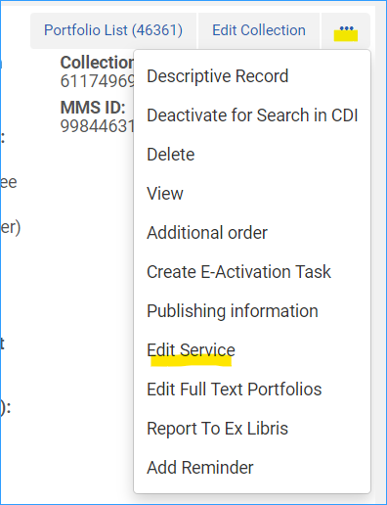
- Select the Linking Tab and scroll to the bottom of the page
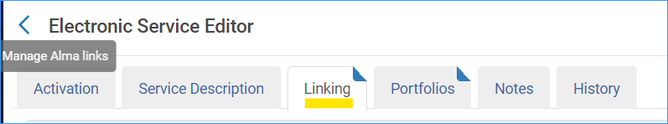
- In the Linking Parser Parameters table fill in the Customer ID and the OPID
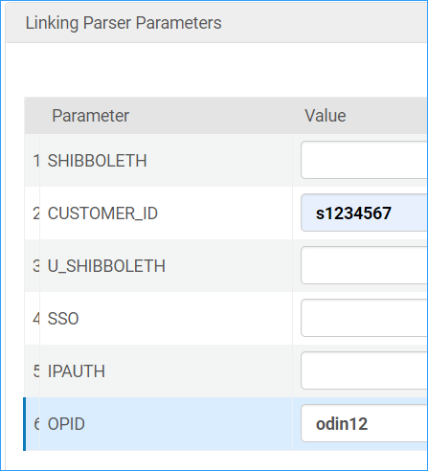
- After you have updated all the EBSCOhost databases with the new parser information, delete the EBSCO Integration profile.
  - Click on Configuration > General > External Systems > Integration Profiles
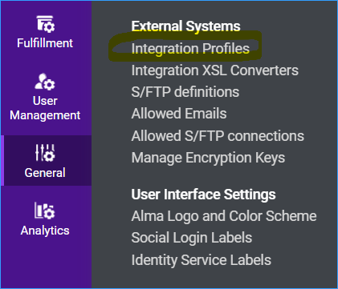
  - Select the row action menu for the EBSCO entry, and select Delete
