Deleting Items using Item record sets in LEAP
Note: if you maintain holdings in OCLC you will want to capture the OCLC numbers for the records so you can update OCLC holdings.
Use the Find tool to search for the record set:
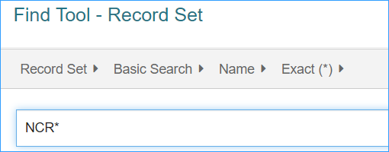
Search by creation date, name, owner, record set ID, record status or type. It is customary to put the library’s code at the beginning of a set name so the set can be easily found later.
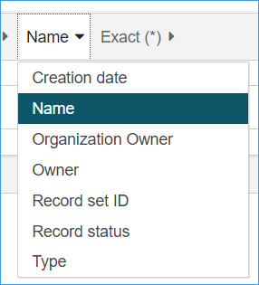

Once you have the record set, highlight the items you want to delete. You may have multiple screens of items.
To select all of them, scroll to the bottom and click the “More” button. Then, scroll back to the top and click the checkbox next to the “Title” heading.

Once you have the items you want selected, click the Actions menu, and select “Delete Selected Records.”
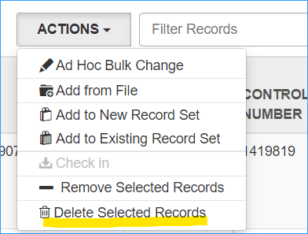
You will receive a dialog box asking about warnings: deselect the “Breakable links” box and click Continue.
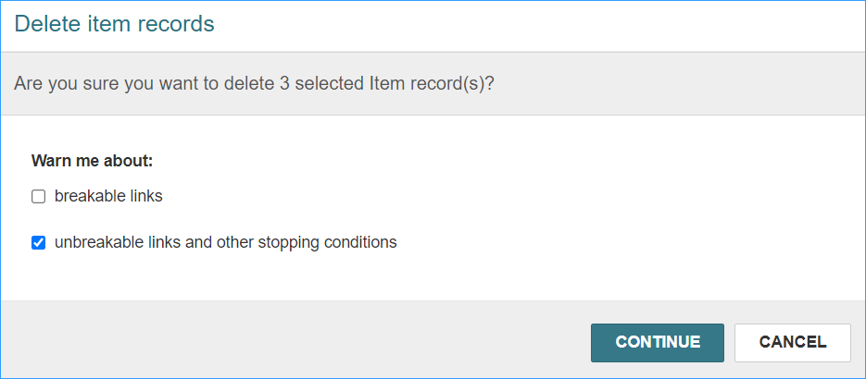
(If you cannot unselect the breakable links box, please let ODIN know, we can update your permissions so that you can.)
Note: If an item is checked out to a user it will not be deleted and it will remain in the record set.
When you are deleting the last item from a bibliographic record, you will be prompted about what to do with the bibliographic record. Click Delete.
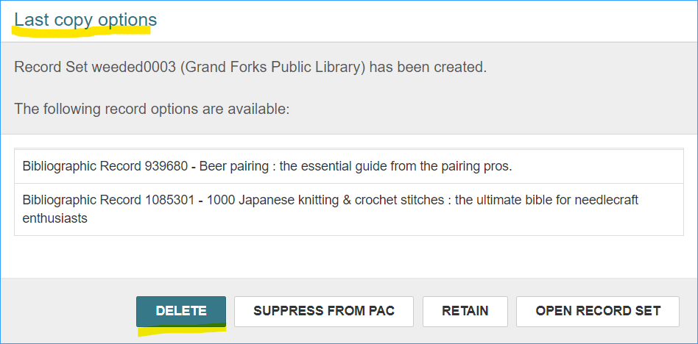
Everything has been deleted. The items have been “single-deleted” and will still be available for statistical purposes. Each Spring after libraries have reported their statistics to the State Library, they are purged by the ODIN office.

Deleting a Record Set
If the record set is now empty, or you no longer need it anymore, you can delete the record set.
From the top of the record set, select the Actions menu, and select Delete. This will delete the set only, and if there are items or bibliographic records still in the set they will not be deleted.
