12/17 via Teams
- Member Updates
UND - CFL: Brittany, Danielle, Shelby, Emily, Kristen, Laura, Sally, Alfred, Brian - bad links for Journals – not going to individually subscribed titles (example Tony hasn’t fixed yet; it should have link to Cambridge UP for current full text access). Packages are working ok though. Problem is that Primo assigned some to what they thought were part of packages – 17K titles to manage - Ebsco target shows on top per our specs – no option to be more granular in target weighting on a per title or per package basis. Not currently on an enhancement request to further refine this since just the per vendor ability is a fairly new enhancement. Working with library chat widget in databases within databases, has anyone else set that up. Jason added the chat widget to Dickinson and NDSCS. Jason can help anyone with Ebsco admin access. Can help with installation of chat.
Jaye Hess sent this information from her technician regarding adding library chat to EBSCO -
“We can have the code as a button that opens a pop up chat window at the top of the page. There is also the option to have it along the right side column in EBSCOhost, which is called in-page. Either way, I can set up a test ehost account and add a chat widget for them to look at, I just need their data-hash for libchat, which they can get by creating either an in-page or button pop-up widget in springshare (Depending on which configuration they would like) and then sending me the widget hash code. Instructions on how to do this are here: http://support.springshare.com/libchat/admin/systemchatwidgets"
Additional information Laura had found about EBSCO chat options -
Under EBSCO Admin - Branding. Chat options - The Ask a Librarian Link is one option (can set up to email reference email https://connect.ebsco.com/s/article/How-do-I-display-an-Ask-A-Librarian-link?language=en_US), or there is another option under Viewing Results where you can add your own chat widget (https://distlib.blogs.com/distlib/2010/02/embedding-chat-widgets-within-ebsco-databases.html except now called widgets under viewing results https://ask.springshare.com/libanswers/faq/1782)
BSC: Tina - working on database maintenance, checking monthly within each database to ensure they’re in working order (esp around midterms and finals); partnering with Student Success Center to create a LibGuide for class aids - additional modalities of learning on topics looking to Spring semester and will share link; recording all classroom session presentations for maternity leave; working to acquaint myself with the TOEFL; (support for ELL students over break when student success center closed)
DSU: Monica – Staci is cleaning up ebooks. (created a collection to eliminate a duplicate problem, and it created problems of its own - primarily Ebsco ones – UND is still working on this exact issue but no problem with new eBook purchases, just the old ones. Old NetLibrary records are being replaced per an Ebsco email* – Liz looking into this but it seems to only be impacting OCLC WMS users vs Primo CDI). Promoting PrepSTEP (separate subscription with coordination with) student success center. Working on reaching enthusiastic but reluctant instructors. Tough for followthrough after showing initial interest.
*"As an EBSCO eBooks customer, your library will receive a delete file from OCLC’s WorldShare Collection Manager between November 15th - 26th for any "EBSCO All eBook Collection" (netlibrary.ebooks) titles in your holdings selected from our free book collection, comprised primarly of Project Gutenberg books. The delete file is necessary because these titles are now only available in OCLC’s WorldShare Collection Manager in a collection called "EBSCO eBooks Subscription Publicly Accessible Collection" (netlibrary.e000mww).
Please note that your library already has access to these e-books on EBSCOhost through the EBSCO eBooks Subscription Publicly Accessible Collection, so your users have not lost access; access has simply shifted from one collection to the other.
When you receive the delete file, we recommend you process it to remove the outdated MARC records, then process the file for EBSCO eBooks Subscription Publicly Accessible Collection (netlibrary.e000mww) so the e-books are appropriately represented in your collection and your OCLC WorldShare Collection Manager account.
If you have any questions about this change please contact Customer Support"

U of J: Amanda - break project updating video tutorials to reflect recent tweak but there’s word of a new University website platform coming this summer

ODIN: Nicole, Jason: FYI: Liz got word from ExL that Gale in Context: College should be fixed now. We plan on reactivating in the NZ and testing over the break. Quick Links is out now on the sandboxes and we activated the option on both of them. One issue we are seeing is with Open Access records. They are currently sending all links through the proxy and we don’t historically or normally proxy OA resources so in order for those links to work, we will need to add proxy stanza definitions for each.
https://bismarckstate-psb.primo.exlibrisgroup.com/permalink/01ODIN_NBJ/31sum8/cdi_narcis_primary_uvapub_oai_dare_uva_nl_publications_db7ee677_8a77_4e8a_8c86_bed7c8cbd13e
https://knowledge.exlibrisgroup.com/Primo/Product_Documentation/020Primo_VE/Primo_VE_(English)/030Primo_VE_User_Interface/Quicklinks_in_Primo_and_Primo_VE

- Other Discussion Items

https://www.leanlibrary.com/pricing/ - browser extension; free option just checks if article open access. One of the paid options allows libraries to add chat to Google Scholar (and of course link to library full text). Example -
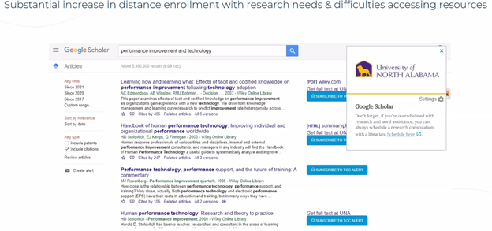
Also works with other resources, including Flipster. Example -
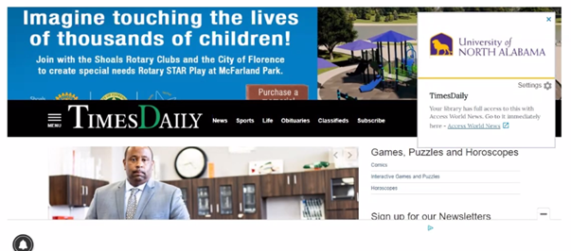
- Laura, UND : Searching Primo – Everything search limit by books vs. Catalog search (example search on the term lignin). In the former many more results appear, with OA titles coming to the top of the results list (coming from CDI) over the ones we’ve cataloged – CDI takes over the results. We don’t add holding records for eBooks except state and federal library documents. Referred to last month’s discussion of wording
Do we want to change wording to “on shelf” versus “held in library” or similar? U J reported on their update at last month’s meeting
DSU defaults to catalog – they may revisit that - about 3 set to catalog only as a first option - also Bismarck and UND Law
Kristen asked about Blackboard conversations statewide? Primo integration? - which Leganto does - just mentioning for now.

