October 28, 2021 -- PKS Cataloging Group Meeting Notes

Agenda:

New items:
- What’s new in your library? Questions?
  - Cindy from Dickinson – nothing new is happening
  - Lori from Grand Forks – still trying to get used to doing the cataloging with the new on-order items. They had a retirement party for a long-serving Children’s staff member.
  - Mary from West Fargo – This is her last meeting. They have not started interviewing people to replace her. A lot have applied. They will begin interviewing November 1st.
  - Stacey from the State Library – their replacement for Marlee who did statewide cataloging will be starting on Monday. They will be busy training her in all libraries the State Library catalogs for.
- State Library discovered a problem with the records that were being reloaded into Polaris to create authority links. For some of the records it was creating a second, false OCLC number from the control number.
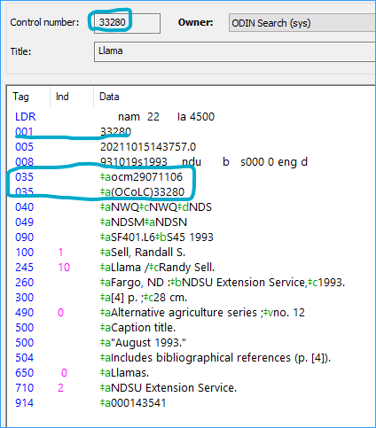
Polaris support provided a solution- delete the 003 $aOCoLC from the bib records before importing them. Then Polaris copies the control number to the 035, but it does not put the OCoLC in front of the number.
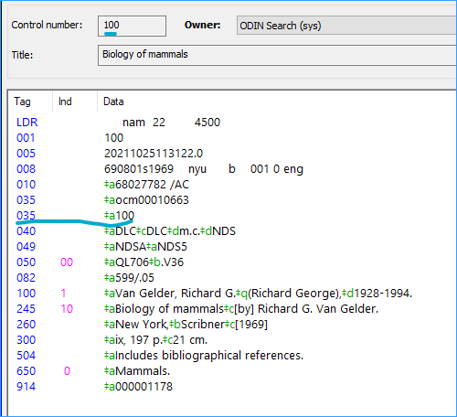
- On-order records from NGF-
  - What they look like
  - Can other libraries overlay them? Will this cause problems for NGF? How is NGF updating the on-order item records?
  - They also have a non-OCLC number in the 035. Example, this looks like a Library of Congress record:
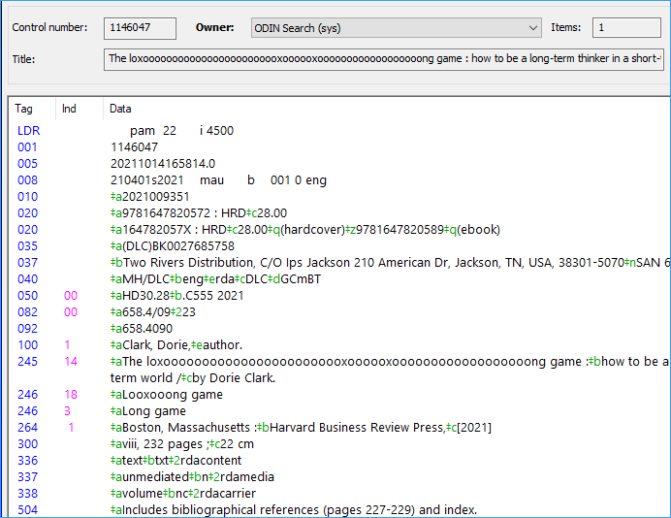
  - Discussion on overlaying Grand Forks’ on-order records: If we are cataloging the same book is it okay to overlay this record? Is that 035 number important to you at Grand Forks? This is still pretty new to Grand Forks- they are using short records from B&T but they have had to make up a lot of records themselves. Lori is starting to see this more and more. Lori replaces the short record with OCLC records, and afterwards it looks like it is supposed to look. Currently the State Library will overlay Dickinson’s brief bibs with fuller records because we don’t want more than one bib for an item. If later when Dickinson receives the item and it doesn’t match the State Library record, they will proceed with bringing in the correct record. Lori said she doesn’t have a problem with anyone overlaying their on-order records either. Since libraries are looking for the OCLC number in the records when cataloging so they can update their holdings in OCLC, they will notice if the full-looking records is an actual OCLC record, and they can overlay it if it is not. Lori will check and ask where these “BK” oclc numbers records are coming from. Lori said they are only doing this on-order acquisitions method for adult books, not children’s books.
- Grand Forks template were inadvertently removed- Lori put in a ticket because all Grand Forks’ item template disappeared. ODIN was able to get them back the next day. This occurred because West Fargo was having a problem with checking in their adult magazines, the shelf location was not being assigned to the item records. Polaris support determined this was because a template without an owner, a “ghost template” was being assigned to the new serial item record instead of WFPL’s item template. Polaris deleted the ghost template and then found 78 more of them and deleted those as well. It turned out that those were not ghost templates, those belonged to Grand Forks. Polaris restored those and added the appropriate branch information based on other location information in the template.
- Polaris has a page of cataloging training resources: https://innovative.libguides.com/polaris/cataloging
- November’s meeting falls on Thanksgiving – Should we cancel or reschedule the meeting?
  - Our next meeting would fall on Thanksgiving, so we don’t want to meet that day. Group decided to cancel the meeting for November. Our next meeting will be in December.
- It is time to start looking for a new chair for this group
  - Help come up with agenda items
  - Chair the meeting
  - Two-year term

Next Meeting:
Scheduled for 4th Thursday of each month or as needed
Thursday, November 25th from 10-11am (Canceled??)
Please send any agenda items to Liz.Mason@ndus.edu (or to this list).

Connection information - session will be recorded.
To join click on the following link:
https://us.bbcollab.com/guest/e1541cbb3ee34da8a29b5fc3d993fa8e

Session dial-in:
Call in anonymously. Attendees using this PIN appear as anonymous callers in the session.
• Dial-in: 571-392-7650
• PIN: 8825858795

