1. Can load multiple item records at once.
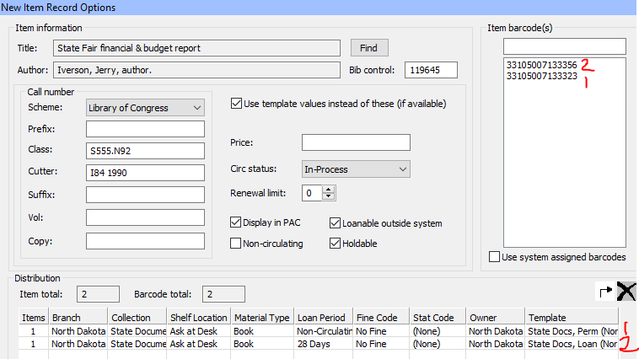

2. Can enlarge font in Polaris windows. Ctrl + Shift + Plus sign to enlarge. Use Minus sign to go back to regular size.
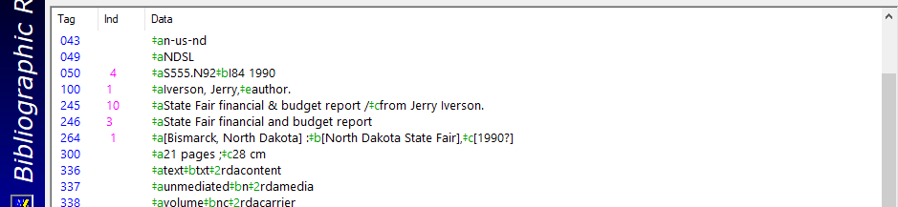

3. Can search for bib records by barcode number.
A bib search on barcode tells you right away how many items are linked. If it’s only 1 – then you know you’re going to delete your OCLC holdings and the bib in Polaris will also be deleted.
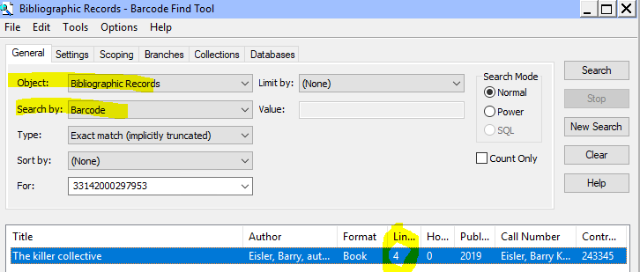
An Item search on barcode won’t immediately tell you how many items are linked. And then when you display the item, you still won’t know how many items, so you’ll have to click on “links”, “all item records”.
