Marking Items as Missing in Alma

Items can only be marked missing if their status is “Item in Place.” If an item is on loan or in a process type it cannot be marked as missing.
- Do a physical titles search (do not search by physical items).
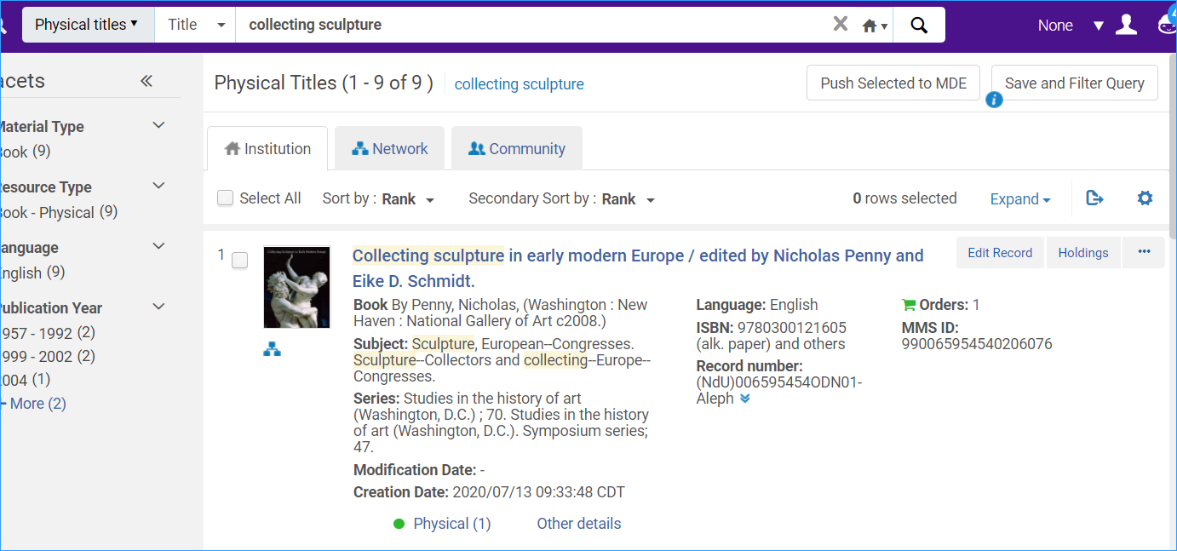
- Expand the record so you can click on the Items link
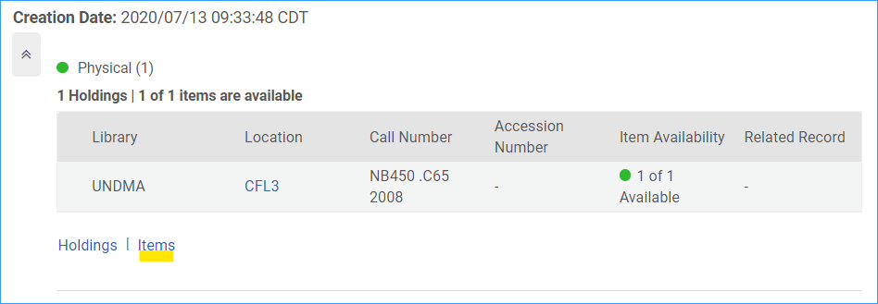
- The item appears
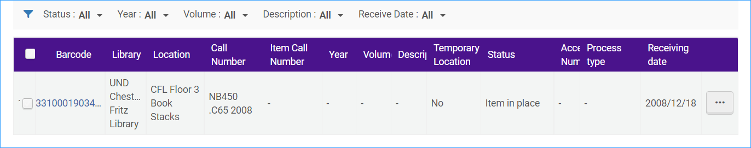
- Click the row action menu and select “Toggle Missing Status”
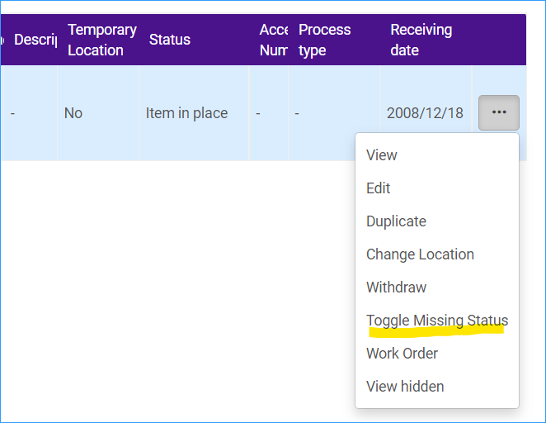
- Now the item status is “Item not in Place” and the Process type is “Missing.” The display in Primo VE is “Not available – Missing”
