For ACAD Discovery User Group Meeting – 9/17/21 10/15/21:

https://knowledge.exlibrisgroup.com/Primo/Content_Corner/Central_Discovery_Index/Documentation_and_Training/Documentation_and_Training_(English)/Your_Move_to_CDI/020Known_Gaps_and_Issues

Few known issues still being worked on for CDI:
- Author Facet: Despite extensive work by the CDI Development team to optimize performance of the CDI Author facet, the feature continues to incur a performance cost. The facet will not be enabled for content in the CDI index at this time. Primo institutions will continue to see author facet values and counts from their local data. The team will continue to address improvements but there is no timeline at this point.
STATUS: no target release date identified
*** Email on Primo listserv from Christian Authried stated:
When asked about the lack of Author facets in an IGeLU session (The Discovery Experience + Primo & Summon Product Update, Roadmap), Christine said: "Currently we have no plans for that." He referenced The Discovery Experience + Primo & Summon Product Update, Roadmap (APAC) presentation at IGeLU 2021

- Collection facet and Activation source: Not all collections currently appear in the collection facet or have an activation source in their source field. This is because DBIDs for some collections with portfolios are missing from CDI records. This requires a reload of collections and will therefore be resolved over time.
STATUS: Q4 2020 - FIXED for the majority of collections. Please see documentation for details.

- Rights update frequency: We are aiming for the CDI rights update to be completed within 48 hours, yet, currently, the process takes longer (around 72 hours). It will be improved gradually to meet the 48 hour target.
STATUS: Ongoing (several changes are required that will be released separately)

- Citation Trail: Currently, a citation will only appear if metadata is available from active collections. This is not correct because every citation should be returned, regardless whether the metadata is coming from a collection that is searchable (either because the full text is active or because it is set to active for search) or not. The impact is very low for institutions that have many collections active for search, it may be higher for institutions with few search activations. STATUS: To be confirmed

- Search: CDI returns for some searches too many results. This can lead to relevance problems when sorting results. This long tail will be reduced over time.
STATUS: March 2020 and ongoing

Tidbits from IGeLU 2021
- ExL has targeted Equity Diversity & Inclusion as an area to focus on. Phase 1 is ongoing
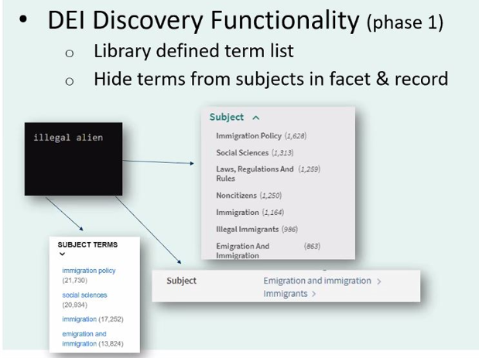

- There was also a session on “algorithmic bias” in the Discovery Systems. This may manifest in both the autocomplete feature and search results.

- “Objectionable terms” will still be indexed but not displayed.

- CDI was a topic in several sessions. They are experiencing about 10% annual growth with over 4.5 billion records right now. Metadata quality from content providers is a big focus. They are also working on CZ speed and quality in the feeds. Other focus areas listed were:
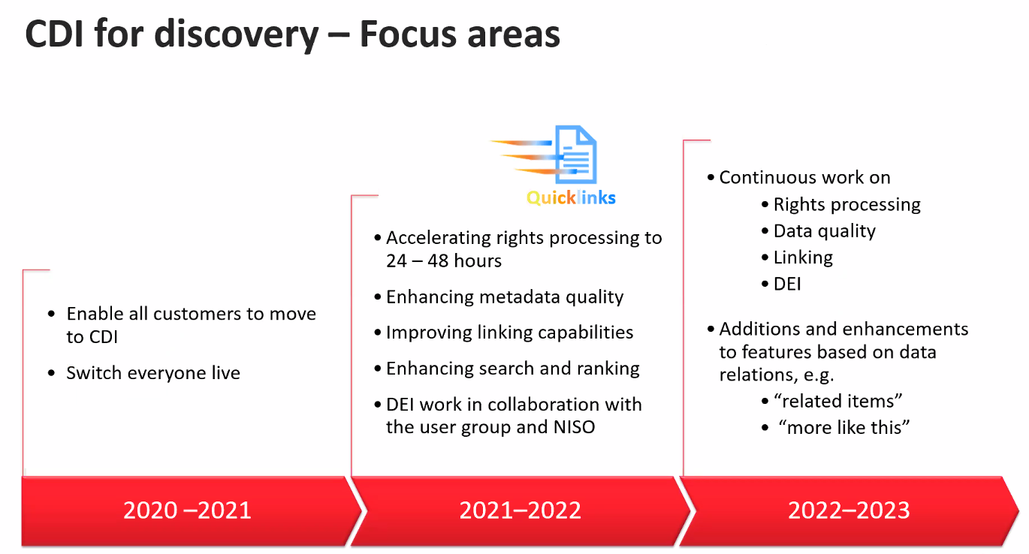

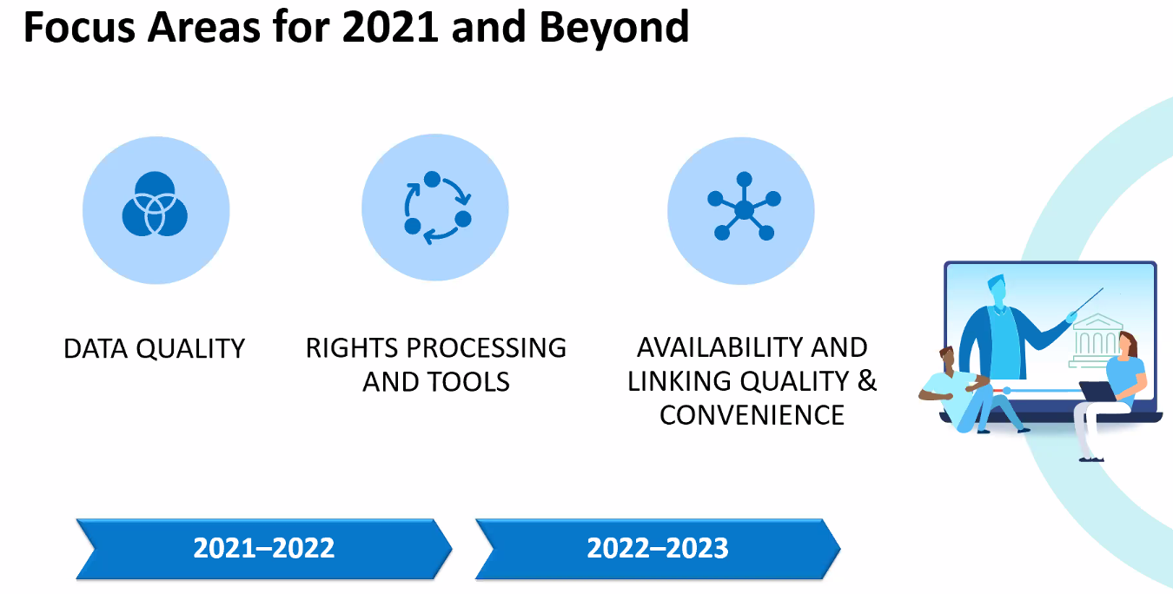

Initial plan was 24-48 hour CDI rights processing time. Increase in customers and volume has led to 24-48-72 hours or more. ExL is working on improvement for that timing.

They are also working on improvement for tracking where a record originated – this would display in the Details session under the Source field.

Another tool expected to be rolled out in the near future is Activation Analysis Tool which will help in troubleshooting. Testing has begun at other sites.
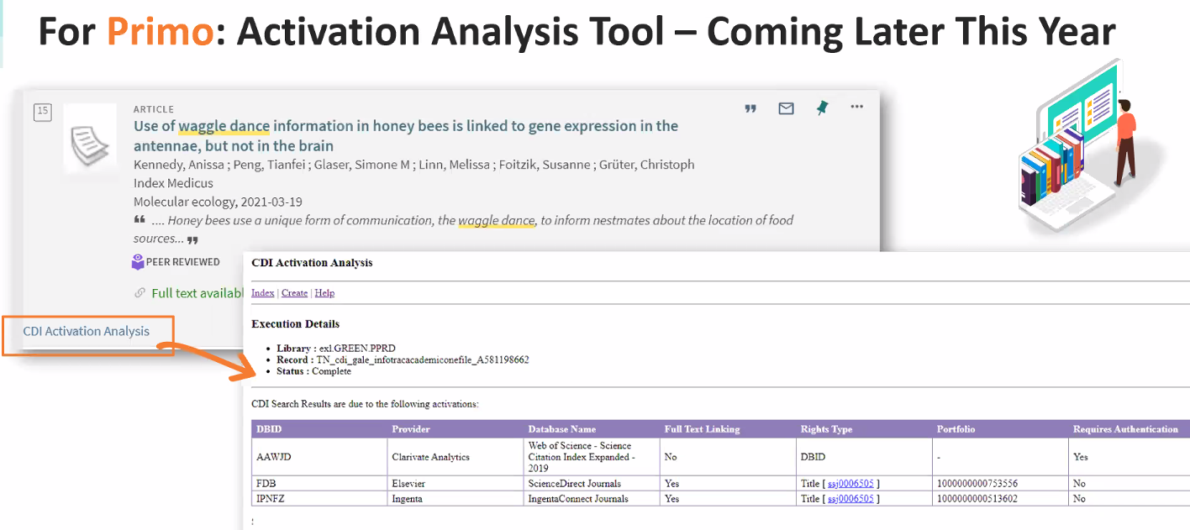

Work is ongoing in the availability and linking quality and convenience areas.
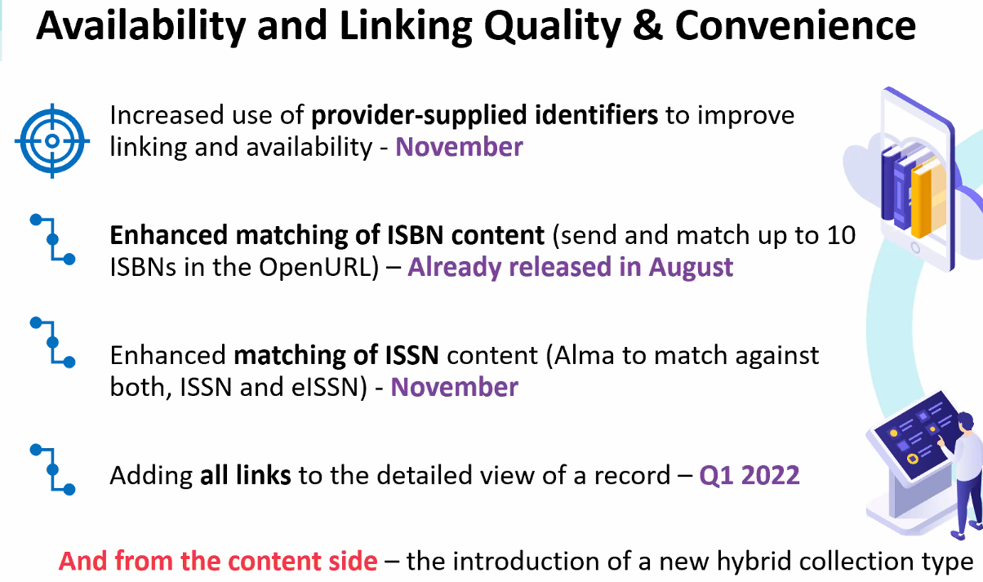

**** Note: the Enhanced matching of ISSN has been delayed until December.

Testing has also started on “quicklinks” which goes from citation to pdf/html full text in one click. November release is expected for that feature.
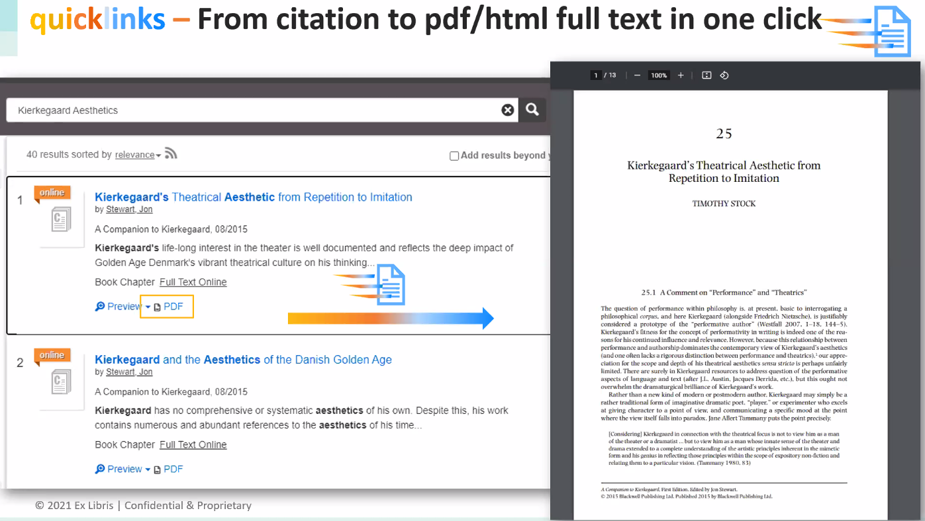

- Several large projects are ongoing but they all take design, development and then a release plan.
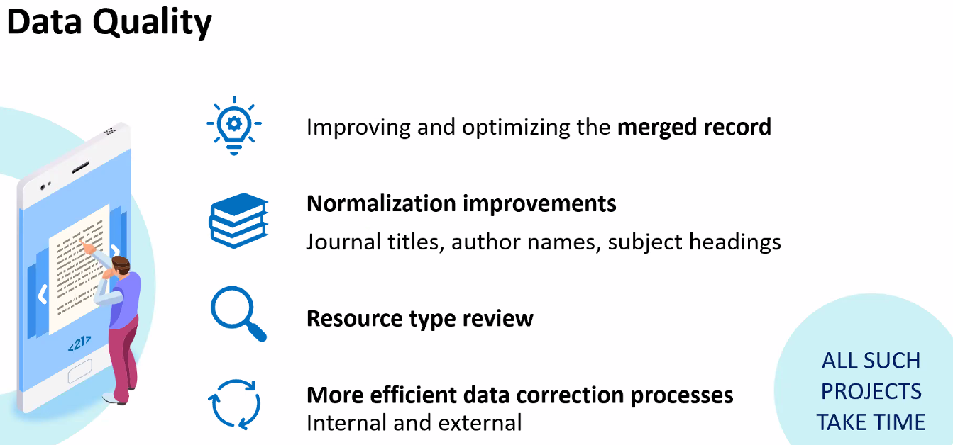

- From the Primo Working Group Business Meeting
  - NERS Enhancement Process 2020
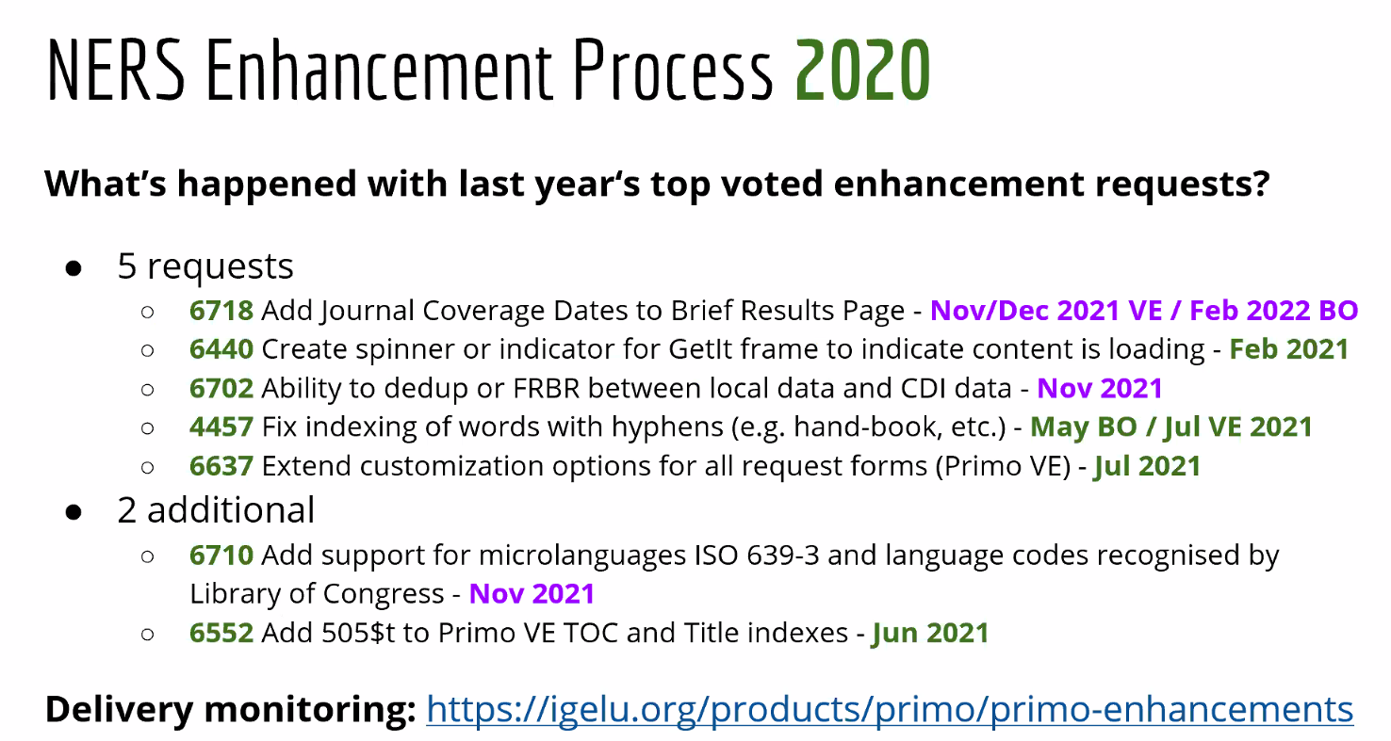

  - NERS Enhancement Process 2021
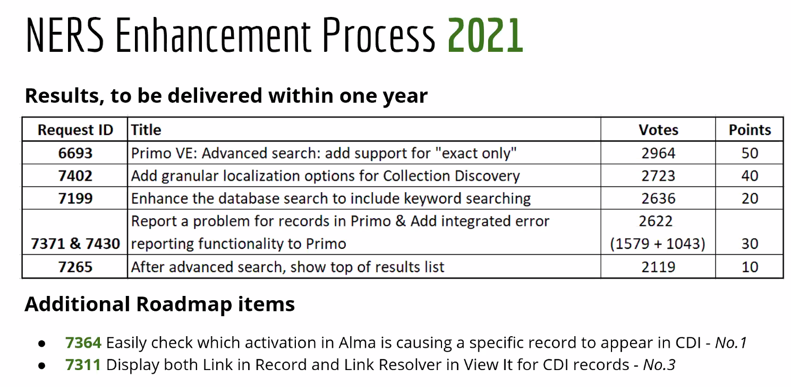
7364 – soon
7311 – February

  - The WG members hold monthly meetings and track issues such as:
    - Monitoring timelines and associated plans for Angularjs end of support.
    - Impact of EDI developments on Primo
    - How Third Party addons are handled for support, fixes and upgrades
    - Support for CDI Advisory Group given ongoing issues and Primo impact
Further information is provided in the IGeLU Annual Report.
  - Feature Alignment Schedule for Primo VE lists the enhancements and release timeline for certain features available in Primo but not Primo VE. About half of the list has been completed. The other half rolls out later this year into the first half of next year.
https://knowledge.exlibrisgroup.com/Primo/Product_Documentation/020Primo_VE/Primo_VE_(English)/020FAQs/Feature_Alignment_Schedule_for_Primo_VE

