How to relink a portfolio to a different bibliographic record

- Find the portfolio in Alma – search by Electronic portfolios and title or keywords:
- Click on Edit Portfolio next to the portfolio you want to relink:
- Click on the “Relink to another bibliographic record” button:
- Search for the record you want to link the portfolio to in the box that appears:
- Click on the record in the search results:
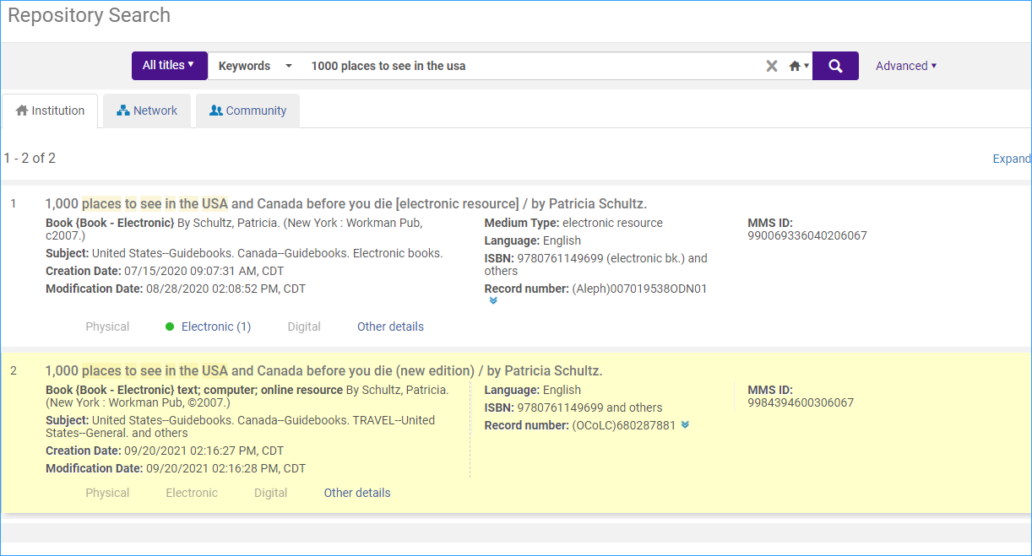
- A confirmation box appears- you will be asked what to do with the original bibliographic record if it will no longer have inventory- no nothing, delete, or suppress. Generally, the best option is to delete.
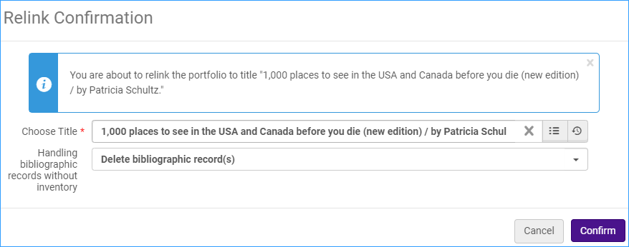
Click Confirm.
- Now the portfolio is linked to the new record:

