How to move an item record to another bibliographic record

- Find the bibliographic record that has the item you want to move. Physical titles search by title or keyword:
- Click on “Expand all” under the title:
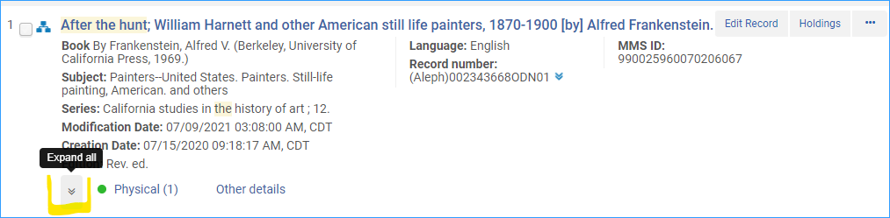
- An information tray appears. Click on the link for Items:
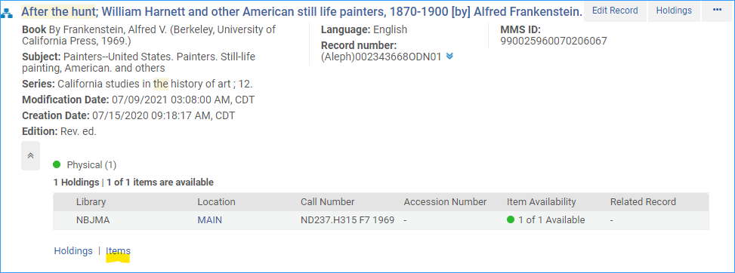
- Select the copie(s) you want to move to another bibliographic record:
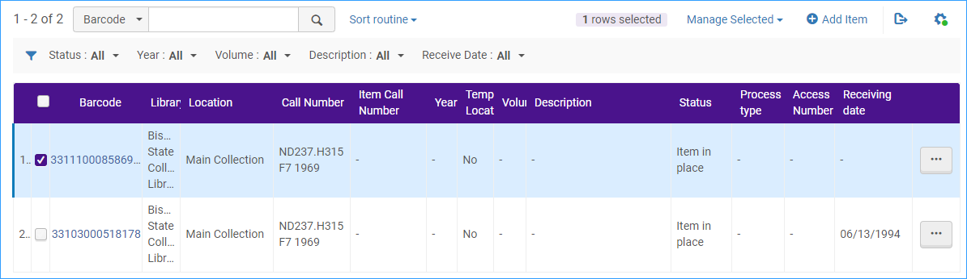
- Click on the link above that says, “Manage Selected” and select Relink to another bib:
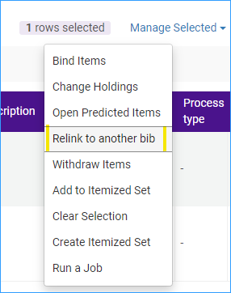
- This workform appears, click in the Select bibliographic record box:
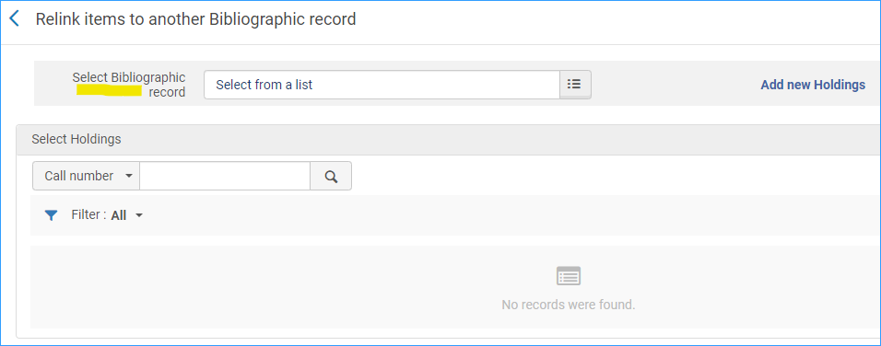
- Search for the bibliographic record you want to link to:
- In the search results click on the title you want to link to:
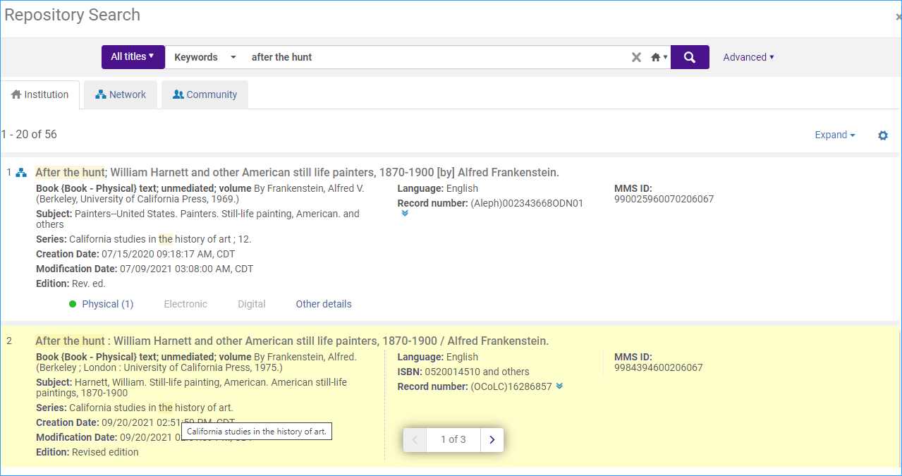
- When the bib record already has a holdings record you will select the holdings record you want to link to, and click Select.
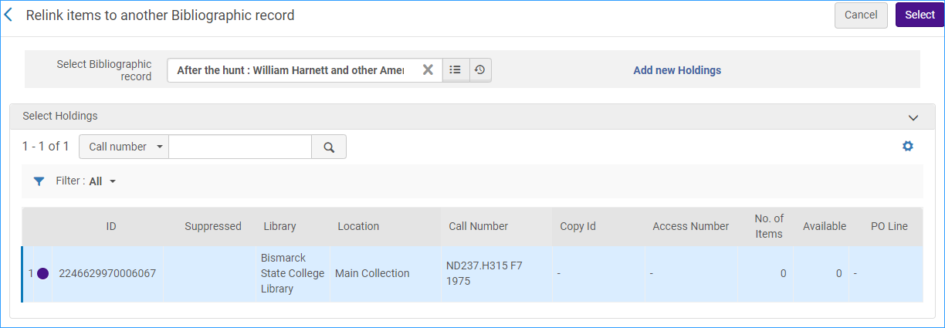
- The item is now linked to the new bib record.

When the new bib record doesn’t have a holdings record
- Click “Add new Holdings”
- It will pop you into the metadata editor where you can create the holdings record.
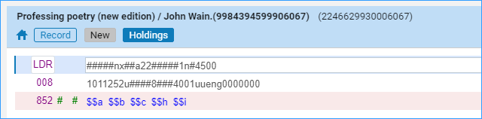
- Save the new holdings record, and click the Metadata editor icon to pop back to the relink items workform.
- Select the new holdings record, and click the “Select” button.
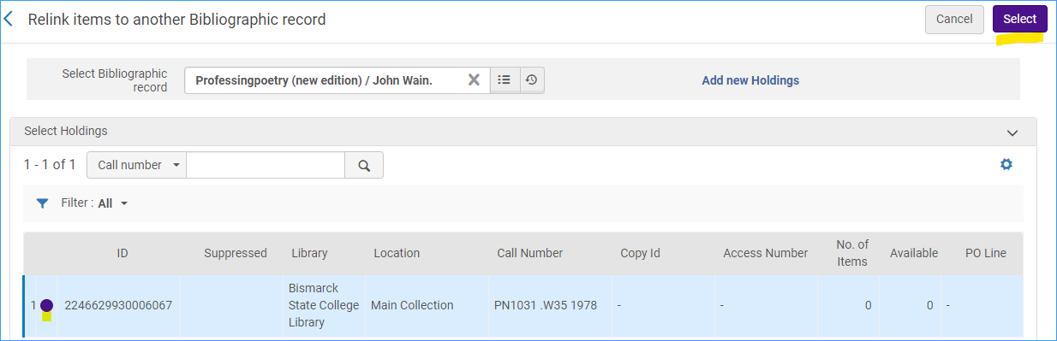
- If the item is the last one on the old bibliographic record, you must decide what to do with the old record- In general you would want to delete the bibliographic record when it will no longer be used:
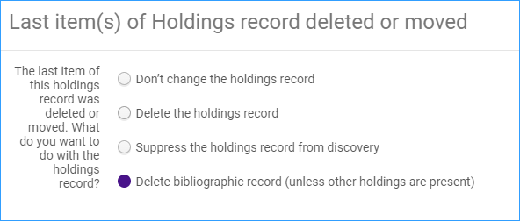
- Now the item linked to the new record:
