How to move a holding record to a different bibliographic record
- Find the bibliographic record that has the holding record that you want to move. Physical titles search by title or keyword:
- Click on Expand all
- An information tray opens, click on the Holdings link
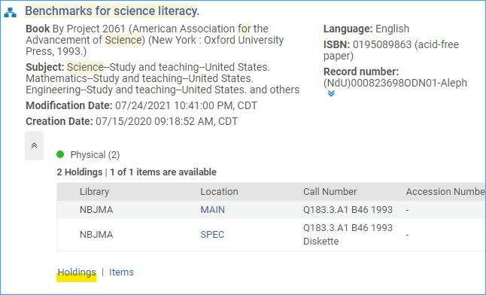
- Select the holdings record you would like to move to another bibliographic record, and click the row actions menu and select “Relink”
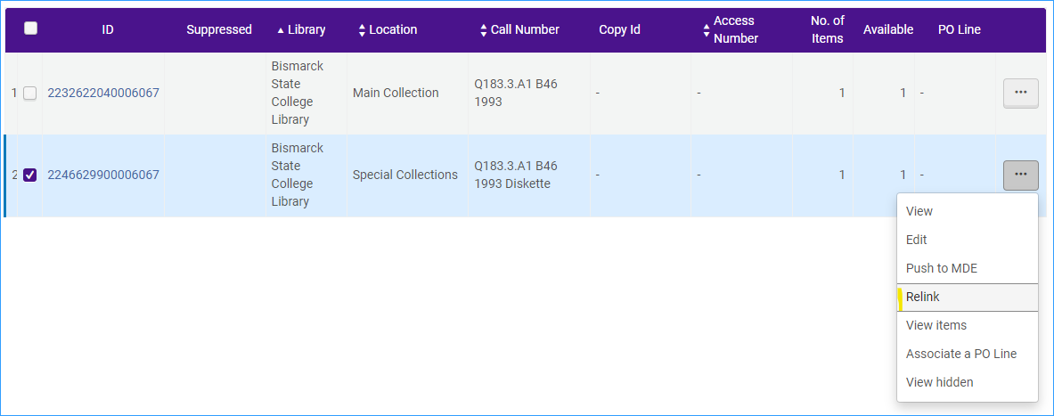
- The Metadata editor will open up with a search panel enabling you to search for the bibliographic record to link to. Type in your search and click Search.
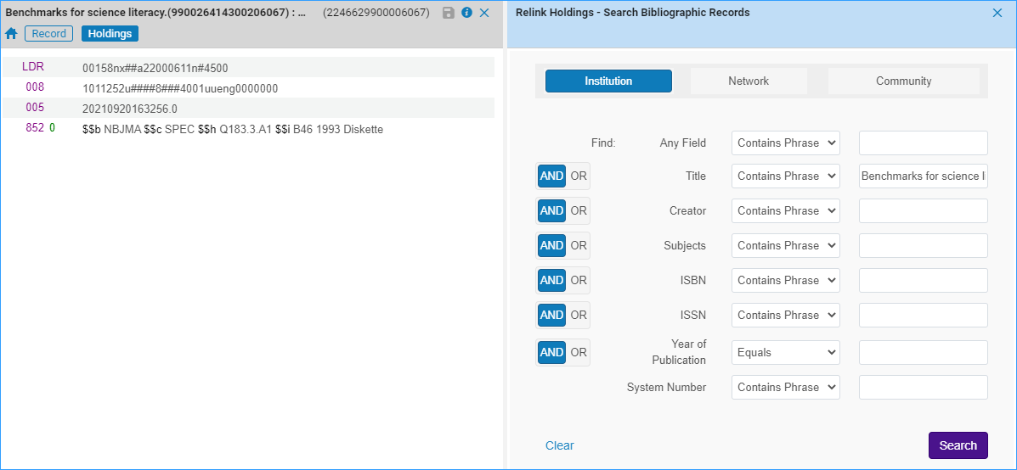
- Select the bibliographic record you want to link to and click Relink.
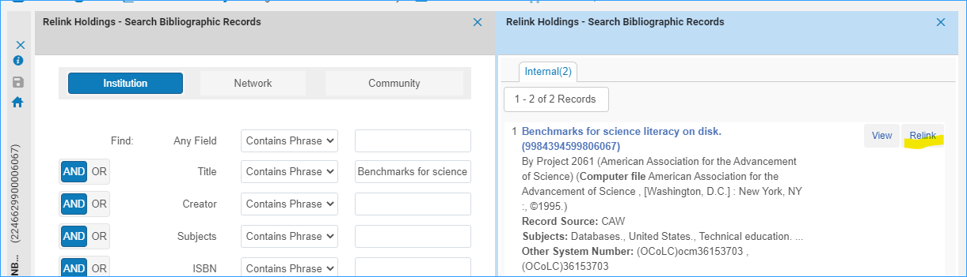
- The holdings record appears on the correct title, click Save.
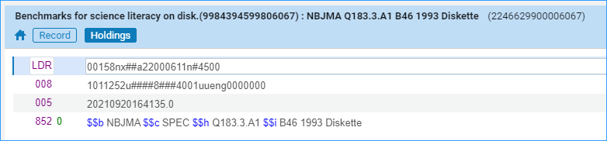
- The holding now appears on the correct bibliographic record, along with its item record:
