How to Deactivate and Delete an Electronic Collection in Alma

- Find the electronic collection by searching your IZ for Electronic Collection > Electronic Collection Name
- Select the Row action menu next to the collection in your search results
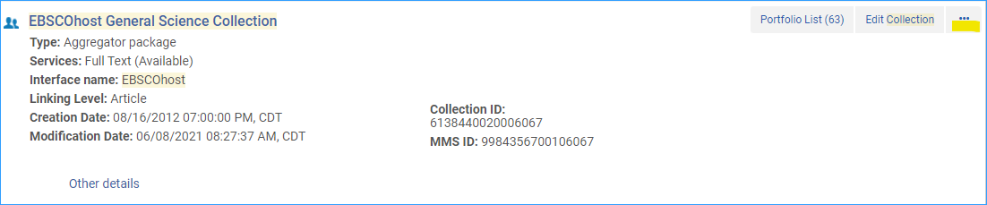
- Select Edit Service
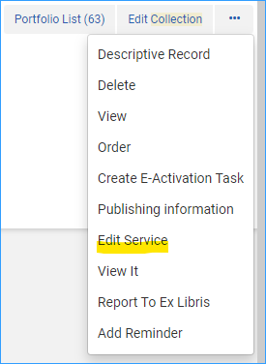
- Click the Portfolios tab, and click on Activate/Deactivate menu option, and select Deactivate All
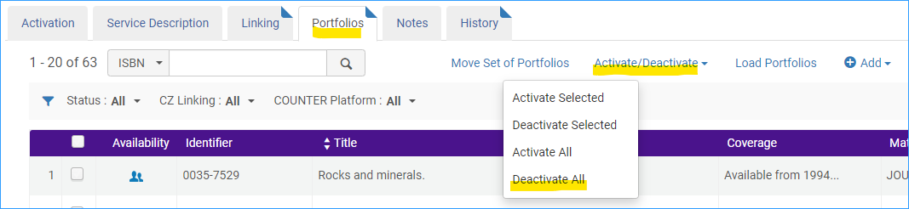
- Then click the Save button

- Alternatively, (or you can do both) you can change the collection from Available to Not Available in the service. Go to the row actions menu, and select Edit Service
- On the Activation tab, click Not Available
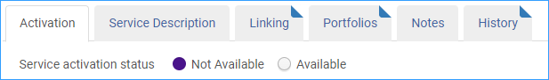
- Click the Save button.
Note: it isn’t recommended to delete the electronic collection from Alma. You may find it useful to keep the collection and its portfolios in Alma for a while so you can have access to data from it for analytics reports.
If you do decide to delete the electronic collection from Alma, click the row actions menu and select Delete.
