Adding a physical serial issue for libraries not using acquisitions

- Search for the serial title in Alma- Search by physical title and title or ISSN:
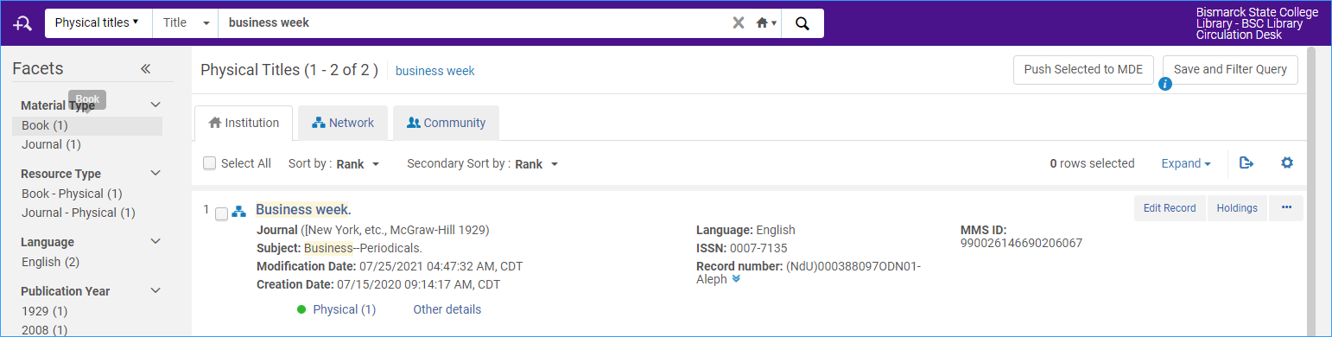
- Click on the Expand all double-arrow drop-down:
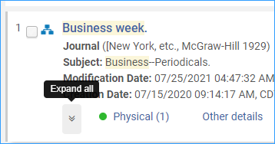
- Click on the Items link:
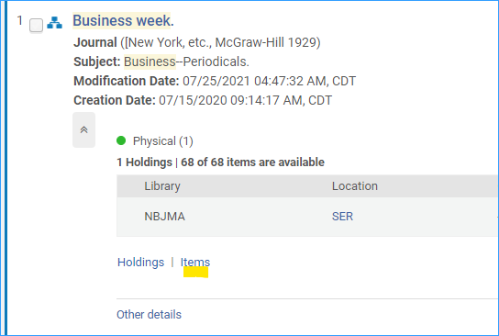
- Find the most recent issue in the list, and click the row action menu next to it, and select the menu option, “Duplicate.”
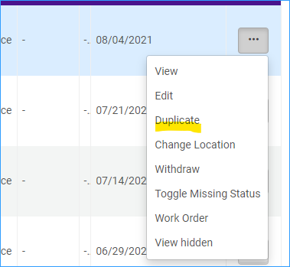
- Everything should be filled in for you. Update the barcode, enumeration, chronology, and description fields.
- Click Save.

