Database Tips

To access your library’s Databases, visit https://www.odin.nodak.edu/ and click A-Z List under e-Resources.
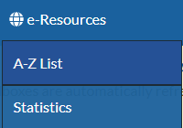

What to do if you are having issues:
- Try using a different internet browser. We recommend Chrome or Firefox.

- Clear your browser’s cache/browsing data.

- Verify you are using the correct Database link.

- Did your library get new computers or a new internet service provider over the summer?

- Submit an ODIN Help Desk Ticket for assistance

