7/16 via Teams

Member Updates (address Campus and Library Assessments)
- U of J: Amanda – Tuya (new director) started last week - super busy but may attend meetings in the future
- Mayville SU: Kelly – busy cataloging and withdrawing items; learned that there will be no replacement for Aubrey’s position probably for this biennium; she recommends the book: Library Assessment in Higher Education/Matthews - and she would be interested in doing a book discussion.
- BSC: Laura, Tina – Tech Days – 3 apps they consistently use – Libby (instead of Overdrive), Flipster, Ebsco – making brochures and holding sessions – pretty great following for #TECHDays – 4 or 5 academics have these subscriptions – could share checkouts between libraries - may want to discuss (revisit) academic consortia for this - uploaded the promotional items in a Teams folder labeled BSU Tech Days
- UND – CFL: Brittany, Shelby, Rebecca, Zeineb, Emily Wros (Welcome!), Kristen - Emily introduced herself – she is a systems librarian who will be working with Alma and most recent experience is with CARLI; Kristen reported on our updated Primo to show beyond first 10 results and navigation with paging through; still having difficulties with Elsevier resources disappearing from Discovery – doesn't matter if logged into Primo or not.
- NDSCS: Amy - Just working on the last of Tech migration clean-up and MasterFILE companion collection clean-up.
Demonstration/Instruction - none
Other Discussion Items
- ODIN reporting of PRIMO enhancements
  - Contractually obligated to dedicate hours to work on these
  - Should expect those listed items to be worked on this year
  - There’s 2 documents that explain what the items are but ODIN indulged Kristen with a “show and tell” on each – much appreciated!
  - Item 7364 , Easily check which activation in Alma is causing a specific record to appear in CDI – this is specific to cataloging; however, if we notice a source for poor link resolution we can report that.
  - 6693 , Primo VE: Advanced search: add support for "exact only" - currently this search pictured below will explode the search term (matching Shakespeare’s for example) and having top displayed items include Shakespeare in areas other than the title. This is all in the name of “serendipity” says Primo, but librarians have said, enough!
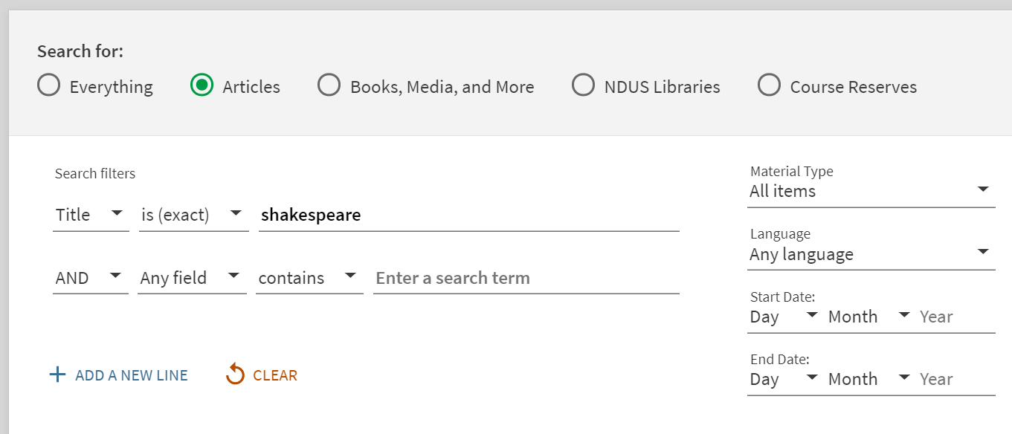

  - 7311 , Display both Link in Record and Link Resolver in View It for CDI records – this is primarily an issue with Open Access sources – which Shelby says are very problematic and bigger than just this fix
  - 7402 , Add granular localization options for Collection Discovery – when consortia create collections, the item targets can get messy but this does not apply to any of us
  - 7199 , Enhance the database search to include keyword searching – no one has the Database Search function set – most of us rely on Libguides or similar tools to manage the display of available databases
  - 7371 & 7430 , Report a problem for records in Primo & Add integrated error reporting functionality to Primo – self-explanatory
  - 7265 , After advanced search, show top of results list – this is a display issue, how when people do a search (especially on mobile devices) it looks like nothing has happened because you have to scroll down to see the results.
- New ODIN website demonstration/usefulness for this group
  - https://www.odin.nodak.edu/academic
  - Let them know if anything missing
  - If you log in – stays longer / can favorite things / set password first time
  - A recording of training is available and definitely worth watching – Home \ Featured Events on Right hand side
- Leganto and NDUS institutions - no comments but a pretty small group today

