Alma Resource Sharing
Completing an Item Request

- To complete the resource sharing cycle, when material has been returned to the lending library, that library conducts a return of the material by going to the Fulfillment menu and selecting Checkout/Checkin | Return Items.
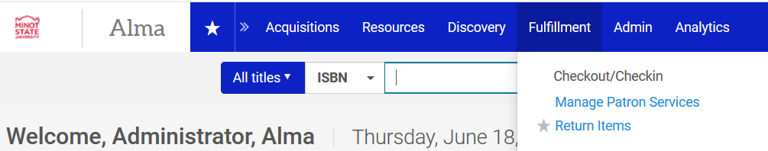

- After scanning the item barcode, the return screen Alma indicates the next step, which is typically reshelving the item.
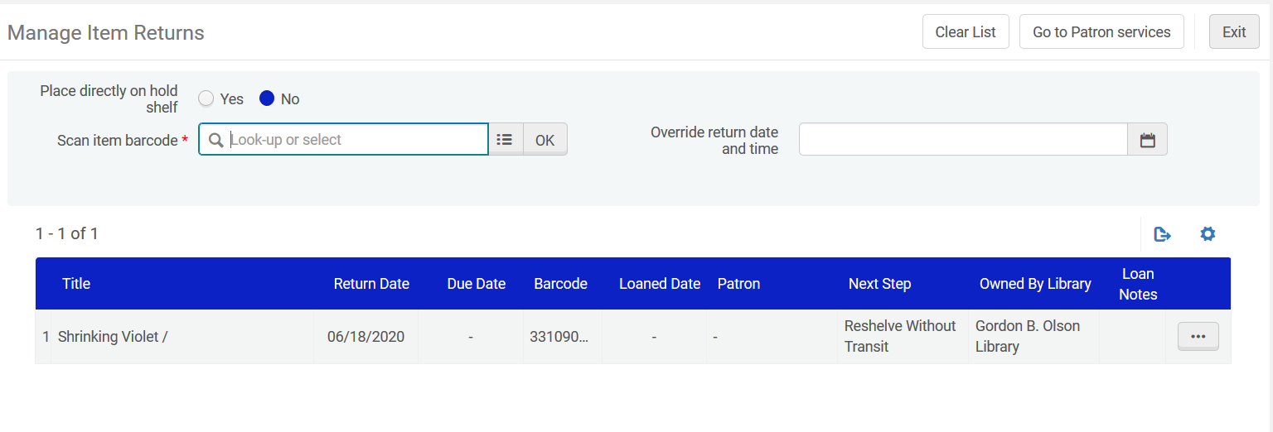
- Alternatively, you may retrieve the item by going to the Fulfillment menu and selecting Resource Sharing | Borrowing Requests. With the request on the screen, use the ellipse button next to the request and select Checked In.
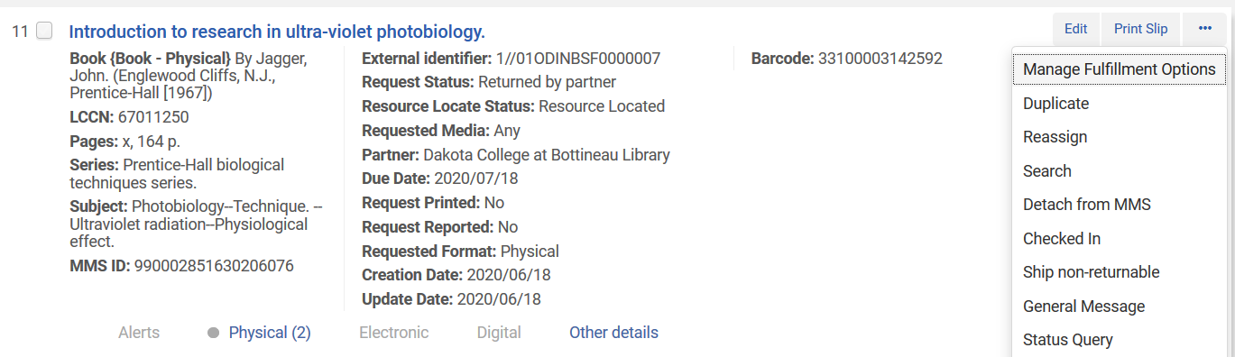

- A workform is displayed allowing for the entry of an Internal note or Note to partner. Click OK to continue.

- Using either method, status of the request is updated to Request Completed.
