Alma Fulfillment
Holds Processing

Holds placed by patrons will typically take place in Primo. After conducting a search, the patron has the ability to place a hold on material.
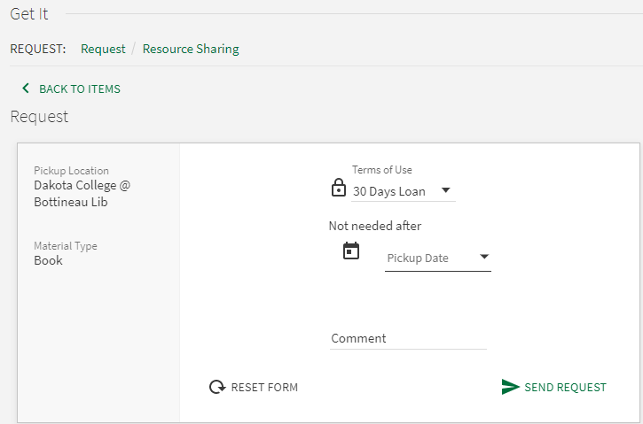

Alternatively, staff may place a hold on a physical item on the patron’s behalf.
- After logging into Alma, conduct a search for the material. Click Request in the upper right of the record.
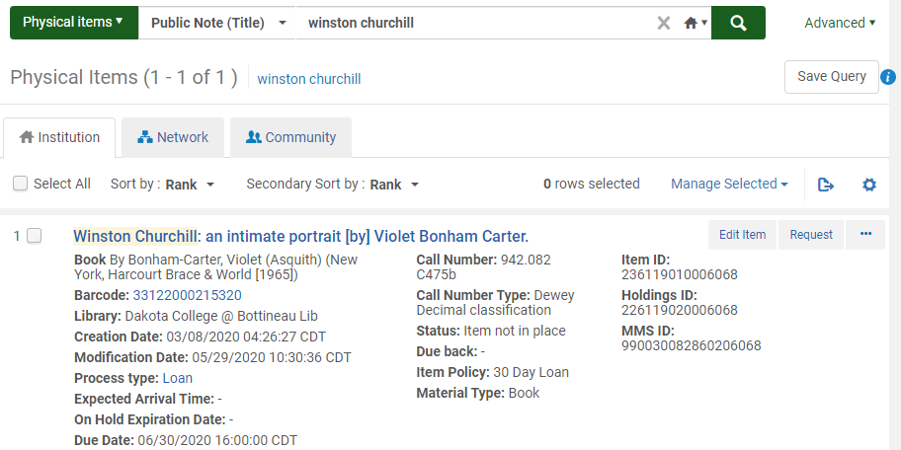

- On the ensuing workform, select the Request Type – typically a Patron physical item request.
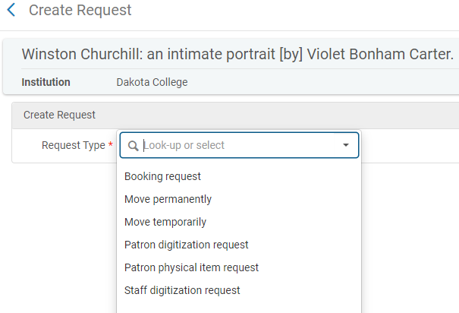

- Fill out the rest of the workform as necessary, including Requester, Pickup At location and Date Needed By. Click Submit to enter the request.
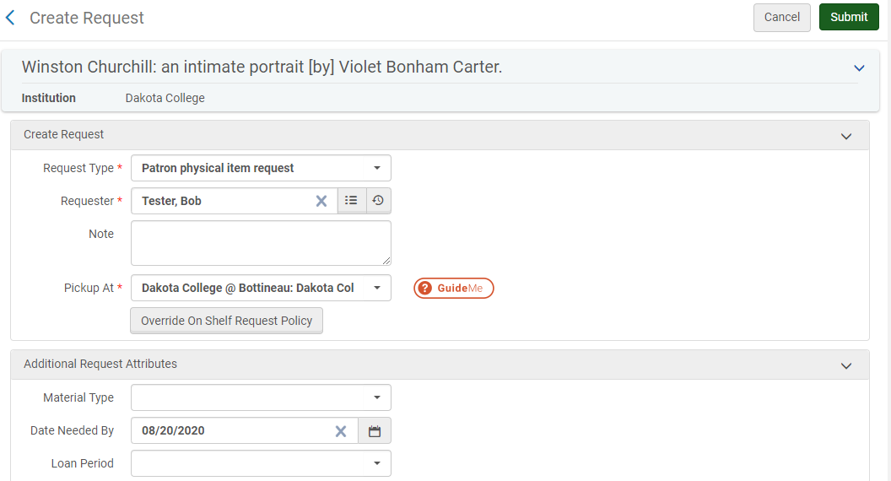
- If the item was on loan, when it is checked in staff will be instructed that it should be moved to the hold shelf.
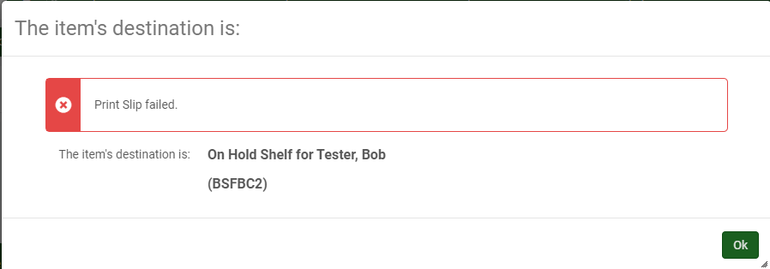
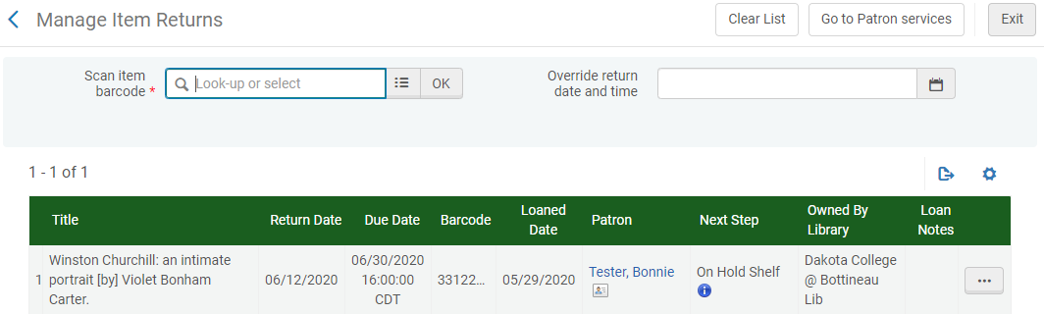

- If your library allows for available items to be placed on hold, you’ll want to check for these holds. In the Fulfillment heading, select Pick from Shelves.
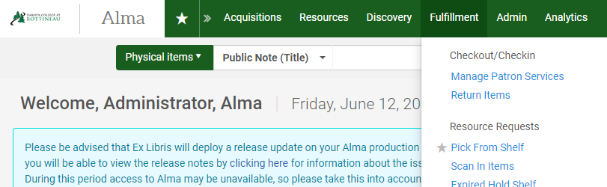

- A list of requests for material that is on the shelf is displayed. You can choose to print a report of all items, or print slips individually.

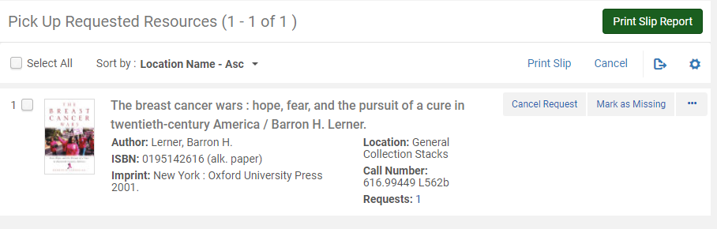
Additionally, you are able to work with the request by canceling it, marking it as missing or using the ellipse button find options for additional actions such as updating the expiry date, convert the request to resource sharing or edit the request.
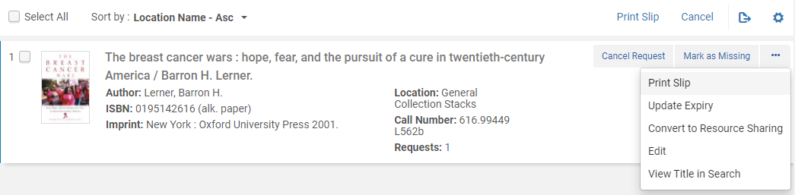

  - Once items are retrieved from the shelves, on the Fulfillment heading, select Scan in Items to process the requests.
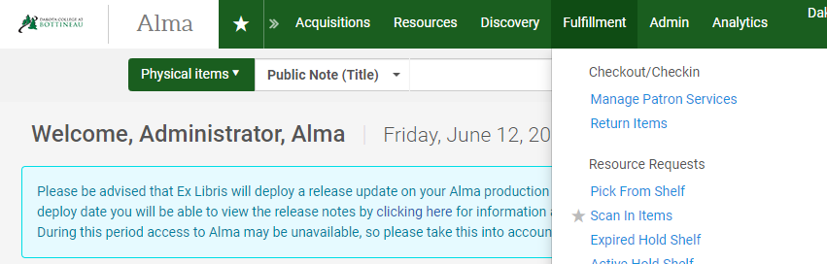
On the Scan in Items screen, you can select whether or not to automatically print a slip. Scan the barcode of the item.
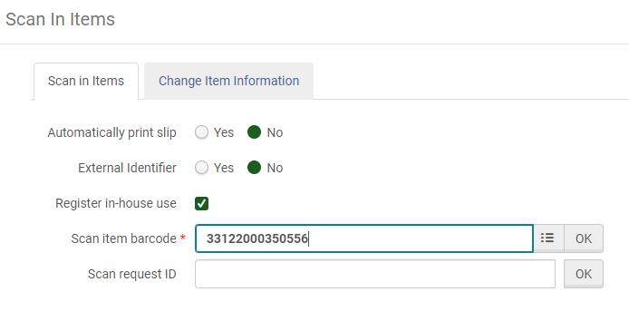
The system indicates the item is on hold, as well as the person who requested it. It can then be placed on the hold shelf for the patron.

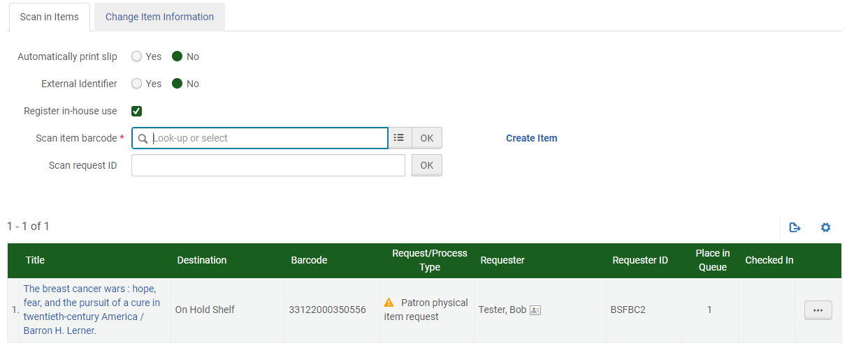
- You are able to monitor requests by going to the Fulfillment heading and selecting Monitor Requests & Item Processes.
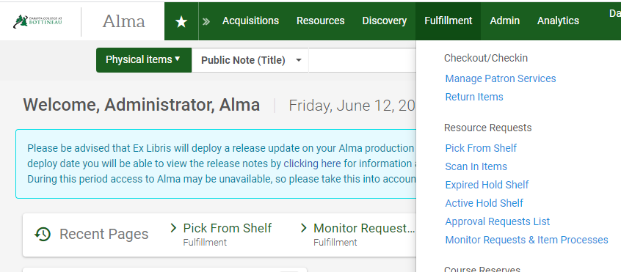

From this screen, you have a view of all hold requests in your library. You can use the facets on the left to filter the requests. On the right of each request is the option to cancel the request, move it to the task list, and an ellipse button which allows for additional actions such as printing a slip, editing or converting to resource sharing. These options vary depending on the status of the request.
