|  |  |
| --- | --- |
| Primo logo | **Implementation Workbook**  **Phase 2**  Customer: ODIN/GENERIC  Customer Code: 01ODIN  Project Manager:  Email to: |

# Table of Contents

Table of Contents 1

Introduction 2

For Your Information 2

ILS and Digital Repositories 3

User Interface: Your Home Page 5

User Interface: Search 10

User Interface: Search Results 11

Comments and Questions 14

Appendix A: Primo Central Activation Wizard 15

Appendix B: Library Codes 17

Appendix C: Collection Codes 18

Introduction

*This workbook is designed to gather the information needed to complete the second phase of your implementation. If you have any questions during this phase, please contact your Project Manager.*

* *Phase 1 – Ex Libris will install Primo and prepare your systems and applications for integration.*
* ***Phase 2 – Ex Libris will configure the user interface and your data in Primo based on your institution’s specific requests.***
* *Phase 3 – You will be given access to your Primo interface, and will be able to test and provide feedback before going live.*

*We understand that you may need to consult with colleagues to complete workbook. You will notice ‘Section Complete?’ checkboxes throughout the workbook; please feel free to use these to track your progress.*

|  |  |
| --- | --- |
| For Your Information | |
| Contact information |  |
| Listserv – all members |  |
| Listserv – all Ex Libris project members |  |
| Project Manager |  |
| Logins |  |
| Customer Center login |  |
| eService login |  |
| Primo Central |  |
| Link to Primo Central Activation wizard *Please see Appendix A for instructions* |  |

|  |  |  |
| --- | --- | --- |
| ILS and Digital Repositories | | |
| *This section gathers information about your ILS & digital repository data which will be loaded into Primo.* | | |
| ILS | | **Section complete?** |
| 1 | **Library Codes**  *If you have a list of library codes and their descriptions, please provide them in tab delimited format in Appendix B* |  |
| 2 | **Collection Codes**  *If you have a list of collection codes and their descriptions, please provide them in tab delimited format in Appendix C* |  |
| ILS Data Extract | | **Section complete?** |
| 3 | **Full data extract**  *Please extract the bibliographic and holdings data from your ILS to load to Primo, and place the file here:*  [*ftp.exlibris-usa.com*](ftp://ftp.exlibris-usa.com)  *IP address: 199.117.46.252*  *Login name: incoming*  *Please use the following convention name the file:*  *CustomerName+date+[.zip,.rar,.tar.gz,.tar.bz, etc].*  *Requirements for the extract are detailed in the Primo Interoperability Guide.* |  |
| 4 | **Ongoing data harvesting and loading**  *To reflect changes to your ILS data in Primo, data must be extracted from your ILS on a regular basis.* |  |
| 5 | What protocol should be used to retrieve the ongoing ILS data extracts? |  |
| 6 | Where will the ongoing ILS data extracts be available? | Server name or IP:  Username:  Password: |
| 7 | At what frequency will your ongoing ILS data extracts be published? |  |
| 8 | Will the ongoing ILS data extracts include only incremental changes or all records every time? |  |
| Digital Repository #1 | | **Section complete?** |
| 9 | **Ongoing data harvesting and loading**  Please provide additional information about how you would like to update data for your first digital repository. Please enter N/A if not applicable. | n/a |
| Digital Repository #2 | | **Section complete?** |
| 10 | **Ongoing data harvesting and loading**  Please provide additional information about how you would like to update data for your first digital repository. Please enter N/A if not applicable. | n/a |
| Comments and Questions | |  |
| 11 | Please note any additional information or questions you have on ILS data or digital repositories. |  |

|  |  |  |  |
| --- | --- | --- | --- |
| User Interface: Your Home Page | | | |
|  | | | |
| Primo Home Page Placeholder Content | | Section complete? | |
| *Some libraries choose to replace their library home page with the Primo home page, while others choose to remove the placeholder content from the Primo home page and access Primo from the embedded search box on their library home page instead.* | | | |
| 12 | Please choose whether or not you would like to customize the placeholder content on the Primo homepage, or remove it entirely. | | We’d like to customize this content  Please remove placeholder content |
| Home Page Tiles | | Section complete? | |
|  | | | |
| 13 | **Header.html**  Please indicate which logo you would like to use.  *If you would like to use a specific logo that is different from the one that currently appears on your website, please include the image file when returning the workbook.* | | Use the logo image currently displayed on our library’s website.  We’ll send a logo image file for use in Primo  *Note: an image with a transparent or white background looks best; the default Primo logo is 168 x 36 pixels –the header area will be resized according to the dimensions of your logo.* |
| 14 | **Help files**  Please indicate whether or not you would like to customize the content found in the help files.  *You can either provide us with the content itself, or you can host and maintain your own HTML file. Based on your selection, your Project Manager will work with you to customize this content.* | | Use the default help file  We’d like to host our own help file  We’ll provide the replacement content |
| 15 | **Featured.html**  Please choose how you would like to handle the replacement of the *featured.html* content.  *You can either provide us with the content itself, or you can host and maintain your own HTML file. Based on your selection, your Project Manager will work with you to customize this content. If you chose to remove all placeholder content in the previous section or would like to leave this area blank, please select N/A.* | | We’d like to host the HTML file  We’ll provide the replacement content  N/A |
| 16 | **News.html**  Please choose how you would like to handle the replacement of the *news.html* content.  *You can either provide us with the content itself, or you can host and maintain your own HTML file. Based on your selection, your Project Manager will work with you to customize this content.*  *If you chose to remove all placeholder content in the previous section or would like to leave this area blank, please select N/A.* | | We’ll host the HTML file  We’ll provide the replacement content  N/A |
| 17 | **Services.html**  Please choose how you would like to handle the replacement of the *services.html* content.  *You can either provide us with the content itself, or you can host and maintain your own HTML file. Based on your selection, your Project Manager will work with you to customize this content.*  *If you chose to remove all placeholder content in the previous section or would like to leave this area blank, please select N/A.* | | We’ll host the HTML file  We’ll provide the replacement content  N/A |
| 18 | **Footer.html**  Please define the links that you would like to appear in the *footer.html* content.  *The links that are present by default do not currently link to a web page. If you would like to use any of the given links, please provide a URL specific to your institution.*  *If you would like to include additional links in the footer, please indicate the link name(s) and URL(s) in the ‘Other’ text box.* | | Home INDIVIDUAL - SEE SPREADSHEET  Blog remove  RSS Feed remove  FAQ INDIVIDUAL - SEE SPREADSHEET  Disclaimer  Contact Us INDIVIDUAL - SEE SPREADSHEET  Other |
| 19 | Please note any comments or questions you may have about this area of the user interface. | | INDIVIDUAL - SEE SPREADSHEET |
| Colors and Fonts | | Section complete? | |
|  | | | |
| 20 | Do you wish to change the text colors, sizes and/or fonts that appear in Primo?  *If yes, please describe the changes you’d like to make in the text box provided.* | | No  Yes: |
| 21 | Please note any comments or questions you may have about this area of the user interface. | |  |
| Main Menu | | Section complete? | |
| *You can choose to customize the display names of the links, hide links, add links, or reorder them.* | | | |
| 22 | **Library Search**  *The default link will bring you back to a new search in Primo.* | | Use default  Rename link New Search  Assign different URL to link  Hide link |
| 23 | **A-Z**  The default link goes to your SFX A-Z List | | Use default  Rename link Journal List  Assign different URL to link  Hide link |
| 24 | **Find Databases (MetaLib only)**  (not shown above) – If you have MetaLib configured to work with Primo, the Find Databases link will allow users to select and search MetaLib resources. | | Use default  Rename link  Assign different URL to link  Hide link |
| 25 | **Help** | | Use default  Rename link  Assign URL to link  Hide link |
| 26 | **Language** | | Hide Language dropdown  Keep Language dropdown |
| 27 | **Additional links** | | Add:  Library Home - INDIVIDUAL HOME LINKS - SEE SPREADSHEET |
| 28 | **Reorder links**  Please indicate whether or not you would like to reorder the links as they appear left to right. | | No  Yes: New Search |Journal List | Library Home | Help | Languages |
| 29 | Please note any comments or questions you may have about this area of the user interface. | | Please include the following in the language drop-down: English | Spanish | German | French |

|  |  |  |  |
| --- | --- | --- | --- |
| User Interface: Search | | | |
| Basic Search | | Section complete? | |
| *Primo’s basic search box includes the options shown below:*  Figure A: Basic Search    Figure B: Multiple Scopes    Figure C: Multiple Tabs    Figure D: Search limiters    *Please choose Figure A, B, C or D, and fill out any information appropriate to your choice.* | | | |
| 30 | We would like a basic search box as shown in Figure A. Primo Central and ILS records will be searched simultaneously. | | Figure A |
| 31 | We would like a basic search box as shown in Figure B. Users will have the option to search Primo Central and ILS records simultaneously or separately. | | Figure B  Combined search scope label  Combined search scope order  Primo Central search scope label A  Primo Central search scope order  ILS search scope label  ILS search scope order |
| 32 | We would like a basic search box as shown in Figure C. Primo Central records will be searched using one tab, and ILS records will be searched using another tab. | | Figure C  Primo Central search tab label Articles and Newspapers  Primo Central search tab order  ILS search tab label INDIVIDUAL - SEE SPREADSHEET  ILS search tab order |
| 33 | We would like to include pre-search limiters as shown in Figure D. | | Figure D |
| 34 | Please note any comments or questions you may have about this area of the user interface. | | INDIVIDUAL - SEE SPREADSHEET |

|  |  |  |  |
| --- | --- | --- | --- |
| Advanced Search | | Section complete? | |
| *Note that the advance search can be configured differently for each tab.* | | | |
| 35 | How would you like to configure Advanced Searching? | | Use default  Please make these changes:  Material Types: All items | Books | Videos/DVDs | Sound Recordings | Journals | Articles | Newspaper Articles  Language: English | Spanish | French | German |
| 36 | Please note any comments or questions you may have about this area of the user interface. | |  |

|  |  |  |  |
| --- | --- | --- | --- |
| User Interface: Search Results | | | |
| Facet Position | | Section complete? | |
|  | | | |
| 37 | Would you prefer to have the facets on the left or right? | |  |

|  |  |  |  |
| --- | --- | --- | --- |
| Facet Configuration | | Section complete? | |
| *Primo contains several facets by default. Please note any changes you would like to make to these defaults below:* | | | |
| 38 | Topic | | Keep as is  Rename (for example: Subject)  Hide facet |
| 39 | Creator | | Keep as is  Rename (for example: Author) Author  Hide facet |
| 40 | Collection | | Keep as is  Rename  Hide facet |
| 41 | Creation Date | | Keep as is  Rename Year  Hide facet |
| 42 | Resource Type | | Keep as is  Rename  Hide facet |
| 43 | Language | | Keep as is  Rename  Hide facet |
| 44 | Journal Title | | Keep as is  Rename  Hide facet |
| 45 | **Reorder facets**  Please indicate whether or not you would like to change the order in which the facets appear from top to bottom. | | No  Yes: Topic | Author | Collection | Year | Resource Type | Journal Title | Language |
| 46 | Please note any comments or questions you may have about this area of the user interface. | |  |

|  |  |  |  |
| --- | --- | --- | --- |
| Brief Results Tab Labels | | Section complete? | |
|  | | | |
| 47 | **Request**  *Displays for physical items; opens a new window to the OPAC* | | Keep as is  Rename  Hide tab |
| 48 | **Locations**  *Displays for physical items* | | Keep as is  Rename  Hide tab |
| 49 | **View Online**  *Displays for online items; opens to full item view* | | Keep as is  Rename  Hide tab |
| 50 | **Details**  *Displays full metadata record for all items* | | Keep as is  Rename  Hide tab |
| 51 | **Reviews & Tags** (N/A in TotalCare environment) | | Keep as is  Rename  Hide tab  N/A |
| 52 | **More**  *Displays delivery options from SFX menu* | | Keep as is  Rename  Hide tab |
| 53 | **Reorder tabs**  Please indicate whether or not you would like to change the order in which the tabs appear from left to right. | | No  Yes: View Online, Locations, Details, Request |
| 54 | Please note any comments or questions you may have about this area of the user interface. | | Do not include 'More' tab |

|  |  |  |  |
| --- | --- | --- | --- |
| Details Tab | | Section complete? | |
|  | | | |
| 55 | Fields available (bold and checked are present by default if the metadata is available) | | **Title**  **Author**  **Subjects**  **Related Titles**  **Publisher**  **Creation Date**  **Format**  **Language**  **Source** *(citation’s data source)*  Other Series (490)  OtherDescription (502, 504, 505, 511, 520, 521, 533, 545, 585, 586)  OtherISBN/ISSN |
| 56 | Links (bold and checked are present by default if the metadata is available) | | **This item in the Library Catalog**  **This item in Syndetics**  **This item in Amazon** |
| 57 | Please note any comments or questions you may have about this area of the user interface. | | #55 - also add Edition |

|  |  |  |  |
| --- | --- | --- | --- |
| Comments and Questions | | | |
| Additional Comments and Questions | | **Section complete?** | |
| 58 | Please note any other comments or questions you may have. | | Rename Source to Record source |

# Appendix A: Primo Central Activation Wizard

Access the Wizard using the following URL:

https://registration.service.exlibrisgroup.com/customer/management/customer.do?customerId=<<customerID>>

This is the first screen you will see:

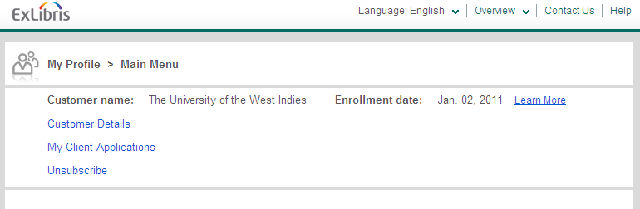

You can view and update your contact information under **Customer Details**.

Click on **My Client Applications** and you’ll see the following screen:

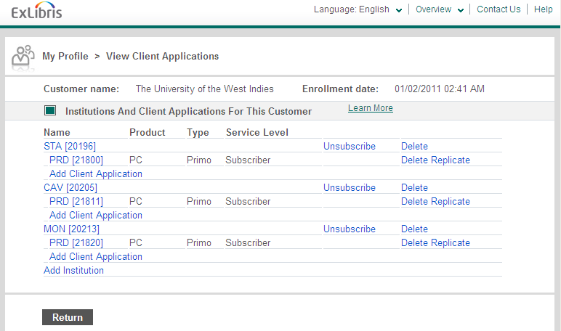

There is an entry for each institution (STA, CAV and MON). Click on the link under your institution that begins with **PRD** and you will see a screen like this:

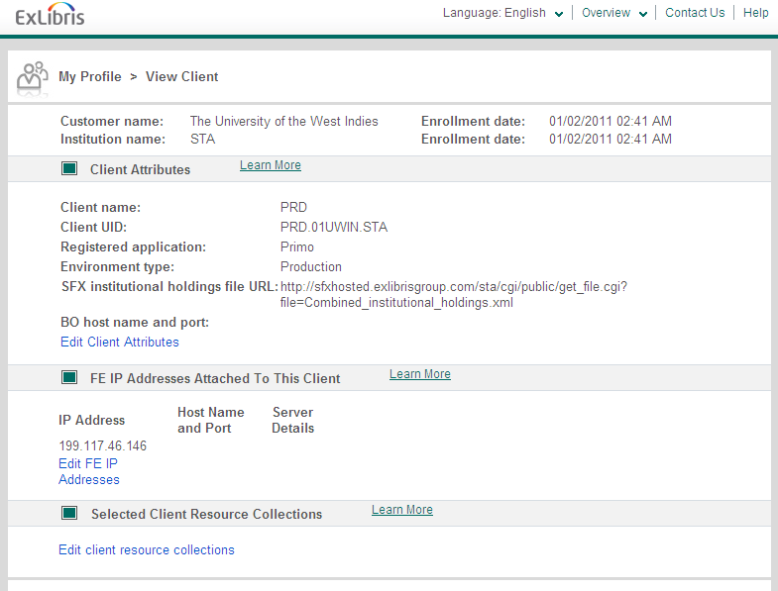

To see the full list of Primo Central collections and make any changes to your current activation, click on **Edit client resource collections**. Be patient – this list takes a while to load.

If you make any changes to your activation, please note that it may take up to a week to see the changes reflected in Primo as they are handled by a process that runs weekly.

# Appendix B: Library Codes

# Appendix C: Collection Codes