Alma Fulfillment
Returning Items

After logging into Alma, assure that you are ‘at’ your current Circulation Desk. To change locations, click the drop-down arrow next to your location to select another from the list.
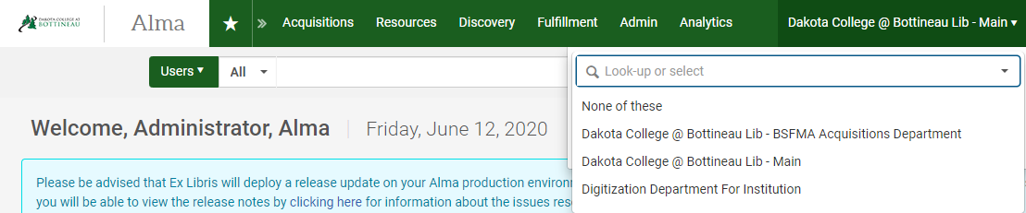

- Returning items
From the Fulfillment heading, select Return Items.
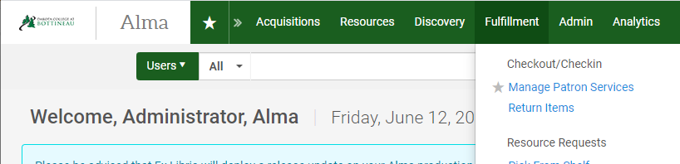
On the Manage Item Returns screen, scan the item barcode.
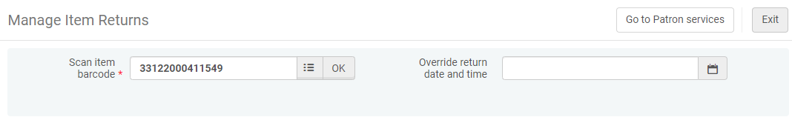
Once the item is checked in, the record will display with instructions on how to handle the item (reshelve, send to hold shelf, etc.) and the cursor returns to the item barcode box so the next item can be scanned and returned.
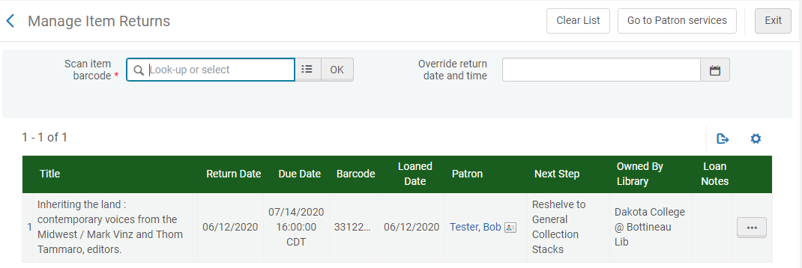
- Backdating items
The Manage Item Return screen allows the user to backdate the time of checkin for items as well, such as when returning material from the bookdrop, or after a library closure. Use the pop-out calendar to select an override date. Click the ‘x’ next to the override return date to clear it, or click Exit.
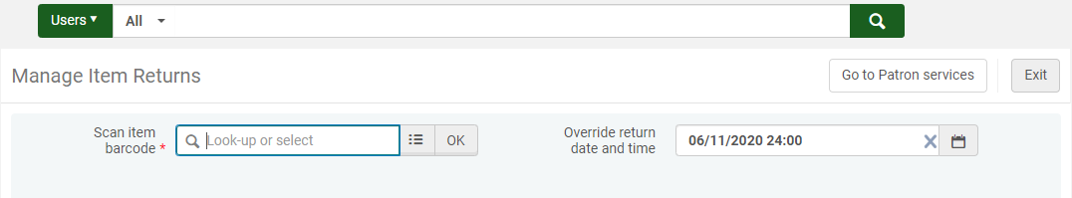

- Returning items from patron’s account page
Alternatively, it is possible to return items when managing a patron’s account. From the Fulfillment heading, select Manage Patron Services.

In the Patron Identification box that is displayed, scan the patron’s barcode, enter the patrons EMPL, or enter a portion of the patron’s name. The system will respond with auto-fill options – select the correct patron in this case to go to their record. Scanning the barcode or EMPL will take you directly to the record without a need to select from a drop-down menu.
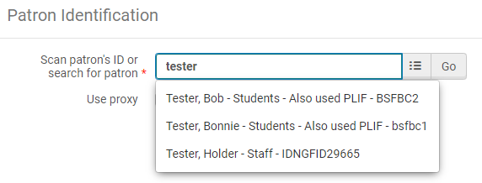

The patron management screen is displayed. There are four tabs available – Loans, Returns, Requests and Network Activity. With the Returns tab highlighted, scan the item barcode into the barcode field.
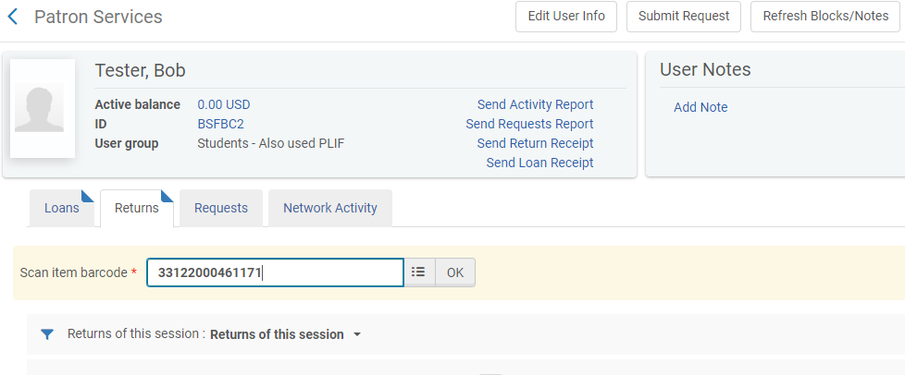

It’s generally not necessary to return from the patron’s record. What may be more beneficial to know is there is the ability to see what items the patron has returned. Change the Returns of this session to All Returns to see a history of what the patron has returned.

