Removing MARC fields during import

The PKS Cataloging User Group discussed certain MARC fields that could/should be removed from the OCLC bib record during import process. Suggested fields are 029 (Other System Control Number), 263 (Projected Publication Date), 938 (Vendor-Specific Ordering Data) since they are vendor-specific fields that are not intended to be used by libraries or patrons. Several options were discussed for removing tags. These may be used individually or in combination.

- Set up tags to delete in the default which would limit your flexibility but standardize across all libraries (assuming everyone can agree). This would be configured by the ODIN Office in the Bibliographic Tags to Retain/Delete Policy Table in Administration Explorer – System. This table is used to specify tags to retain from duplicate records that are overlaid or to specify tags to delete from incoming records that are saved to the database.
NOTE: The group determined this was not the best way to handle these fields as it lacked flexibility for the catalogers.

- Define recommended standard for the Import Profiles and let each library determine what is best for what they are doing. The configuration for this is found in the client under Utilities / Importing / Profile Manager. When creating or updating an existing profile, the Bibliographic Records tab is the area to define the tags you wish to remove on the incoming record.
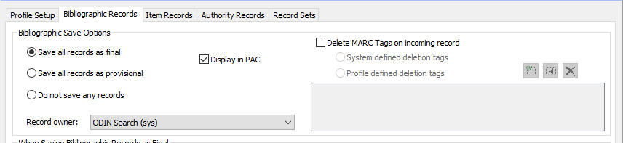

To customize, click the box in front of Delete MARC Tags on incoming record and select the Profile defined deletion tags. This will allow you to define which tags to delete.
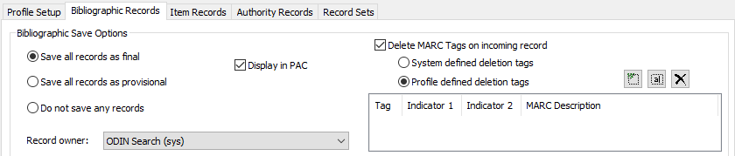
Online help for this screen:
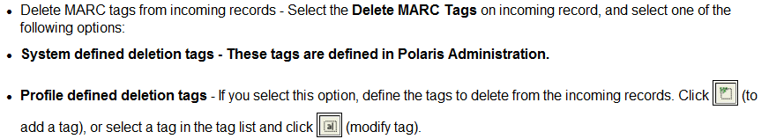
NOTE: This was determined to be the best option as it allows flexibility for different tags to be deleted in different profiles as needed.

- In release 6.4, an option to delete all instances of a defined tag was added. Before that release, only the first or last instance could be deleted during a Bib Record Bulk Change. Bibliographic Record Bulk Changes are generally requested through the ODIN Office. The bulk change Data Fields tag drop-down for Operation has been expanded to include “Delete an existing tag (all instances)”
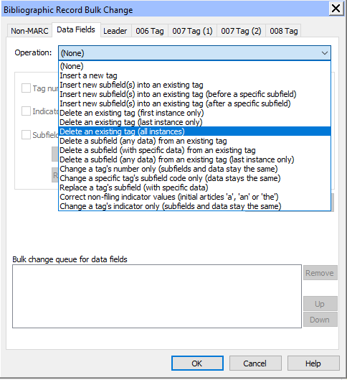
NOTE: This option could be used when record cleanup is needed.

- Configure your OCLC profile to strip out tags during import. Each library/OCLC account would configure their own profiles to best suit their individual needs.
NOTE: This option would be useful for the tags listed at the beginning of this document.

