Resource Sharing Agenda – Nov. 18, 2020

Please review the following information sent out earlier this month. We will address any questions regarding those issues and Linda will demo the analytics reports.

If you have items you would like added to the agenda, please contact me. Sandi.bates@bismarckstate.edu

Linda’s Nov. 3 email discussed the following items:

After conducting some testing, I’ve pulled together some information on a few topics we’ve been discussing in the Resource Sharing User Group meetings. The topics include analytics, statistics, the user of the change status button, rejecting lending requests that cannot be filled and locates, and I’ve gone into  explanations below.

1. Analytic statistical reports for Resource Sharing are available in the ODIN Consortia folder. With special thanks to Liz Mason at Bismarck State, 6 general Resource Sharing reports have been placed in the ODIN Consortia folder. **IMPORTANT NOTE**: as announced in previous messages, Alma Analytics is being updated, and is therefore FROZEN 11/1 – 11/8. You are welcome to run reports, but do not copy or make any modifications until the update is complete – changes made during the upgrade WIL NOT be saved.

If you navigate to Analytics | Design Analytics from the Alma menu, you’re taken to the Analytics. In the left pane, navigate to Community | Reports | Consortia | ODIN in order to see the reports. To run the report for your institution, click ‘Open.’ You will be prompted to enter start/end dates for the statistics. **The LENDING reports are working as expected. The BORROWING reports require a bit more work.** We’ll let you know when they are ready for use.

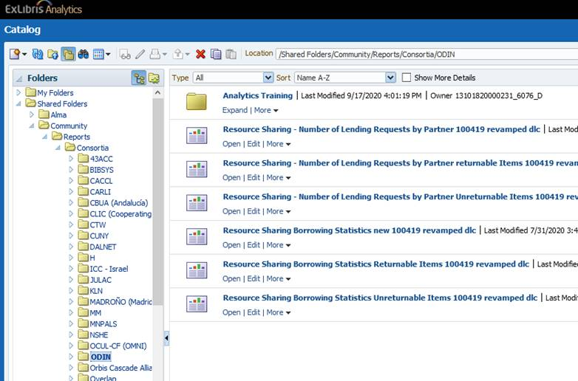

1. Lending statistics/fills are counted at the point of ship. We’ve conducted testing to verify this is the case. Remember, analytics are only updated once daily. The time the data was updated and became available can both be found in the Analytics menu in Alma. Sample:

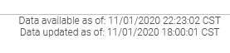

1. Please use the Change Status button as a **last resort**. Very similar to Aleph, we’ve verified that updating a status on a request does not update the status in the other library’s corresponding record. Additionally, changing the status can cause incorrect statistics on analytics reports. The change status button can be found on both the Lending and Borrowing request lists. Sometimes using the change status is unavoidable – especially during our times of testing. We’ve also verified if a request is updated to completed in order to be able to remove or delete it, Alma will treat the completed request as a FILLED request, regardless if it was filled or not.

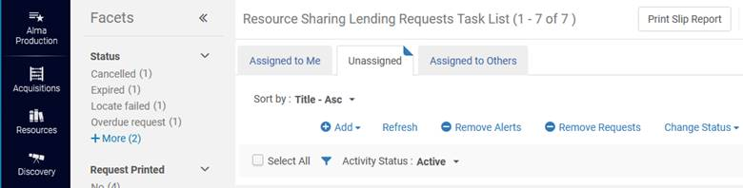

1. If you find that requests you reject as a lender (not supply) do not disappear from the Lending list, it is due to a configuration setting. You should not substitute changing the status to Complete and then deleting the request as a means to remove the request from the Lending list. Changing the status to Complete will cause Alma to treat the request as filled, even though it was not sent. Additionally, changing the status as opposed to rejecting the request does not allow a message to be passed to the borrowing side, so the borrowing request does not get moved to the next library in the rota.

A configuration setting is responsible for rejected or not located requests to remain or be deleted from the lending or borrowing lists. This setting has three options – None, Borrowing or Both.

1. None – this was the default we were setup with, meaning that any borrowing request that couldn’t be located or lending request that was reject were automatically removed from their respective lists in Alma.
2. Borrowing - any borrowing requests that cannot be located stay on the borrowing request list until further processing can take place. Lending rejected requests are removed from the lending request list.
3. Both - any borrowing requests that cannot be located stay on the borrowing request list and lending rejected requests stay on the lending request list. The **RECOMMENDED SETTING** is Borrowing.

To alter the setting in your Alma configuration, Navigate to Alma configuration and go to Fulfillment | General | Other Settings. Here you’ll find a setting called rs_keep_rejected_request_active (it’s currently #100 in the list of settings).



1. Locates. Lastly, if you encounter any issue where the locate fails when you believe it shouldn’t have – either on the borrowing side or lending side – please submit those examples to us. We’ve been able to address many of the locate issues that have been submitted, and want to continue work in this area to assure locates work as expected.