Alma Resource Sharing
Life-cycle of Digital Request

- Borrowing

- Create a borrowing request as per usual.

If processing a request submitted via Primo, skip to step 2. In this example, a request will be entered from a search.
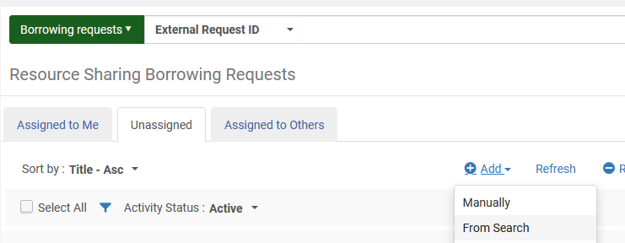

After conducting a search for the material in the Network Zone, click the radio button next to the appropriate record and click Select.
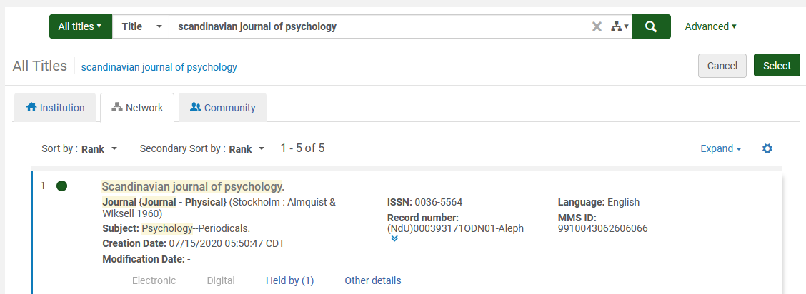

In the workform that displays, enter the following information:
- Requester
- Request Format – Digital
- Preferred Send Method
- Date Needed By
- Delivery Location – Deliver to library
- Agree to Copyright terms
When completed, click Save and Edit
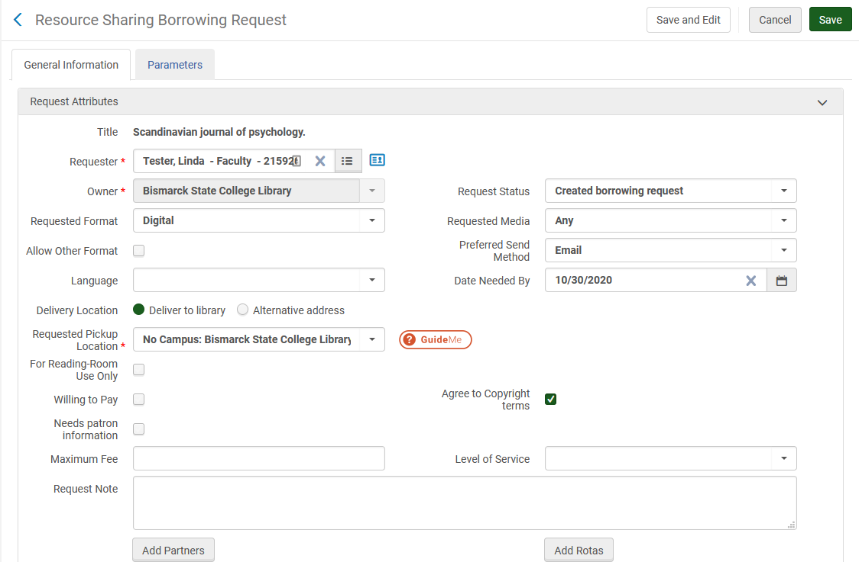

Continue editing the request to add citation information:
- Article/chapter title
- Volume/Number
- Pages
- Date
Click Save to save changes to the record. You’ll be taken to the Borrowing Request list.
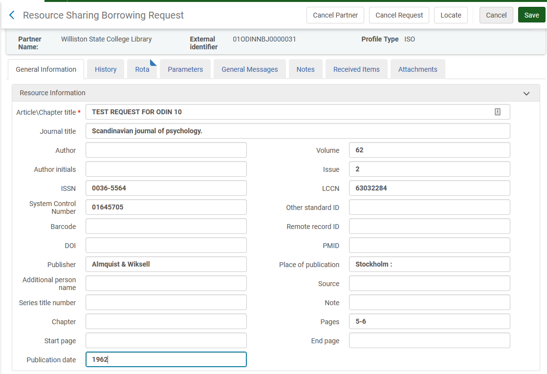

- From the borrowing request list, click ‘View’ next to the record.
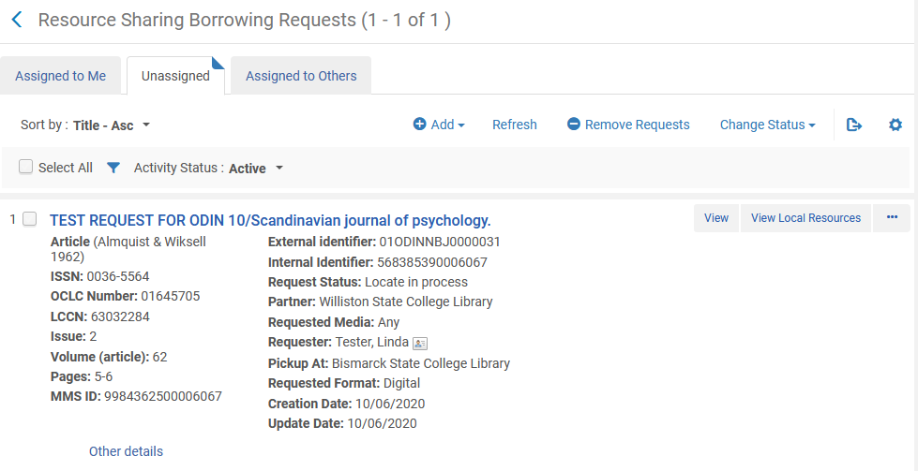
By default, when a request is created, all libraries in the rota are added to the request. Click the Locate button so Alma can determine which libraries to retain in the rota. Other libraries that do not own the material will be deleted.
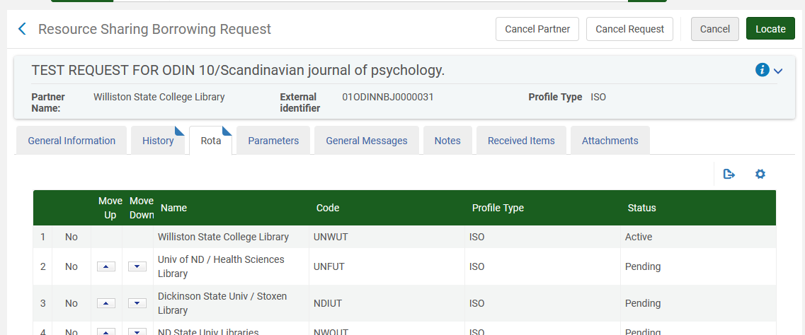

After locating, you are returned to the borrowing request list. Once the locate has completed, the request will have a status of Ready to be sent (if no locations could be found that own the material, a status of Locate failed results). Sometimes it may take a moment for the locate to finish. Click refresh to see updated statuses.
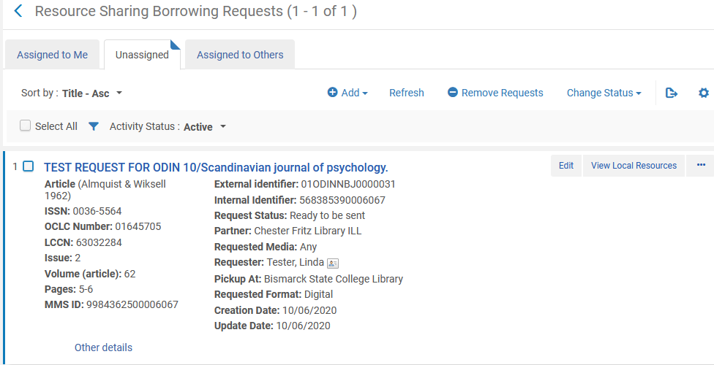

- From the borrowing request list, click ‘Edit’ next to the record (alternatively, this next step of Send can be accomplished through selecting a task in the ellipse menu).
With the request displayed on the screen, click Send to send the request to the first partner in the rota.
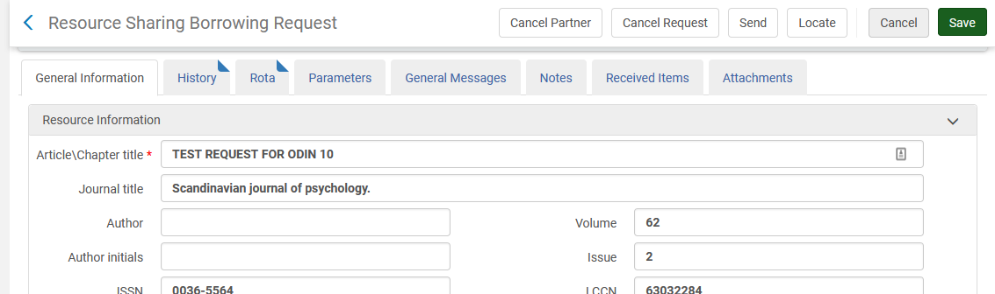

- LENDING

- The new request appears on the Lending Request task list. Once you’ve secured the digital file to be sent, click Ship Item.
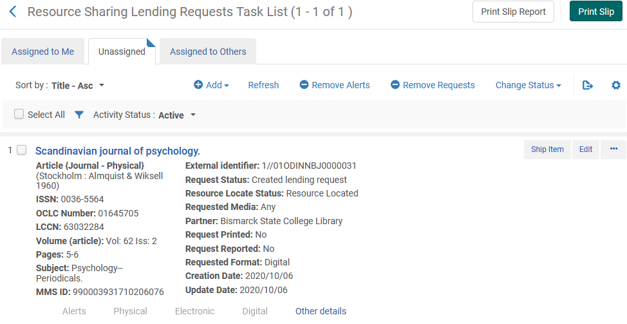

- On the shipping items workform, assure the following fields are filled out:
- Shipping format – Digital
- Complete the request – determine if you wish to update the request to completed, or wish to leave it in a shipped digital status
Click Add File and add the file to the request. Once the file is attached, click ‘OK.’
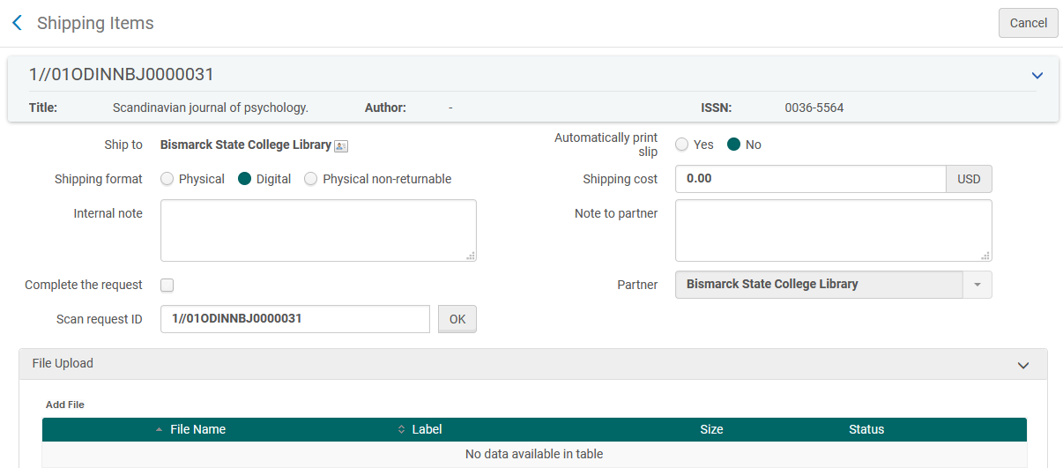

- The request is removed from the Active Lending Request task list, and a message indicating the file was sent is displayed.
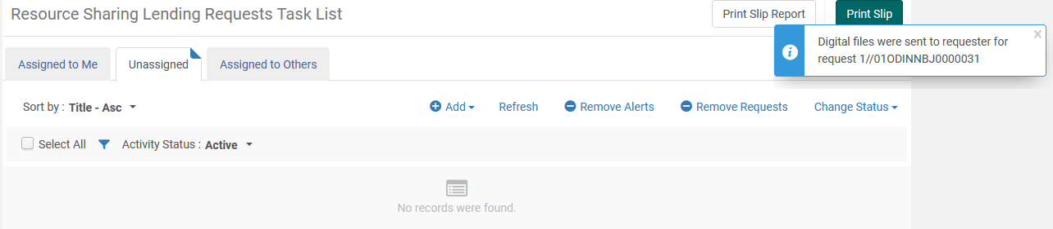
Upon searching Completed request, we see the request with a Shipped Digitally status. No further action is needed on the part of the lender. If the Complete the request box was checked on the Shipping items screen, the status would be Request completed.
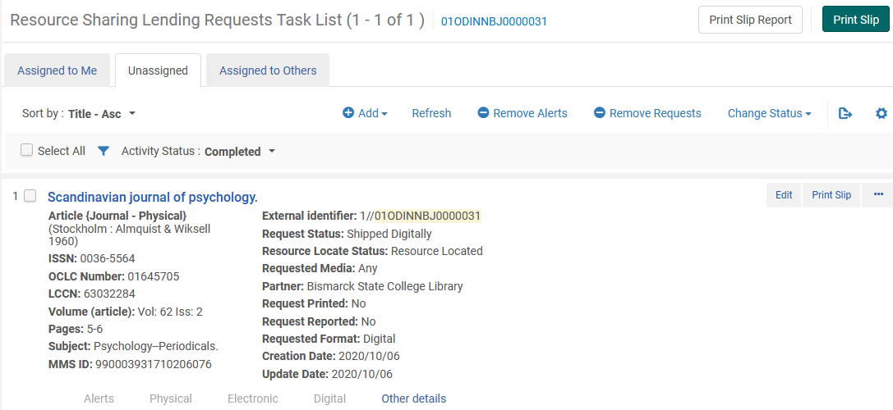
- RECEIVING

- Once the email with the pertinent article has arrived, the borrowing library can update the request to received. Using the ellipse menu, select Receive.
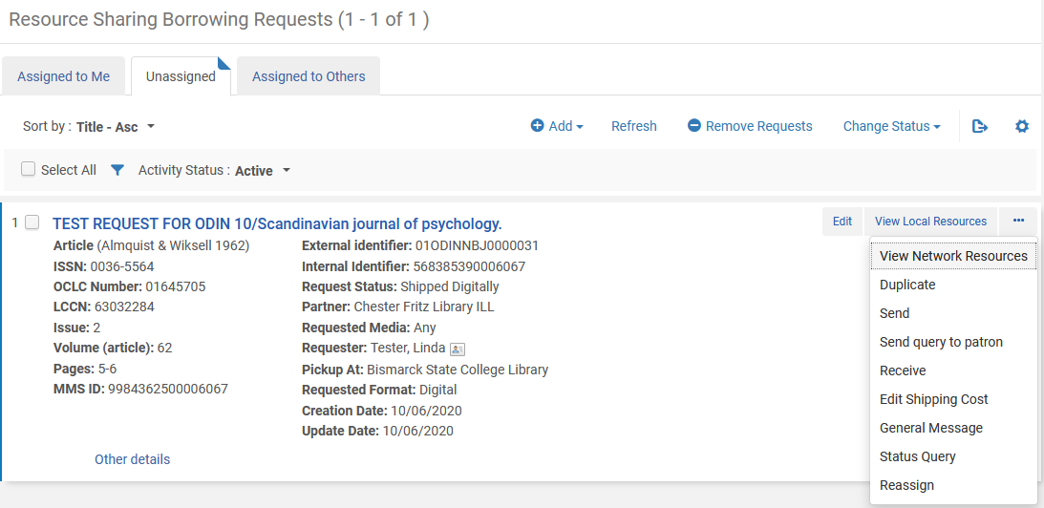

- On the Received Items workform, assure the following fields are set:
- Received format: check to be sure digital is selected
- Automatically notify patron: leave unchecked. If you are forwarding the article to the patron, you likely do not wish to have Alma also notify the patron the article has arrived.
- Complete the request: check to update the request to completed.
Click Go to receive the request.
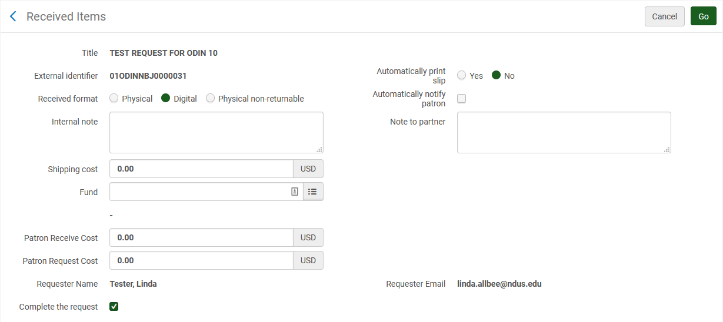
- The request has been removed from the Active Borrowing Requests list. You may receive a message indicating the corresponding lending request could not be found. The request on the lending side has been completed, so there was no need for a message to be sent to update it.
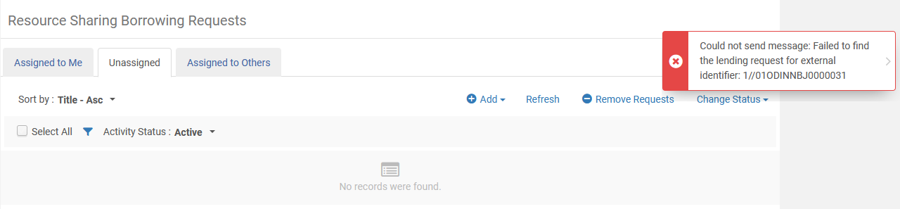
Upon further search of the completed requests, the Borrowing request now has a status of Request Completed. The cycle has completed.
