Polaris weeded record sets:

A question was asked how/why record sets names “weeded000n” were created. In the Polaris client, you can do a search as the one below to find:
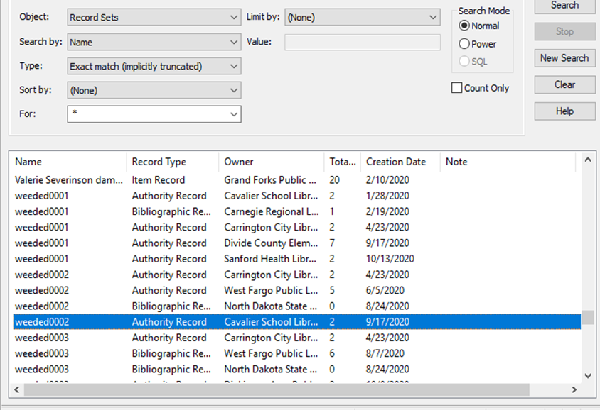

During cleanup for one of the libraries, a weeded0001 record set was automatically created. It listed bibliographic records where the last item attached was being deleted. Example:
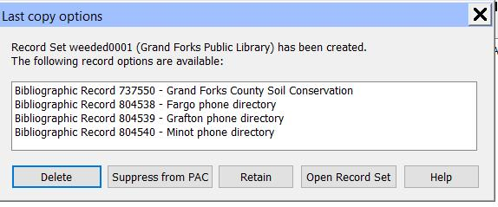
In this case, Delete was selected and the bib records listed were marked for deletion (single delete) where they could be completely deleted during the annual purging/”double delete” process in the spring.

