Polaris Cataloging
Copy Cataloging a Record from Another Source

Before copying a record from another source, be certain to first check the ODIN Polaris database to assure the material is not already in our local catalog. After doing so, you can search WorldCat or the ODIN Academic libraries to check for record availability.

- After logging into the client, conduct a search for a bibliographic record. First go to the Databases tab and select which sources you wish to search. You are able to select from WorldCat and/or the ODIN Academic libraries.

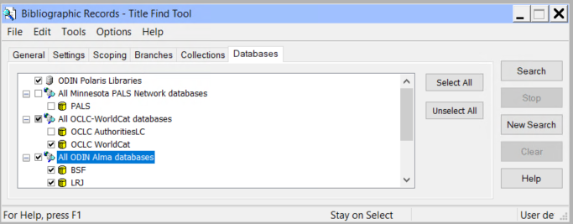

Once the source is selected go to the General tab and conduct your search. The best search to yield a match to your item is an ISBN search. Results for each database selected dispay. Double click on the desired line to the full bib(s).

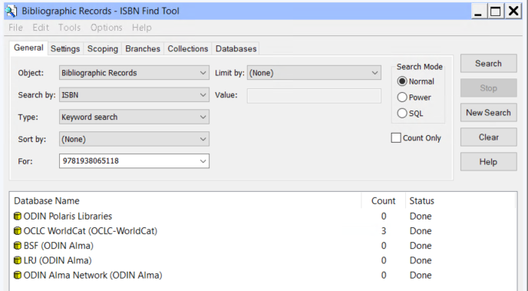

- Once the bib is selected and displayed on the screen, it’s important to verify that the record matches the item you have in hand. Check for obvious matching fields – such as author, title, publisher, ISBN – but also look at the physical description field (for example to assure you are viewing a physical book record and not an e-book record). Once you’ve determined this is the record you wish to copy, click the Save icon or go to File | Save (shortcut ctrl + S) to save the record in the Polaris database. The record will undergo several validation checks. Click continue on these boxes to continue saving the record.
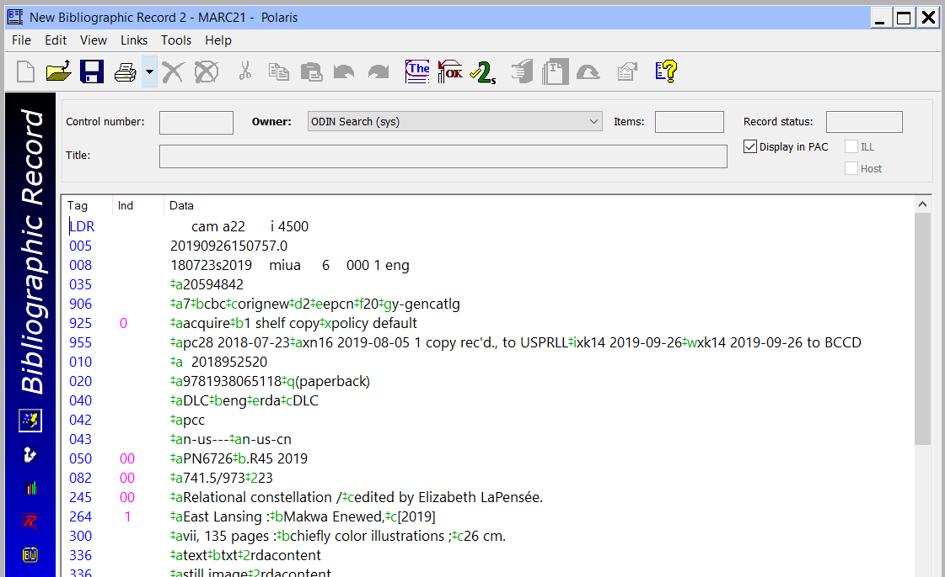

- Once the record is saved, a control number is assigned. At this point, you are able to add the item record to the bib. Please see the ‘adding an item’ documentation for that process.

