Polaris Cataloging
Adding a Record from Template

Before adding a record from a template, be certain to first check the ODIN Polaris database as well as other sources (such as Worldcat or ODIN Academic libraries) to assure a record doesn’t exist in the Polaris system or in another system in order to copy.

- After logging into the client, go to File | New. On the New screen, select Bibliographic Record, Choose from Existing Template, and double-click the template you wish to use. Alternatively, highlight the name of the template and click OK.

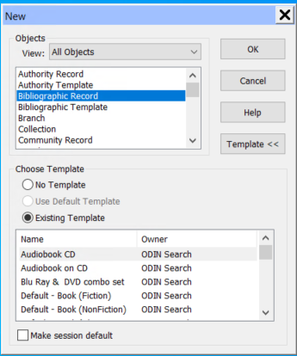

- Once the template has been selected, a blank bibliographic record appears on the screen. Fill out the fields needed, and delete the fields not utilized. Click the Save icon (or select File | Save or shortcut ctrl + S) to save the record to the system.
**NOTE: Depending on the template selected, the fields may differ. Two examples shown are for a fiction book and a DVD.

  - Default – Book (Fiction):
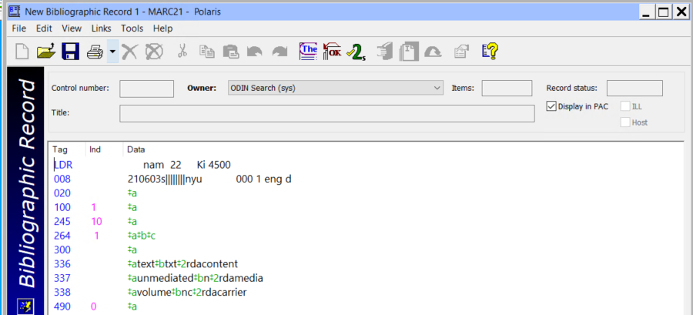

  - LDR – do not modify
  - 008 – do not modify
  - 020 – Enter the ISBN
  - 100 – Enter the author in format Lastname, Firstname
  - 245 – Enter the title
  - 264 – a - Enter the publication place, b – enter the publisher, c – enter the publication date.
  - 300 – Delete
  - 336 – do not modify
  - 337 – do not modify
  - 338 – do not modify
  - 490 – Enter the series if applicable or delete

Default – Video Recording (DVD):
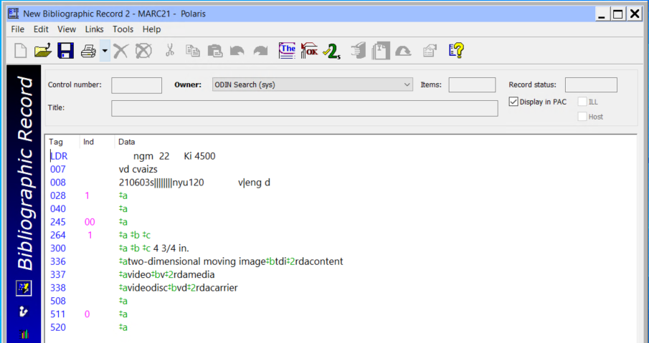

- LDR – do not modify
- 007 – do not modify
- 008 – do not modify
- 028 – enter publisher or distribution number if available
- 040 - Delete
- 245 – Enter the title
- 264 – a - Enter the publication place, b – enter the publisher, c – enter the publication date.
- 300 – Delete
- 336 – do not modify
- 337 – do not modify
- 338 – do not modify
- 508 - Delete
- 511 - Delete
- 520 - Delete

- Once the record is saved, a control number is assigned. At this point, you are able to add the item record to the bib. Please refer to the ‘add an item’ documentation for that process.

