**ODIN – POLARIS**

**Holds Processing**

The Polaris LEAP webapp is used for all circulation activity, including holds processing – both for patrons within the library and within the library system. https://polaris.odinlibrary.org/leapwebapp

The hold process in Polaris pertains to all items in ODIN Polaris libraries, not just the items in our own individual library as we’ve become accustomed to for holds. Any item that would have previously circulated between PKS libraries in Aleph as an ILL, will now be processed as a hold in Polaris. Holds processing will be for both material in your library and material in other ODIN Polaris libraries.

When a hold is placed (either by a patron or by staff on behalf a patron), there are three potential scenarios that could occur.

* The system determines the item is owned by the patron’s local library. If it is **available** on the shelf, the item is put on the local library’s pick-list for retrieval for the patron as a local hold.
* The system determines the item is owned by the patron’s library. If the item is **NOT available** on the shelf, the request stays in the local library’s queue for a certain number of days (for example, at West Fargo, Dickinson and Grand Forks it is 180 days, ND State Library 112 days, and all other libraries 14 days). This allows for the local library to fill the hold request for their local patron first, before sending the hold to other libraries. If the local library is unable to fill the patron’s hold in this time period, the hold is then distributed to other ODIN Polaris libraries on a randomized basis for fulfillment.
* The system determines the item is not owned by the patron’s library. The hold is then distributed to other ODIN Polaris libraries on a randomized basis for fulfillment.

If material is on hold for multiple patrons throughout the ODIN Polaris libraries, and the item is checked in at a library where one of their local patrons is in the hold queue, that patron will rise to the top of the list, and the library’s copy will fulfill the hold for their local patron first, even if that local patron is not first in the hold queue. For example, The Color Purple is on hold for Patron A at the State Library, and Patron B at West Fargo Public Library. When West Fargo checks in their copy of the book, the hold for Patron B (the West Fargo Patron) will be fulfilled first, instead of the State Library’s patron. This is to ensure that a local library is filling requests from their local patrons first before sending the item outside their library.

There are two types of holds in Polaris – a title level hold and an item level hold. The vast majority of holds will be title level hold – a hold is placed on a particular title in the system, and any associated copy can fulfill the hold. In the case of an item level hold, a hold is placed on a specific barcode – and ONLY that particular item can fulfill the hold. This document will talk about title level holds.

1. Placing a hold

A logged in patron can place a hold from the PAC, or a staff member can place a hold on behalf of a patron.

1. Placing a hold from the PAC

Once a record is located, the patron can click PLACE REQUEST or ONE-CLICK REQUEST on right side of the screen.

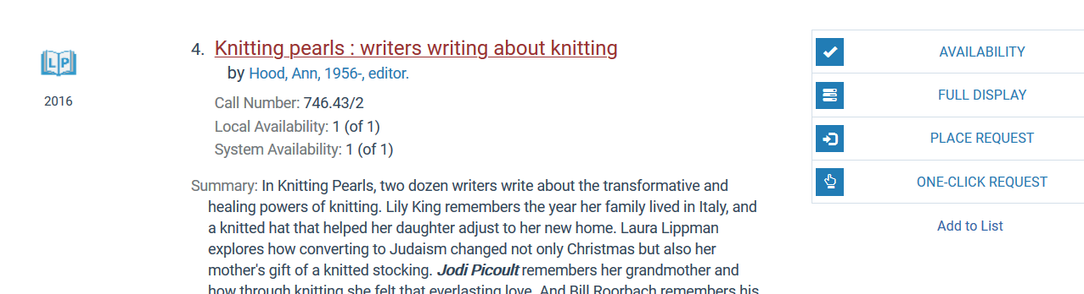

If a patron selects PLACE REQUEST, a form will display, containing the patron’s pickup library, activation date (when the hold should become valid) and a field for notes. The patron clicks Submit Request, and the hold is placed.

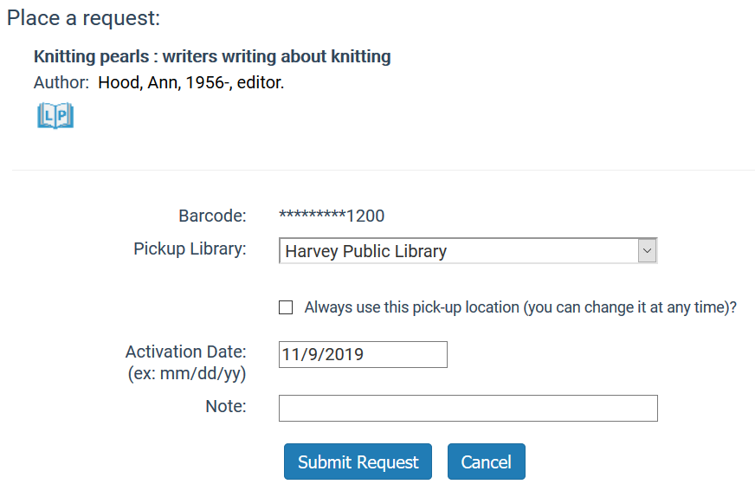

Alternatively, if the patron selects ONE-CLICK REQUEST, the hold is placed without the interim screen. The patron received a message indicating the hold was placed.

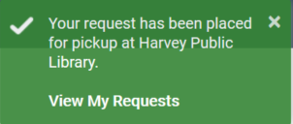

1. Placing a hold from Leap

Staff have the option to place a hold on behalf of a patron either via the patron record or the bibliographic record.

1. After locating a patron record, select tab 5 Holds/Held. The first option is to create a new hold.

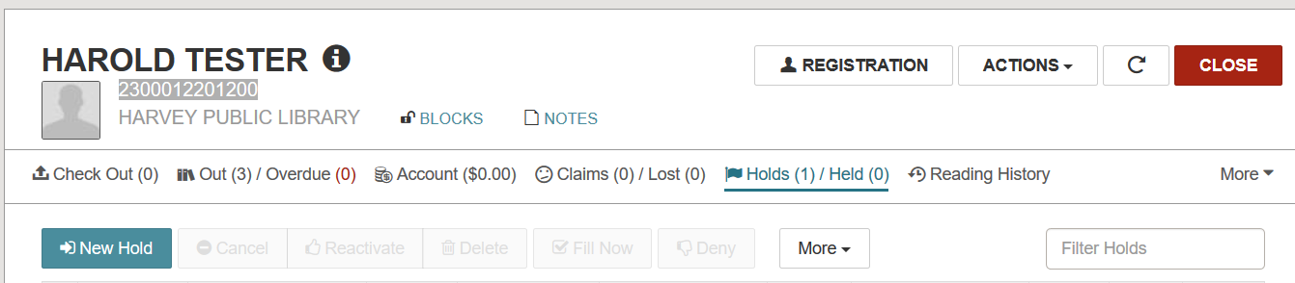

Clicking New Hold presents the opportunity to search for a title using the search box, or to click FIND TOOL for other search options. See the Polaris Overview document for more information about searching.

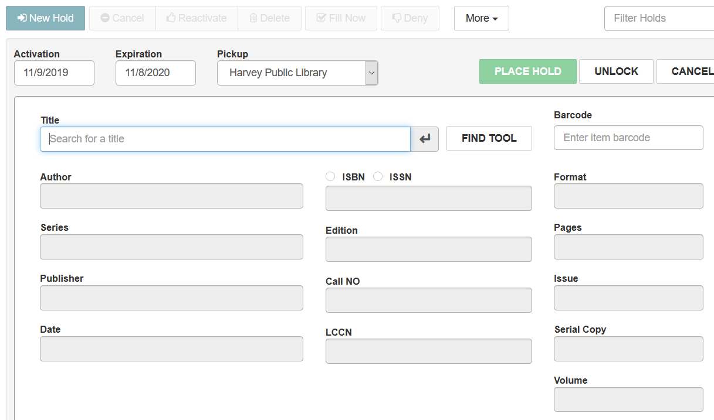

Once the title is selected, the activation/expiration date is entered, and the Pickup library defaults to the patron’s library. If any bibliographic information needs to be altered, first click UNLOCK, and the fields in the record will become editable. Any notes can be entered in the notes field at the bottom of the form. Click PLACE HOLD to register the hold.

The hold then appears on the patron’s record.

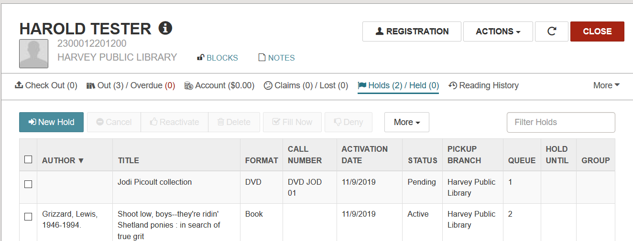

1. After locating a bibliographic record, click Actions and select Place Hold.

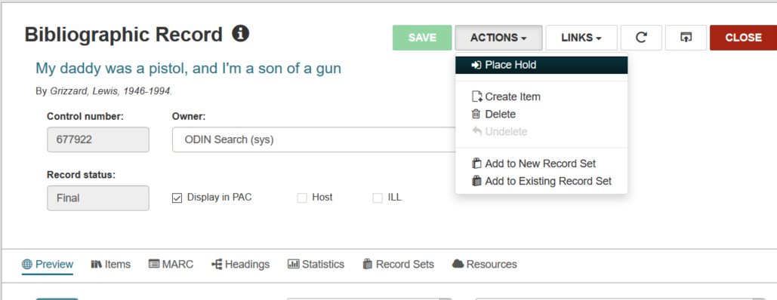

The system opens the find tool to locate the patron record to associate with the hold. Alternatively, if patron records are currently open, you’ll be prompted if you wish to select one of the open records.

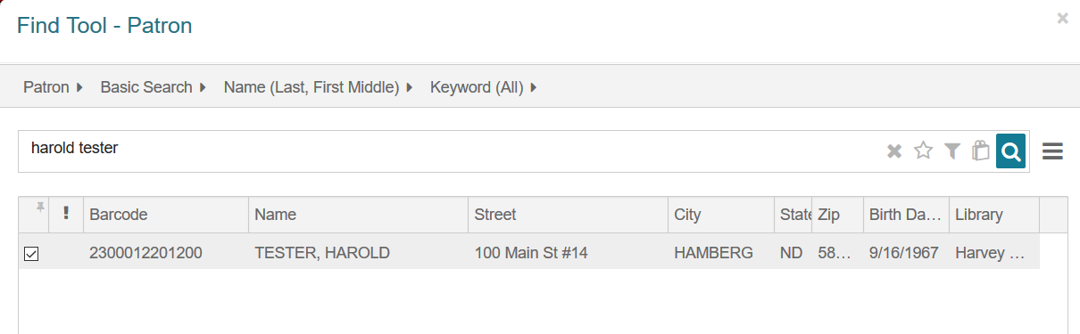

The system opens the patron record | hold tab, and the hold is processed the same as if it originated from the patron record.

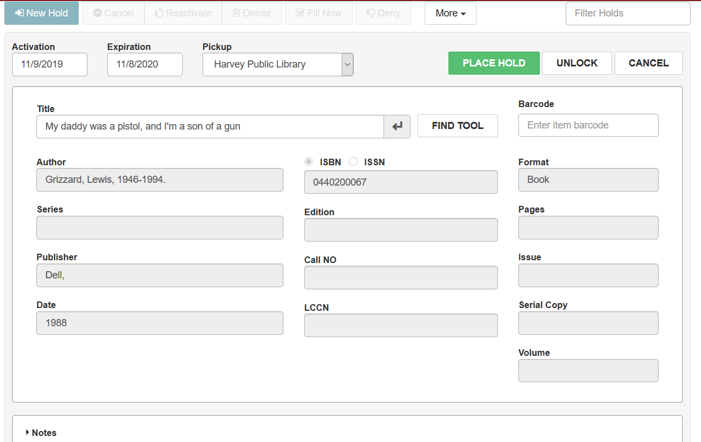

The activation/expiration date is entered, and the Pickup library defaults to the patron’s library. If any bibliographic information needs to be altered, first click UNLOCK, and the fields in the record will become editable. Any notes can be entered in the notes field at the bottom of the form. Click PLACE HOLD to register the hold.

The hold then appears on the patron’s record.

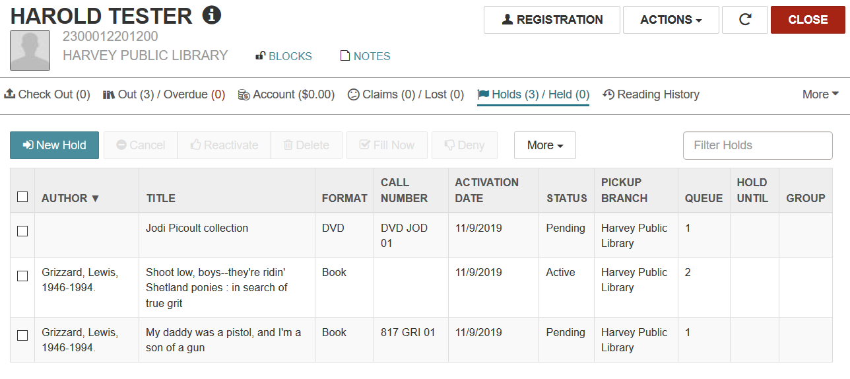

1. Processing hold requests.

Hold requests are processed via the Utilities menu. The Holds Queue allows you to search for outstanding holds, the Picklist Processing allows you the fill current holds, and the Request Manager allows you to see all holds that originated from your library.

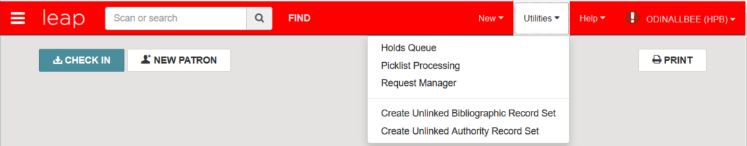

1. Holds Queue

The Holds Queue allows you to locate outstanding holds by bibliographic or item record. Clicking on Holds Queue opens the find tool. After locating the record, the Holds Queue displays. From the holds queue, you can create addition holds by clicking the PLACE HOLD button. The option also exists to change the order of the hold queue, though this is not a recommended practice.

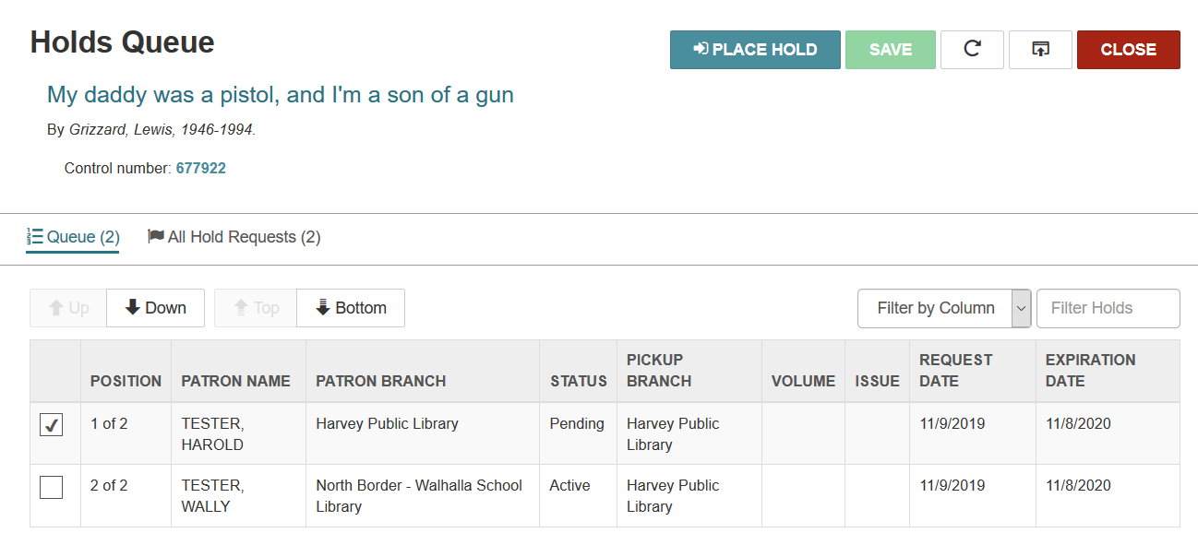

1. Picklist Processing

Picklist Processing presents a list of material in your library that can fulfill a hold. A hold request only appears on one picklist at a time – for example, Green Wilma (first item below) is only on the Harvey picklist. If Harvey determines they are unable to fill it, the request will then go to the next library and appear on their picklist.

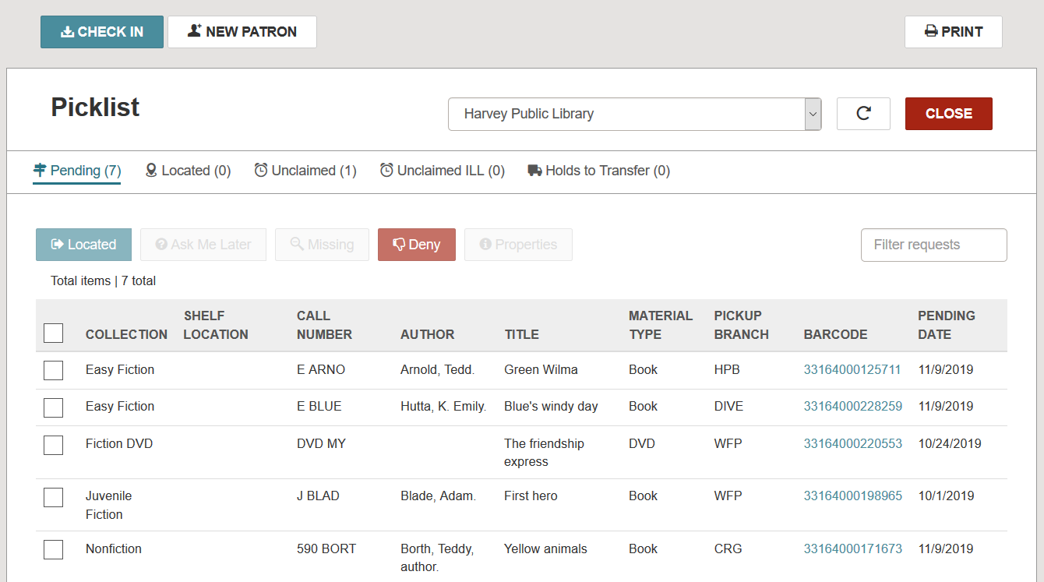

Recommended practice is to print the picklist, take it to the shelves to retrieve the material, and then process the hold requests.

Each request can be selected and worked with. With the request selected, you can click:

* Located: indicates you found and will be filling the request. This is an optional step that is not necessary to filling the request.
* Ask Me Later: indicates you are unable to fill the request at this time but may be able to at a later date. This option removes the request from your picklist and sends it to another library. If all locations are exhausted without finding a lender, the request will eventually be routed back to your library.
* Missing: indicates the item is missing from your shelves and removes the request from your list and sends it to the next library. The system also automatically puts the item into a missing status.
* Deny: indicates you are unable to fill the request. The request is removed from your picklist and is sent to another library.
* Properties: displays information about the request.

1. Filling requests. To fill a request, you can select the request on the picklist and click Located. The request moves from the Pending status to the Located status. This step is extraneous, and not necessary. It is a matter of personal preference if you wish to conduct this step.

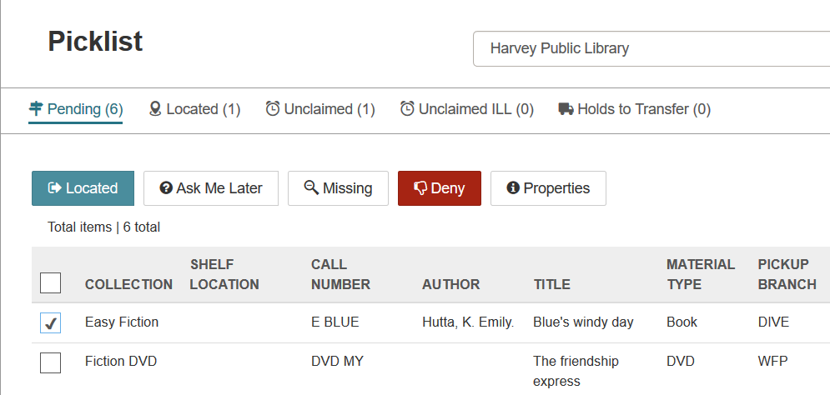

The actual fulfillment of the request is conducted by the Check In action. Click the CHECK IN button and scan the barcode of the item you’re using to fill a hold.

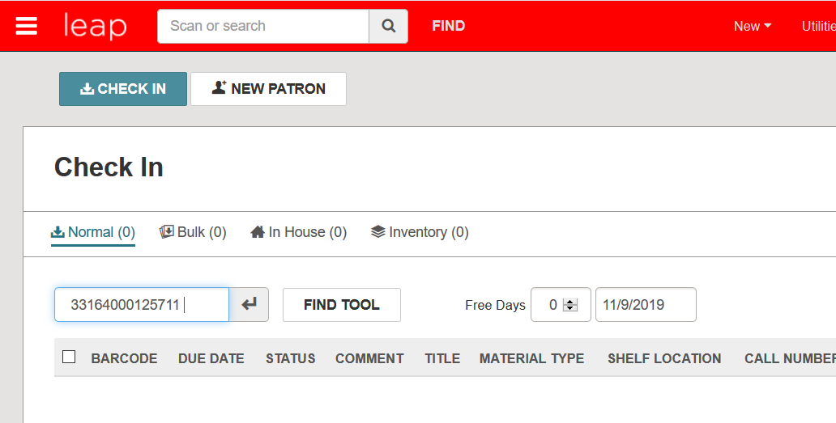

A message is received that this item **fills a hold for a patron in your library** (Fill hold request). Click Yes to hold the item.

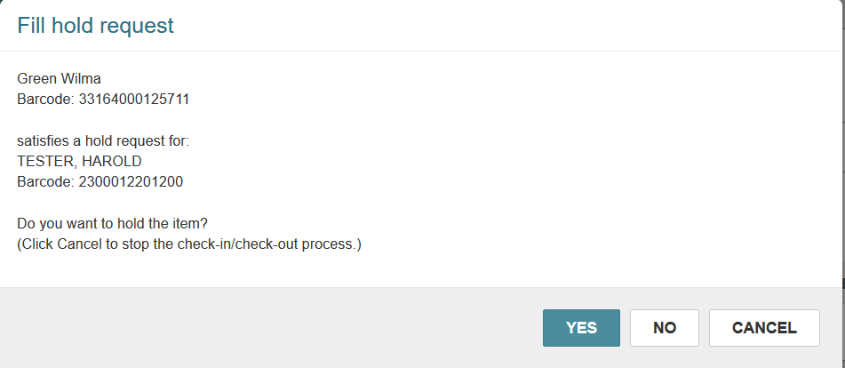

A hold slip prints, and the hold is ready to be put on the hold shelf and await pickup.

You are then ready to scan in the next item on our picklist.

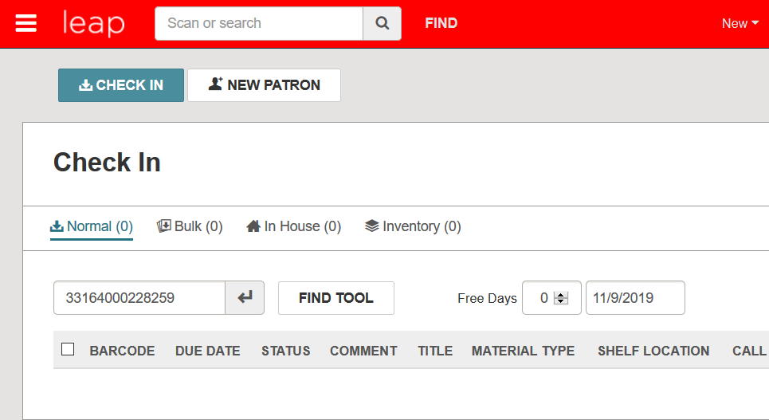

This time a message is received that this item fills a hold for a patron at another library (Transfer for hold). Click YES to transfer the hold.

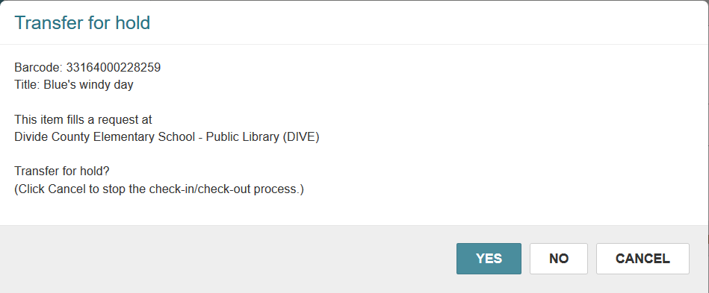

A hold transfer slip is printed, and the item can be sent to the library.

1. Denying a hold request.

If for whatever reason you are not able to fill a hold request, you are able to clear it from your picklist.

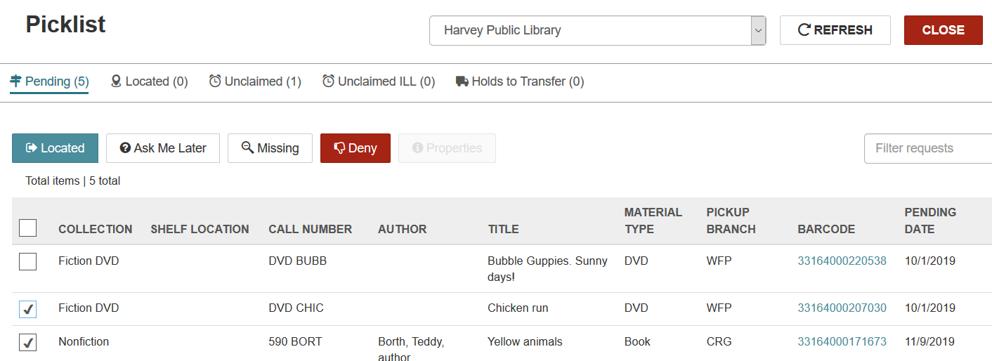

Ask me Later – with the request selected, you can choose Ask Me Later. This will remove the hold from your picklist and send it to the next library that may be able to fill the hold. If no one is able to fill the hold, it will eventually work its way back to your library’s picklist.

Missing – with the request selected, you can choose Missing. This will remove the hold from your picklist and send it to the next library that may be able to fill the hold. This action will also automatically put your item in a missing status.

Deny – with the request selected, you can choose Deny. You are presented with a dialog box where you can select a reason the request is being denied. This will remove the hold from your picklist and send it to the next library that may be able to fill the hold.

**Note: all above actions can be done in bulk. I.E. you can select several requests and click Deny to deny all selected requests.

**All additional hold functionality is conducted via the Check-In button. When material arrives from another library, check-in the item, and a hold slip can be produced – along with notification to the patron that the material has arrived. When material is to be sent back to a library, check-in the item to generate a transfer slip which indicates what library to send it to.**



**SET-UP**

In order to ensure hold transfer slips print, your workstation options must be configured. To access the settings page, in the upper right corner, use the drop-down menu next to your logged-in name and select Settings.

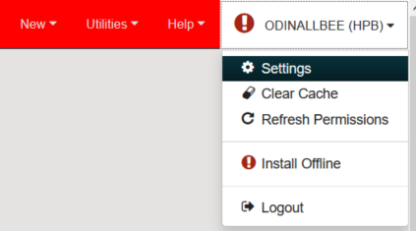

On the settings page in the Check In section, click the ‘In-transit slip’ box

