Polaris Client Cataloging
Deleting Items

Basic Information for deleting items via Polaris Cataloging in the Client.

- Deleting item records for NON-OCLC USERS

- After logging into the client, conduct a search for the item to be deleted. The best search to yield a match will be a barcode search. Go to the menu bar and select Cataloging | Item Records, or use the shortcut Ctrl+Alt+F9.

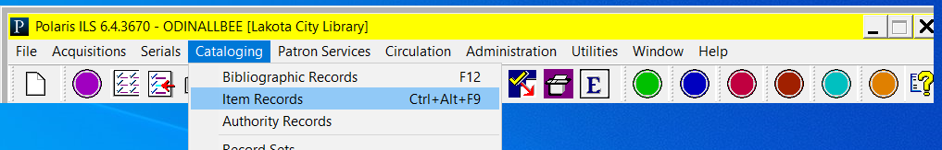

In the search box presented, select search by Barcode, enter the barcode in the For field and click Search.

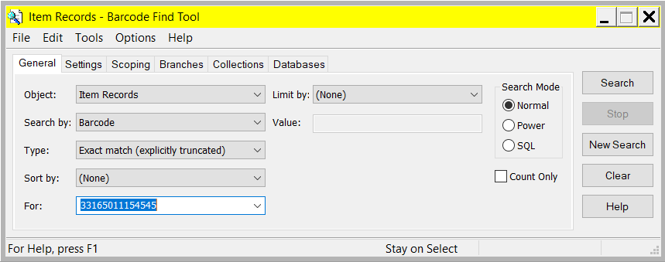

- You’re presented with the search results. Double-click on the item.

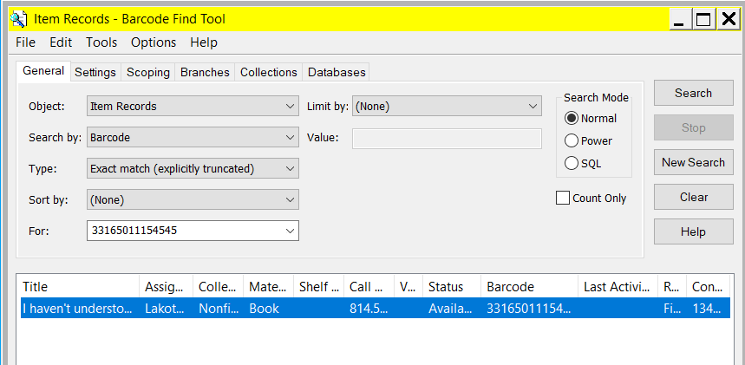
- With the item displayed on the screen, uncheck the Display in PAC button and save the record. Because deleted records are being retained in the system, conducting this step ensures that the item will no longer be displayed in the online catalog.

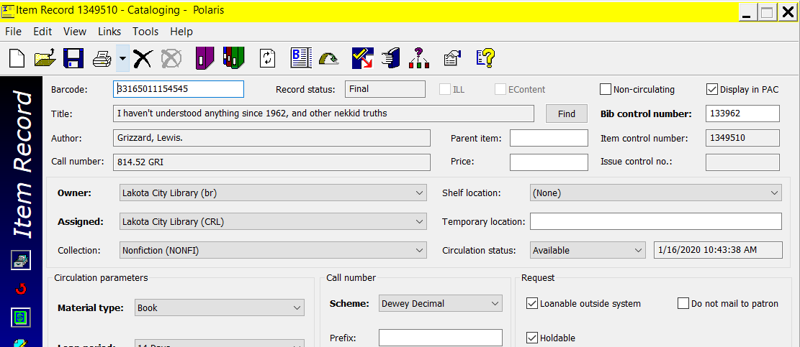

- click the X icon, go to File | Delete or use the shortcut of Ctrl + D to delete the record.

- You will be prompted to confirm the deletion. Click Yes.

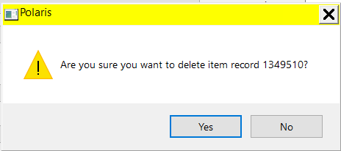

The item is deleted.
- If Polaris detects the item being deleted is the last item that is attached to the record, you will be asked if you also wish to delete the bib record. Click Delete to delete both the item record AND the bibliographic record.

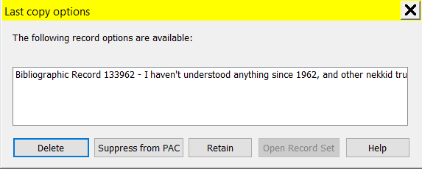

- The records are deleted.

- Deleting item records for OCLC USERS

- After logging into the client, conduct a search for the item to be deleted. The best search to yield a match will be a barcode search. Go to the menu bar and select Cataloging | Bibliographic Records, or use the shortcut key F12.

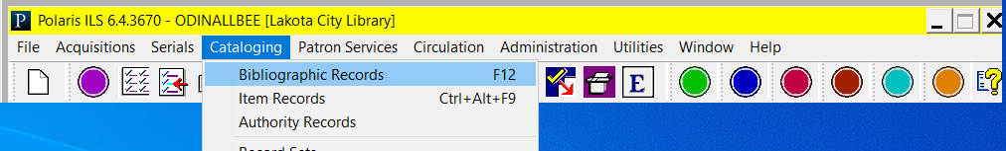

In the search box presented, select search by Barcode, enter the barcode in the For field and click Search.
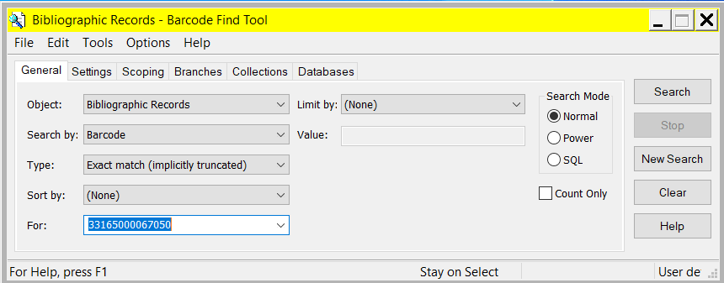

- You’re presented with the search results. Double-click on the record.

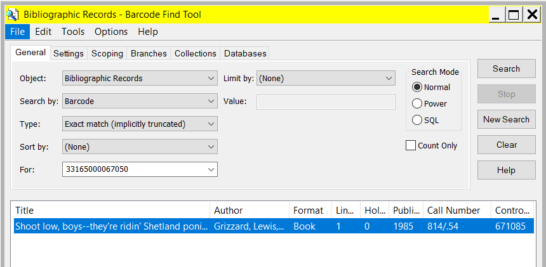

- With the bibliographic record on the screen, make note of the OCLC (035) number or any other identifiers that will assist you with deleting the record from OCLC.

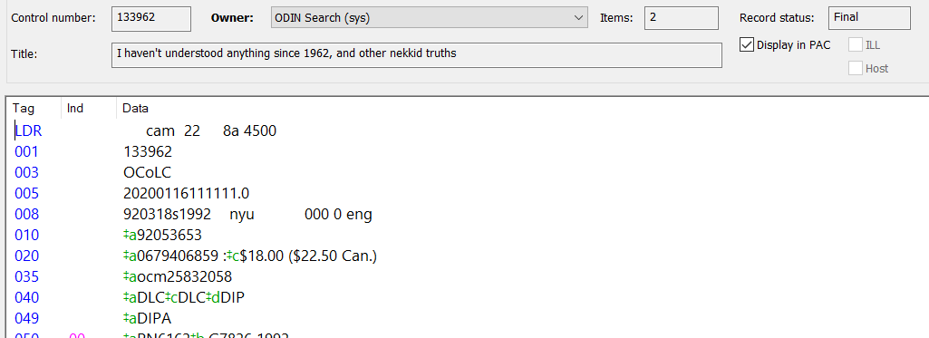

- Go to the Linked Item Records icon, select Links | Item Records or use short Ctrl + T. tab.

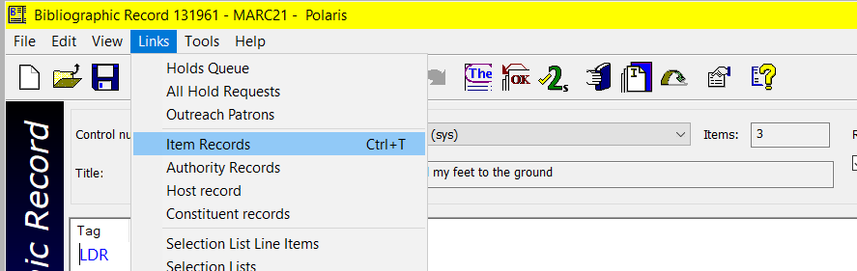
- Select (double-click) the item record you wish to delete.

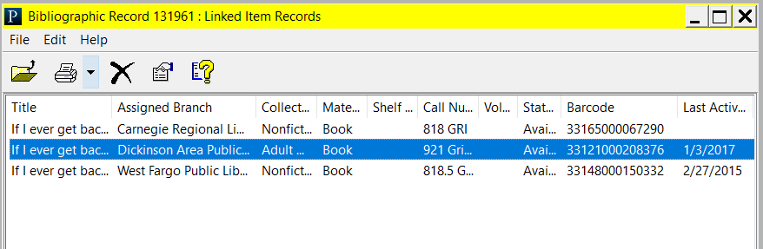

- When the item displays, close the bibliographic record box. If you ultimately delete the bib record as part of this process, you will be unable to complete the delete if the bibliographic record is open.

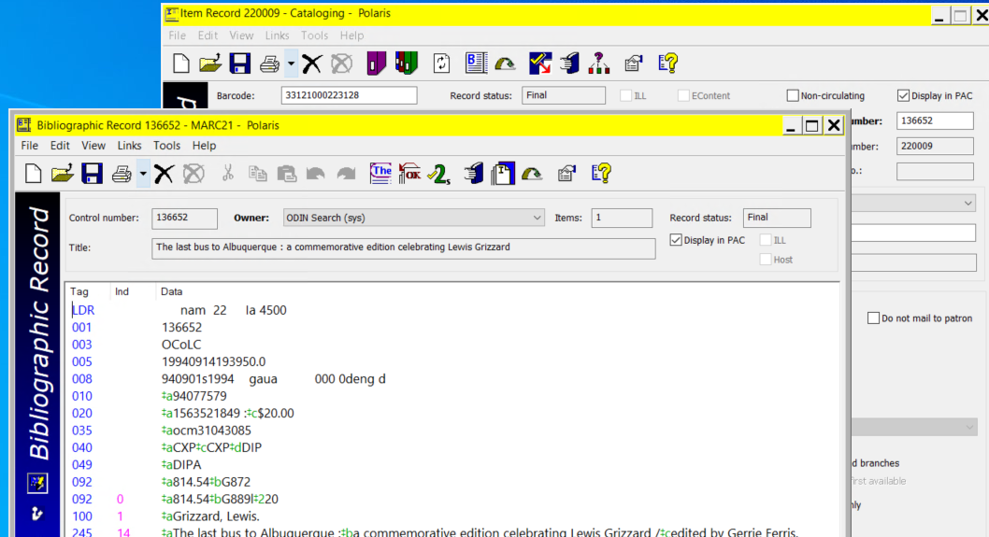

- In the item record, uncheck the Display in PAC button and save the record. Because deleted records are being retained in the system, conducting this step ensures that the item will no longer be displayed in the online catalog.

- click the X icon, go to File | Delete or use the shortcut of Ctrl + D to delete the record.

- You will be prompted to confirm the deletion. Click Yes.

The item is deleted.
- If Polaris detects the item being deleted is the last item that is attached to the record, you will be asked if you also wish to delete the bib record. Click Delete to delete both the item record AND the bibliographic record.

- The records are deleted.

