Polaris LEAP Cataloging
Deleting Items

Basic Information for deleting items via Polaris Cataloging in Leap.

- Deleting item records for NON-OCLC USERS

- After logging into Leap, conduct a search for the item to be deleted. The best search to yield a match will be a barcode search. Instead of using the find tool, a barcode can be entered into the quick search box.

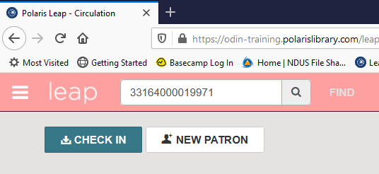

- With the item displayed on the screen, go to the Details section, uncheck the Display in PAC box at the bottom of the screen and Save the record. Because deleted records are being retained in the system, conducting this step ensures that the item will no longer be displayed in the online catalog.

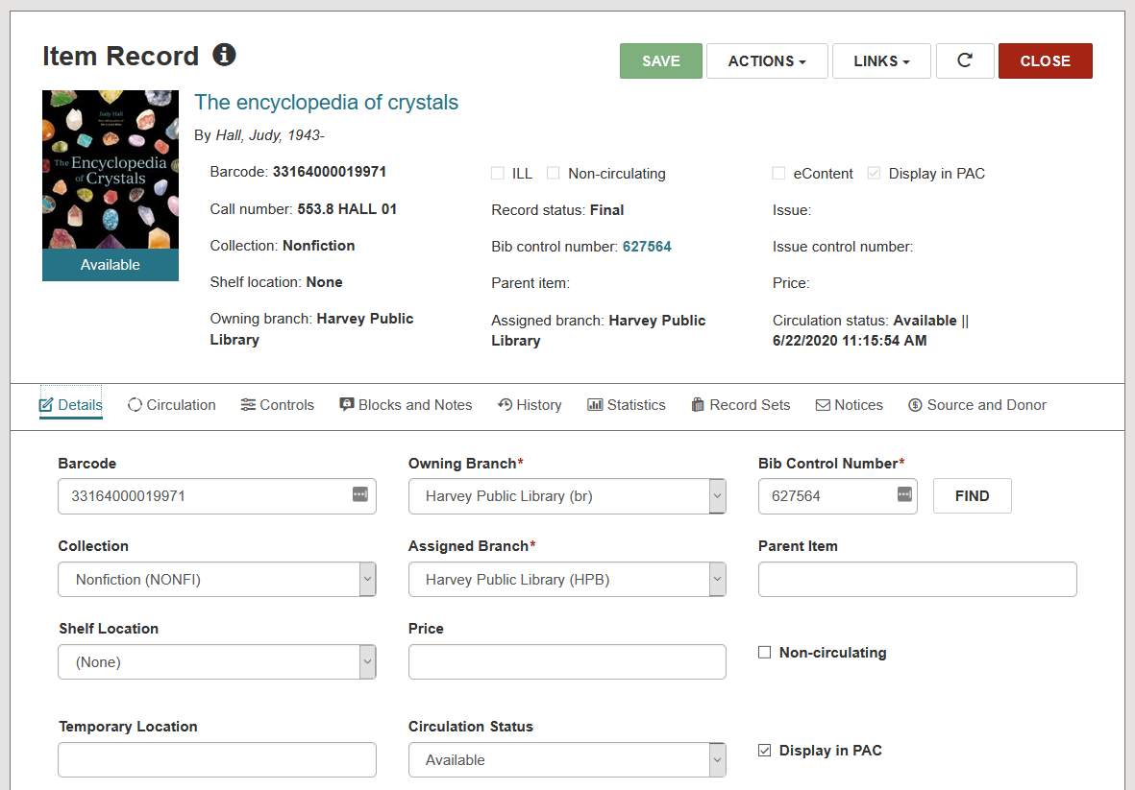
- In the item record, then go to Actions and select Delete.

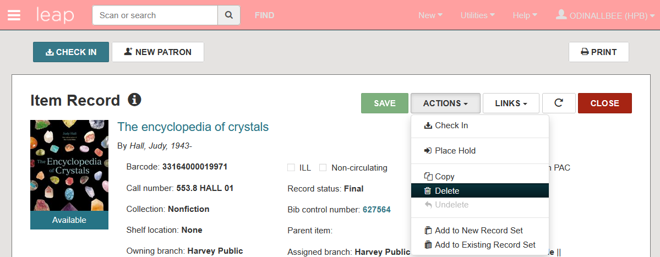

4. You will be prompted to confirm the deletion. Click Continue.
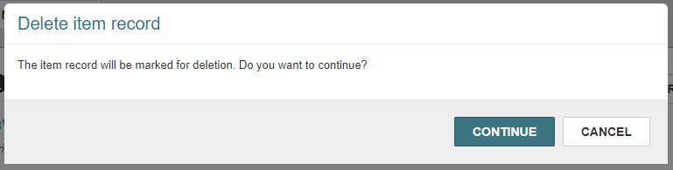

5. The item is deleted.

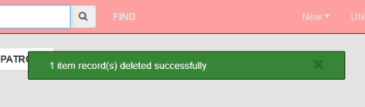

- If Polaris detects the item being deleted is the last item that is attached to the record, you will be asked if you also wish to delete the bib record. Click Delete to delete both the item record AND the bibliographic record.
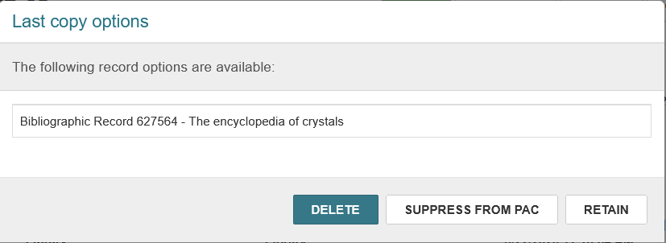

- The record is deleted.

- Deleting item records for OCLC USERS

- Conduct a search for the record to be deleted using the FIND TOOL. Instead of searching the item database, conduct a search in the bibliographic database for barcode.

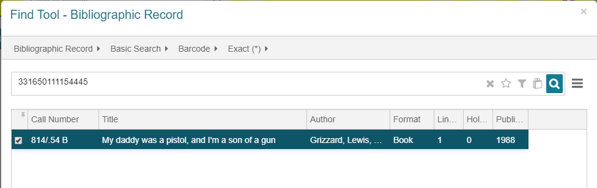
- With the bibliographic record on the screen, view the MARC tab to gather information – such as the 035 OCLC number – in order to delete the record from OCLC later.

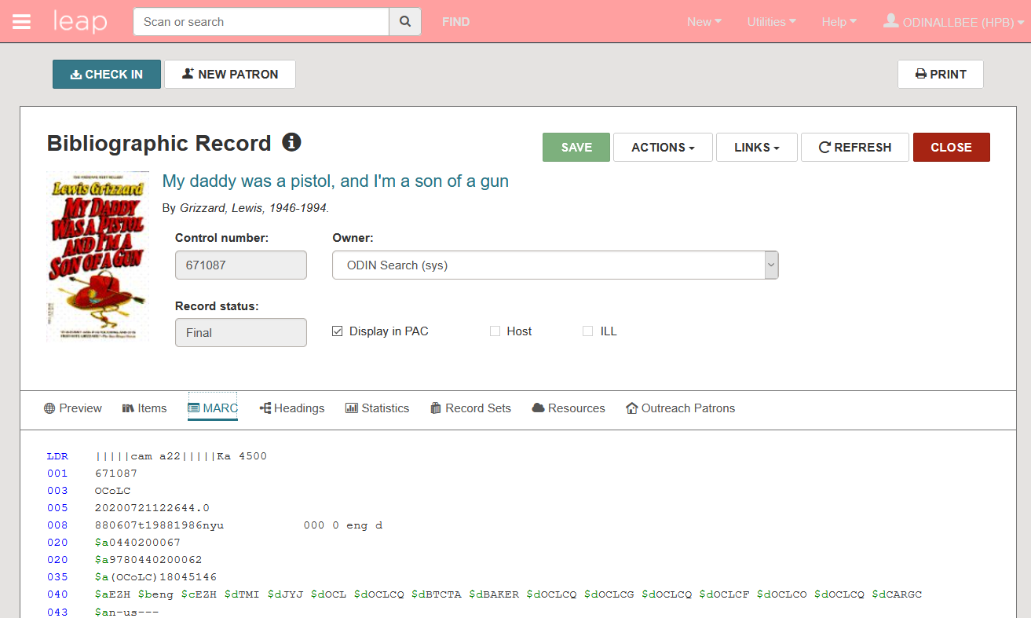

- Go to the Item tab. IF YOUR COPY OF THE ITEM IS THE ONLY COPY attached to the record, proceed to step 4. If your copy of the item IS NOT THE ONLY COPY attached to the record, double click on it to go to the item record. Delete the item record as per section I, steps 2-5.

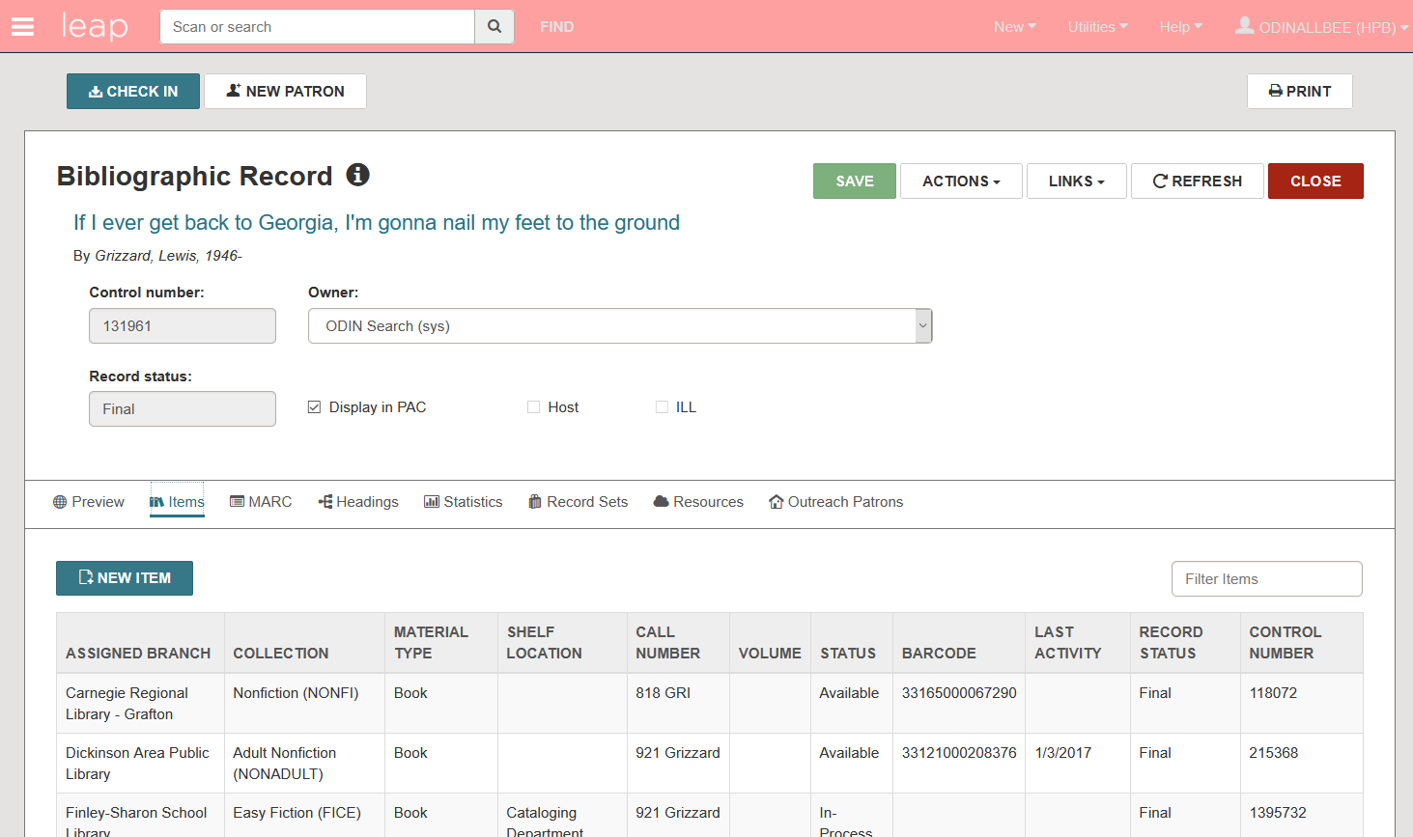
- If your copy of the item IS THE ONLY copy attached to the record, CLOSE the bibliographic record and conduct the steps in section I to delete an item record.
**Note: if you do not close the bibliographic record before searching for the item, during the item delete process you will not be permitted to delete the bib.

