Polaris LEAP Cataloging
Copy Cataloging - Adding Item Records to Existing Bibs

Basic Information for adding item records to existing bibs via Polaris Cataloging in Leap.

- After logging into Leap, conduct a search for a bibliographic record. The best search to yield a match to your item is an ISBN search. Double click on the record in order to view the full bib.

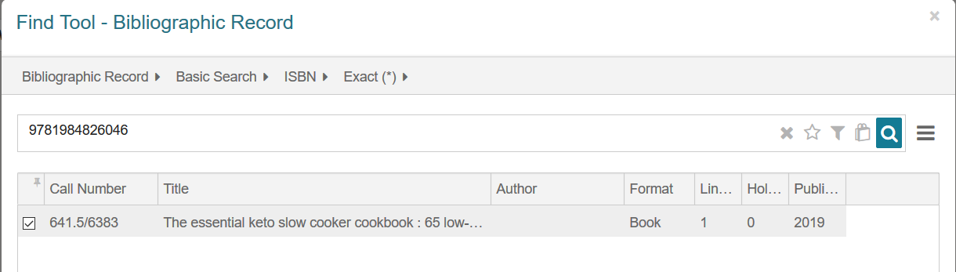

2. With the bib on the screen, it’s important to look at the MARC tab to evaluate the record.

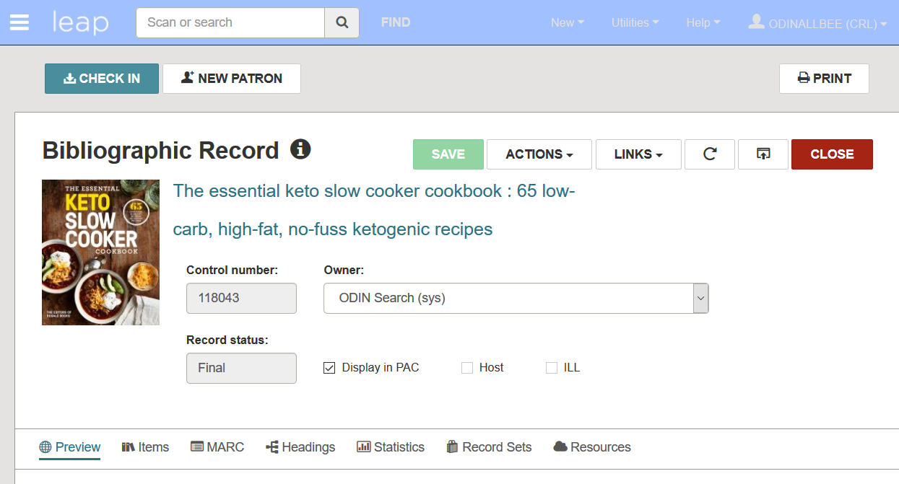

3. In the MARC tab, verify that the record matches the item you have in hand. Check for obvious matching fields – such as author, title, publisher, ISBN – but also look at the physical description field (for example to assure you are viewing a physical book record and not an e-book record).
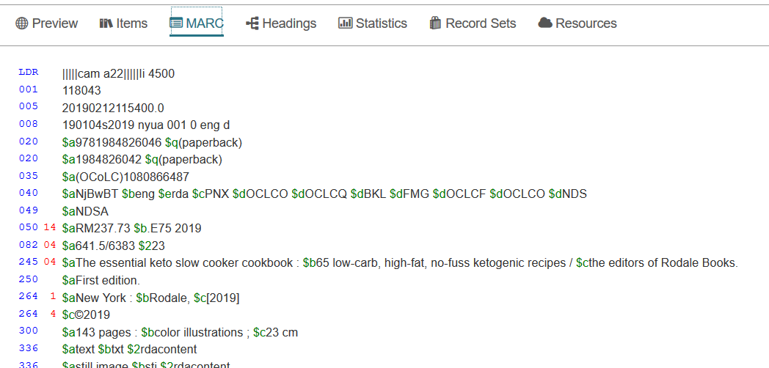

4. Once you assure the record matches your material, add your item to the record. Go to the Item tab and click NEW ITEM.

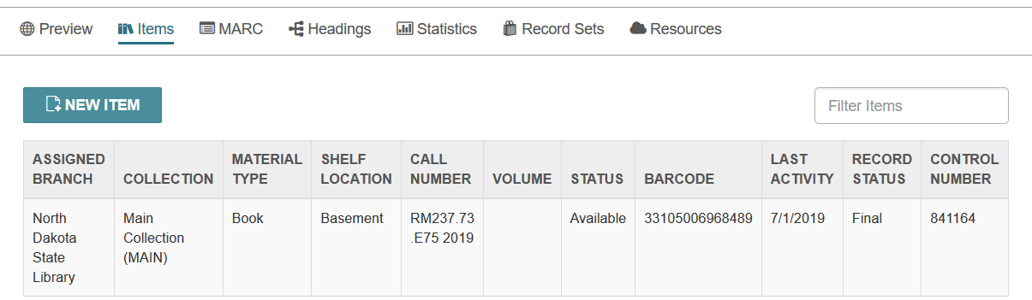

Alternatively, click the Actions menu and select Create Item.

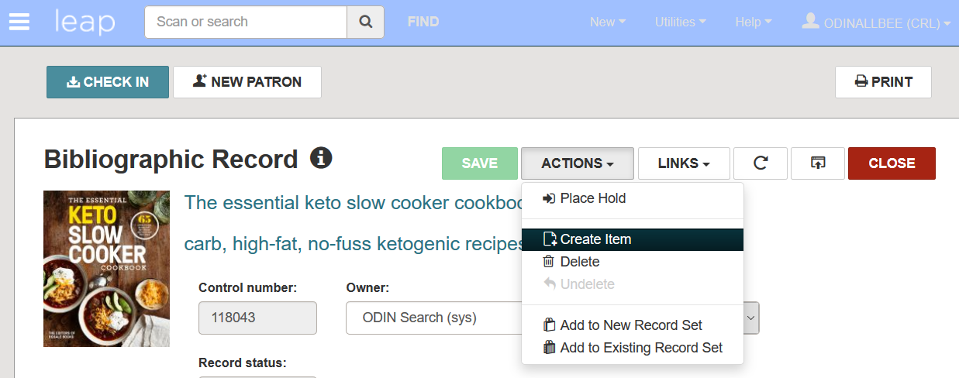

5. A New Item Record form displays. Fill out the form, and click CREATE ITEM to add your item to Polaris.

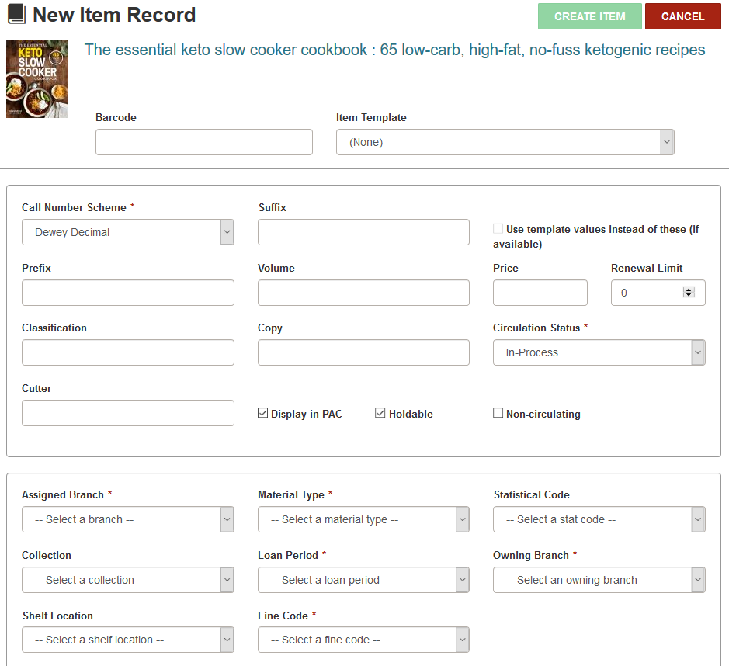

- Barcode – Scan or type in the barcode being assigned to the item
- Item Template – If your library has set up item templates, select the template from the list. The templates are a convenient way to automatically fill in several fields in the record. If a template is selected, the Use template values instead of these (if available) becomes checked.
- Call Number Scheme (mandatory) – Select the call number scheme. Dewey for nonfiction items or Other for fiction.
- Prefix – If your library uses prefixes on call numbers (prestamps) enter that information here.
- Classification – Enter the call number of a nonfiction item, or the cutter of a fiction item.
- Cutter – Enter the cutter of a nonfiction item.

- Suffix – If your library uses suffixes on call numbers (post stamps) enter that information here.
- Volume – Enter a volume if applicable.
- Copy – Enter the copy number if applicable.
- Price – Enter the item price if desired.
- Renewal Limit – Enter the number of times a patron may renew the item.
- Circulation Status (mandatory) – Enter the circulation status of the item. If the circulation status is In-Process, before shelving the item it will be necessary to check in the item first. This is beneficial to catch any holds the item may have, and is a recommended practice.
- Display in PAC – Check if the item should be displayed in the online catalog.
- Holdable – Check if the item can be placed on hold.
- Non-circulating – Check if the item is not allowed to circulate.
- Assigned Branch (mandatory)* – Select your branch
- Collection* – Select the collection.
- Shelf Location* – Select a shelf location if applicable.
- Material Type* – Select a material type.
- Loan Period (mandatory)* – Select the loan period. In the case of non-circulating items, select a loan period in case the item is ever checked on a special circumstance.
- Fine Code (mandatory)* – Select a fine code.
- Statistical Code* – Select a statistical code if applicable.
- Owning Branch (mandatory)* – Select your branch.

