Polaris Acquisitions
Supplier Records

Setting up Supplier records in Polaris. The supplier record holds addresses, default currency, EDI information and the default claiming cycles for a vendor.
- To create a new Supplier record, from the toolbar click on File | New, click on the new icon or use the hot-key Ctrl+N.

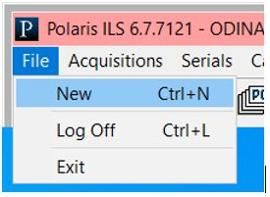

Select Supplier Record from list.
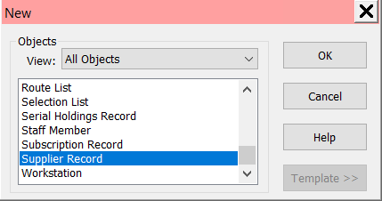

- The supplier record workform displays. Note there are four pages to this form, and each can be navigated to using the icons along the left side of the form. Fill out the form and go to File | Save or click the save icon to save the supplier record.
- Name (mandatory) – Enter the name of the supplier.
- Alternative name (mandatory) – The alternate name can be a short form of the working name, an abbreviation, popular name, etc.
- Currency (mandatory) – defaults to US Dollar
- SAN – Enter the SAN (standard address number). This field is only required for EDI orders.
- Account – Enter your account number with the vendor. Note: If you have multiple accounts with the vendor, you’ll need a separate supplier record for each account.
- Owner (mandatory) – defaults to the logged in users library.
- Encumbrance/Expenditure Limits – enter line item, supplier and order limit for encumbrances or expenditures. These fields are informational only.
- EDI Setup – If using EDI, enter information accordingly
- Notes - enter any notes to be associated with the supplier.
- Plan – enter any information regarding approval plans, blanket purchasing arrangements or like.
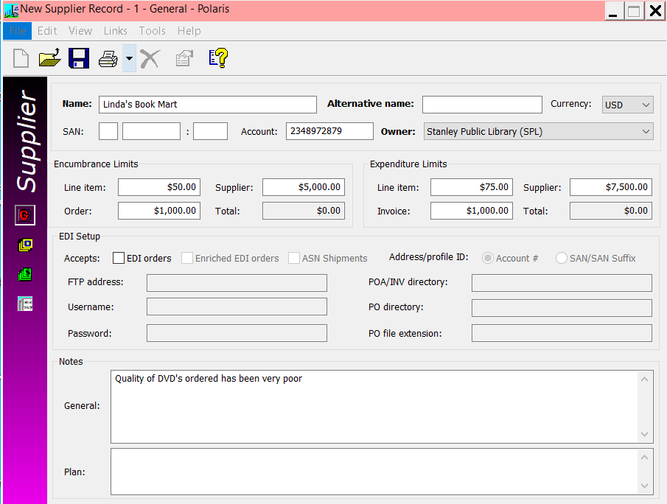

Orders screen:
- Send orders to: Enter the address and contact information for where orders to this supplier should be sent. The city, county and state fields are filledi n automatically once the postal code is entered. NOTE: After entering the address, there is an option to use the Copy to… button which allows information to be copied into the Payment Address, Claiming Address or both in the subsequent screens.
- Discount – Enter the discount percentage (if any) that is typically applied to orders.
- Financial – Enter an identifying number if Polaris Acquisitions is integrated with a financial system.
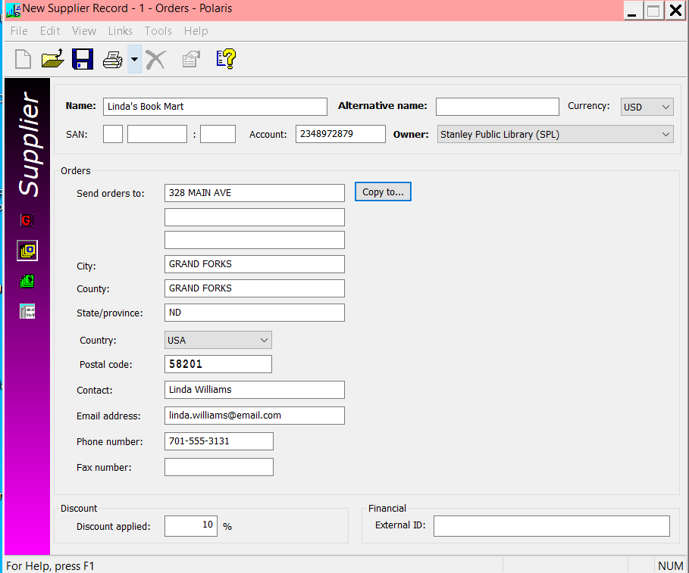

Payments screen:
- Send payments to: If you did not (or could not) use the copy feature from another screen, enter the address and contact information for where payments to this supplier should be sent. The city, county and state fields are filled in automatically once the postal code is entered. NOTE: After entering the address, there is an option to use the Copy to… button which allows information to be copied into the Order Address, Claiming Address or both in the subsequent screens.
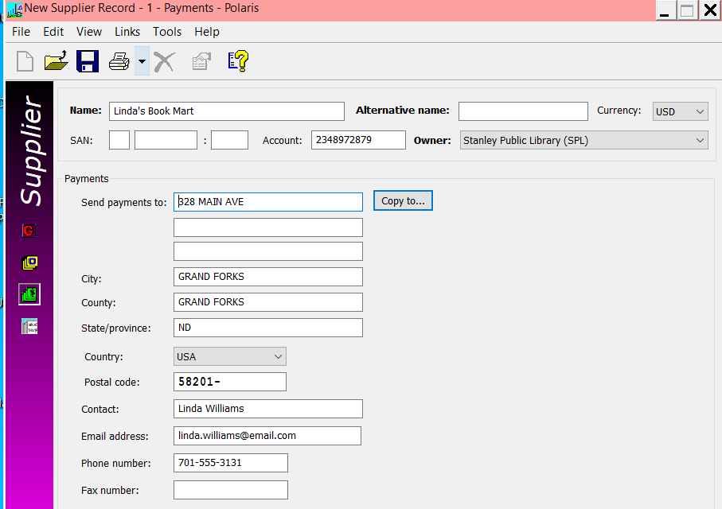

Claims and cancellations screen:
- Send notices to: If you did not (or could not) use the copy feature from another screen, enter the address and contact information for where payments to this supplier should be sent. The city, county and state fields are filled in automatically once the postal code is entered. NOTE: After entering the address, there is an option to use the Copy to… button which allows information to be copied into the Order Address, Payment Address or both in the subsequent screens.
- Maximum claims – enter the maximum number of claims (up to 4) to be sent for material that is not received.
- Claim waiting period – depending on the number of claims to be sent, fill out the waiting period between claims.
- Cancel notice – check if you wish to generate a cancel notice
- Auto-cancel – check to cancel purchase order line items automatically after the claim cycle is complete.
- Claim notice – check to send claims. If checked, select the notice method from the drop-down menu.
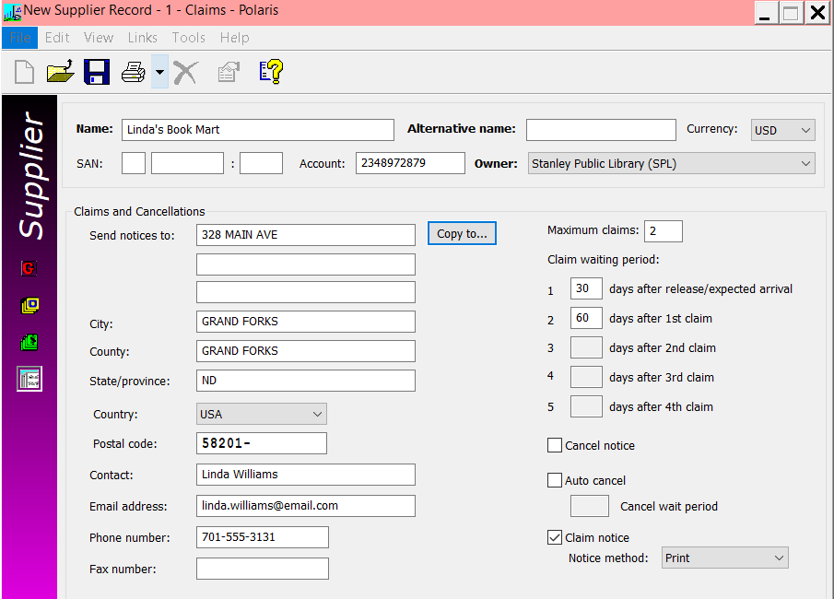

- Suppliers can be searched for within the client. On the menu bar, select Acquisitions | Suppliers or click the supplier icon.
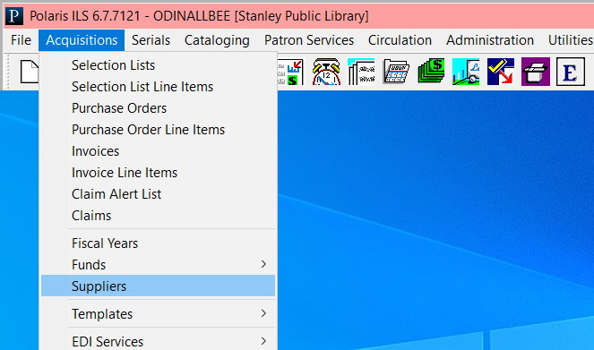

A search box is presented.
