Polaris Acquisitions
Fiscal Year Records

Setting up Fiscal Year records in Polaris. An unlimited number of fiscal years can be created, and an unlimited number of funds and subfunds may be associated with them. Fiscal years may overlap.
- To create a new Fiscal Year record, from the toolbar click on File | New, click on the new icon or use the hot-key Ctrl+N.
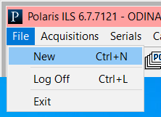
Select Fiscal Year from list, and click OK.
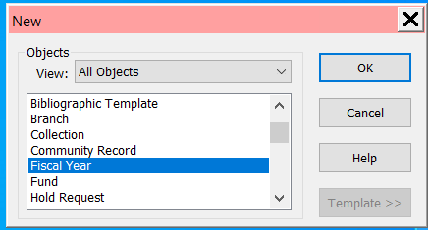
- Fill out the workform and go to File | Save or click the save icon to save the fiscal year.
    - Name: Enter a name for your Fiscal Year
    - Start/End date: Enter the range of dates the fiscal year should encompass
    - Owner: The system automatically defaults the owner to be the logged in library
    - Note: Add any notes required
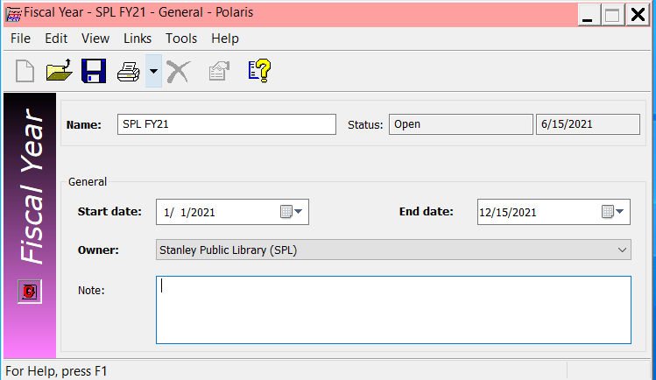
- To retrieve Fiscal Year records, on the menu bar go to Acquisitions | Fiscal Years or click on the Fiscal Year Icon within the Acquisitions marble.
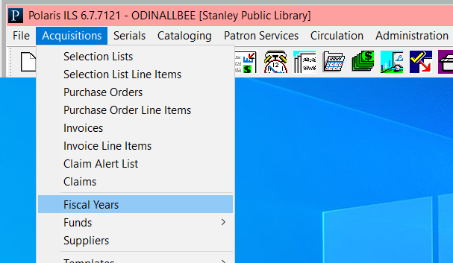

A searchbox displays that allows you to search for a fiscal year. The asterisk (*) acts as a wildcard to retrieve all fiscal years.
