October 22, 2020 -- PKS Cataloging Group Meeting Notes:

Agenda:
New items:
- Record sets named “weeded000n” both authority records and authority records -- automatically created? What should be done? ANSWER: unknown – Lynn to investigate contents
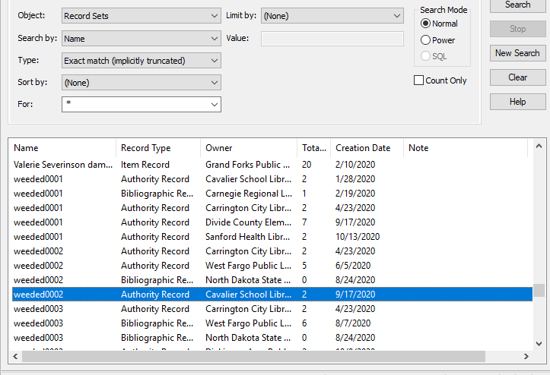
- When weeding, Jess (NDSL) encountered message asking if wanted to delete authority records as well as the bib. What should be done? ANSWER: Authority records can be left undeleted since if they are linked to future bib records, it would save time in retrieving from ZMARC.
- What’s new in your library? Questions?
  - Stacey working at home Wednesdays and Thursdays due to high COVID numbers.
  - NDSL was featured on NBC news in regard to Universal Class database usage numbers increasing drastically.
  - GFP_ doing curbside and things are going well. Oct 15th started appointments for in building.
  - WFP encouraging mask use. City ordinance passed last night strongly encourages masks. Otherwise, things are moving along.
- Diacritic documentation - small script l (for leaves) can actually be spelled instead of using the out and designated as leaves. Documentation will focus on copyright symbol updates. Lists will be distributed to libraries for titles to update.
- Deletes – when deleting do you have to delete multiple times or when will they go away? ANSWER: If you delete just once, records will be marked for deletion. Once all the stats are compiled for Annual Reports ODIN will be deleting those records marked for deletion.

Pending/old items:
- Bibs and items marked for deletion and impact on circ stats. Circ UG discussed and will need stats for annual reports (number of deleted bib/items, statistical summary).
  - Statistical Summary Report should show some of the stats needed.
  - Simply Reports can exclude the deleted records but must remember during setting up report.
  - Lynn received list from prior years of what was needed for Annual Reports so will work on document for procedures and see if we can delete.
- Documentation to be created/posted on Cat User Group page: MARC fields to strip out of OCLC during import: 029, 263, 938. These are all vendor-specific fields that are not intended to be used by libraries or patrons.
We have several options ….
  - #1 set up tags to delete in the default which would limit your flexibility but standardize across all libraries (assuming everyone can agree)
  - #2 have a recommended standard for the Import Profiles and let each library determine what is best for what they are doing. This would allow for different tags to be deleted in different profiles as needed
  - #3 In release 6.4, there was an option to delete all instances of a defined tag – not just the first or last during a Bib Record Bulk Change.
  - #4 set up profile in OCLC to strip out tags on import.

Next Meeting:
Thursday, November 19th from 10-11
Please send any agenda items to Lynn.Wolf@ndus.edu by Wednesday, November 18th.

Connection information - session will be recorded.
To join click on the following link:
https://us.bbcollab.com/guest/90d20ccbea9a407399fd573431fd4372

Session dial-in:
Call in anonymously. Attendees using this PIN appear as anonymous callers in the session.
• Dial-in: 571-392-7650
• PIN: 4111272841

