January 28, 2021 -- PKS Cataloging Group Meeting Notes

Agenda:

New items:
- What’s new in your library? Questions?
  - State Library- open in the mornings and locked in the afternoon, but people can come in by appointment. They are limiting to five people.
  - Grand Forks – On January 19 they extended their hours. On Tuesdays and Thursdays, they have appointments from 10am-5pm. 30-minute appointments are now 45 minutes. They are still doing curbside pickup. They are now open a few hours on Saturday, but they are still closed on Sunday. Everything is going smoothly.
  - West Fargo – Closed Sundays but are open every other day. They do not limit the number of people who come in. Almost back to normal.
- 024 field (Other Standard Identifier) The UPC code on DVDs. – The UPC code is useful for DVDs and for acquisitions, Cindy from Dickinson has noticed that new records coming into Polaris are missing the 024 field. We’ve always said you can enhance a record, but please do not delete things that can be useful for others since we share bibliographic records. We do not know that anyone is bringing the record in and then deleting the tag. It might be that you have your OCLC Connexion software set up to strip that field upon import. Tools > Options > Export > Export field options. It would be a good idea for everyone to check their settings. Taking this opportunity to outline what we have all agreed it is okay to delete: 020 $z, (OCLC can’t do this); 776; 263. Email Stacey if you need help with your OCLC Connexion settings.
- RB Digital/OverDrive update – RB Digital records and OverDrive automatic record loads – December 17 RB Digital records moved to OverDrive. The RB Digital records remained in the PAC, but they did not work. Liz suppressed the RB Digital records this week with plans to delete them later. Patrons will not find them in the Pac. Lynn: If you want them gone sooner, we can do that because they do not have items and do not impact usage statistics. Otherwise, we will fold them in with the other cleanup we will do after libraries’ annual reports are done. The due date for the reports is the end of March, so we are looking at the mid-to-late April to do the final deletes.
- OverDrive record loader – There used to be an automatic process that loaded OverDrive records into Polaris. We noticed in early November that records were no longer coming in. Lynn investigated further and found that they had stopped in August. It was during an upgrade in Polaris that the test environment was getting the upgrades and that the production environment was not. Lynn reported it in November and asked them to fix it and load the back log. Lynn continues to ask them for updates and to push them to fix it.
- Import profiles – Import profile NDSNORTHRUP is no longer being used by the State Library, and Stacey is asking Liz to delete it. Lynn: suggests that libraries that if someone is using and import profile consistently but it is not associated with your library, it would be a good idea to make a copy of it and save it with your library initials. That way it would not get caught in the cleanup process.
- Orphaned bibliographic records – how to handle these? Liz will send an email with bibliographic records that do not have items to the original library that imported that record. There are reasons (below) that a library may have a bibliographic record without an item on it. The goal is to try to get these cleaned up. Just a reminder it is okay to click delete when you are deleting the last item on a bibliographic record. Polaris will prompt you if you are deleting the very last item, and you can proceed to withdraw it. If later, a library is cataloging it again they can bring in a new more up to date record. Also, we do not want patrons to be confused by finding bibliographic records without a call number.
  - Discovered that there are valid reasons records could have no items:
    - We needed a bib in Polaris to close out the POb in acq module but we circulate the book club kits in KitKeeper product (we’ll keep these)
    - Some sort of vendor/acq record migrated from PALS to Aleph and Aleph to Polaris (we’ll delete these ones that describe a Thorndike plan that we bought)
    - Libraries might be “bib record only” libraries and didn’t use items in PALS or Aleph
    - Someone forgot to add an item on a new bib
    - We recataloged titles from individual bibs for each issue to a serial bib, moved all the items over to the serial and forgot to delete the individual issue bibs
    - Someone deleted the last item record and didn’t delete the now unattached bib
    - Someone brought in a bib and added an item then brought in that same bib again and did not do an item
    - Legitimate acq record that will have an item record soon but doesn’t yet. Or someone wanted a dummy item record attached and forgot to do it
    - Bib records for analytics
- Grand Forks – they are cataloging board games and need to set up a new holding code with OCLC for a new collection. Stacey says she has an email address that she can share to contact OCLC.

Pending/old items:
- What topics would you like to see covered in documentation, training seminars, or the next ODIN Work Day? Please submit to odin-pks-cat@listserv.nodak.edu or odinhelp@listserv.nodak.edu
- 035s with dollar signs – Stacey: Last spring or early summer some 035s in Aleph had $ signs on them. This did not seem to effect Aleph, but it did Polaris. For example, deep linking did not work, so Lynn pulled a list, and Stacey has finally finished fixing them.
- EBSCOhost/Netlibrary ebooks – last month we discussed these ebooks and Grand Forks Public and Dickinson Public decided to delete them from the catalog. I wanted to ask the group how they would feel if I edited the remaining records to remove the urls for GFPL and DPL? – Liz: GFPL and DPL said yes to delete their EBSCOhost/Netlibrary ebooks, the State Hospital opted to keep theirs in the Polaris catalog. Liz asked the group if she could delete the URLs from the bibliographic records. GFPL agreed that would be okay. Liz will touch base with Cindy first before she does it.
- Diacritic documentation - small script l (for leaves) can be spelled out instead of using the symbol and designated as leaves. Documentation will focus on copyright symbol updates. Lists will be distributed to libraries for titles to update. UPDATE: The small script “l” is cleaned up, and Lynn is working on the copyright symbol clean up and she has about 4,000 left. Copyright symbol migrated as an A with a symbol on top of it. This cannot be done with a global change.
- Record sets named “weeded000n” both bibliographic records and authority records -- automatically created? What should be done? UPDATE: Lynn sent an email to the list saying that the weeded000n record sets are created during a bulk delete job when the last item attached is being deleted. The documentation is available in the PKS cataloging user group page toward the bottom under “ODIN Created.” Liz will delete every 3 months.
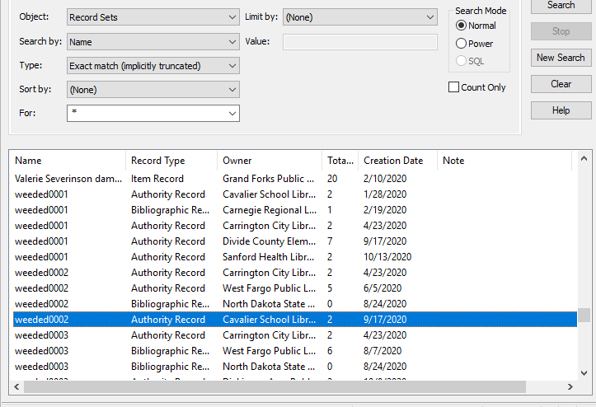
- Bibs and items marked for deletion and impact on circ stats. Circ UG discussed and will need stats for annual reports (number of deleted bib/items, statistical summary). Update:
  - The draft instructions for annual reports are complete and Lynn worked with West Fargo to test them, and it is ready to go except two items regarding ILL/Holds.
  - Bib record clean up will be after libraries complete their annual reports, so sometime in April.
  - Stacey noted that in the past the reports were run by ODIN via Aleph, now is each library running their own reports? Lynn pointed out that all libraries have access to Simply Reports, the documentation is step-by-step with screen shots, so there is no reason people cannot run it for themselves. If libraries have questions they can put in a ticket and ODIN will help them. Lynn will send out the instructions to the listserv.
  - Passwords- everyone should have access to Simply Reports, Jason has everybody added by default. If you find you cannot access it, please let ODIN know.
  - Stacey is going to be doing an ODIN Work Day session on Simply Reports and canned reports that are useful for cataloging.
- Documentation to be created/posted on Cat User Group page: MARC fields to strip out of OCLC during import: 029, 263, 938. These are all vendor-specific fields that are not intended to be used by libraries or patrons. Update: This is completed, and the documentation has been added to the website.
We have several options ….
  - #1 set up tags to delete in the default which would limit your flexibility but standardize across all libraries (assuming everyone can agree)
  - #2 have a recommended standard for the Import Profiles and let each library determine what is best for what they are doing. This would allow for different tags to be deleted in different profiles as needed
  - #3 In release 6.4, there was an option to delete all instances of a defined tag – not just the first or last during a Bib Record Bulk Change.
  - #4 set up profile in OCLC to strip out tags on import.

Next Meeting:
Scheduled for 4th Thursday of each month or as needed
Thursday, February 25th from 10-11am
Please send any agenda items to Liz.Mason@ndus.edu (or to this list).

Connection information - session will be recorded.
To join click on the following link (this is the new link to Liz’s Blackboard):
https://us.bbcollab.com/guest/e1541cbb3ee34da8a29b5fc3d993fa8e

Session dial-in:
Call in anonymously. Attendees using this PIN appear as anonymous callers in the session.
• Dial-in: 571-392-7650
• PIN: 8825858795

