Alma Resource Management
Deleting Items

Items can be deleted manually (either one at a time or selected as a group among those linked to the same bib) or in bulk (by uploading a file of barcodes or creating a set).

- Manually deletion of items.
  - Search for the item in Alma using the Physical titles search in the institution zone. The quickest search and best way to assure a match is to search by barcode. If a barcode is not available, search by any other limiter.

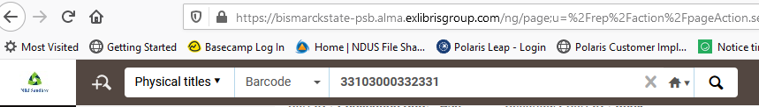

  - Once the record has been located, in the Physical tab, select the Items link. *Note: before going to the item, you may wish to click on the title and from the marc record retrieve the OCLC number for updating holdings in OCLC.

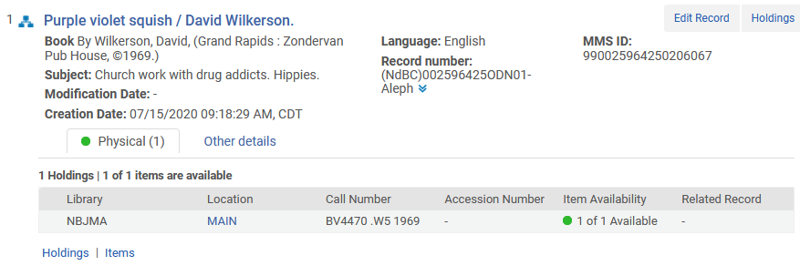

  - With the item(s) on the screen, click on the ellipse next to the item to be deleted and select Withdraw.

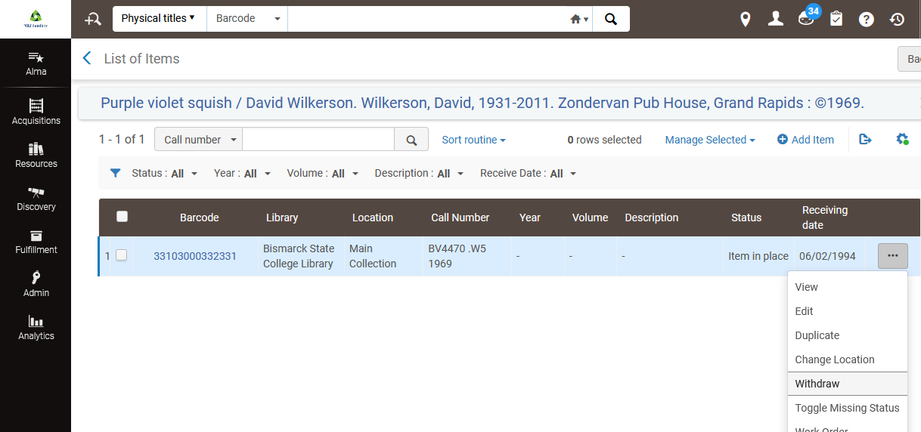

Alternatively, select the item(s), click Manage Selected from the menu bar and select Withdraw Items.

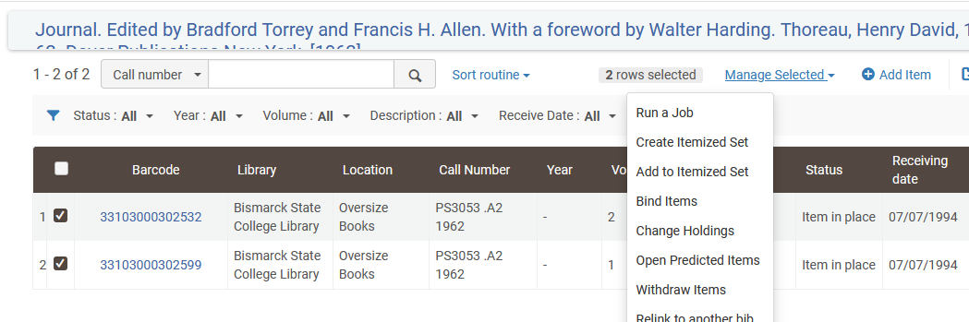

  - You are prompted to confirm if you wish to delete the item(s).
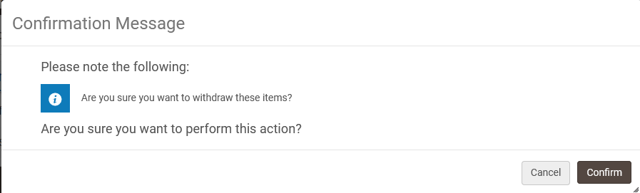

  - If the item(s) being deleted is the last item attached to the holding, Alma prompts you to decide what next step (if any) should be taken. You can leave the holding/bib as is, delete the holding record, suppress the holding record, or delete the bib record (including the pertinent holding record) unless other holdings are attached to the bib. It is common practice to delete the bib unless other holdings are present. **NOTE: taking this action may result in the bib no longer being searchable in Alma. If you wish to obtain the OCLC number for deletion on that system, you’ll want to have already retrieved that number (step b above).

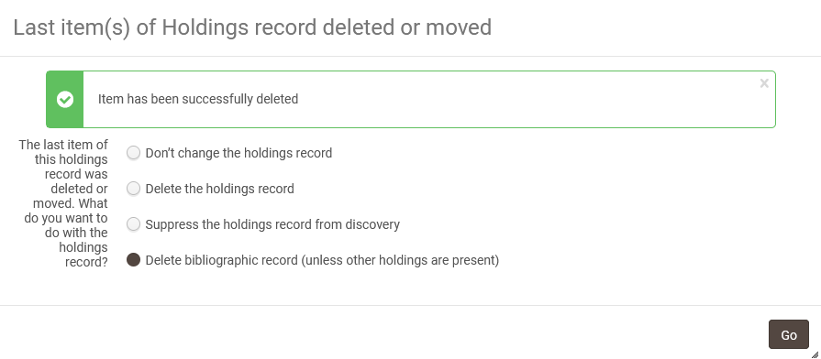

- Bulk deletion of items.
  - A record set can be created via a search in Alma or by uploading a spreadsheet of barcodes.
    - Conduct a search for your item(s) using the same methods described in section I.
      - With the list of items on the screen, select the items to be added to a record set, and then select Manage Selected | Create Itemized Set or Add to Itemized Set if a record set already exists.
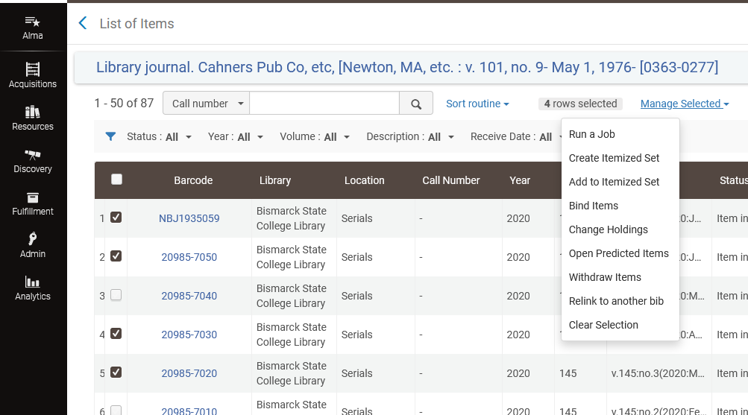

      - When creating a new set, a screen will display allowing you to name the set and add any description or note desired. Click Save to Continue.
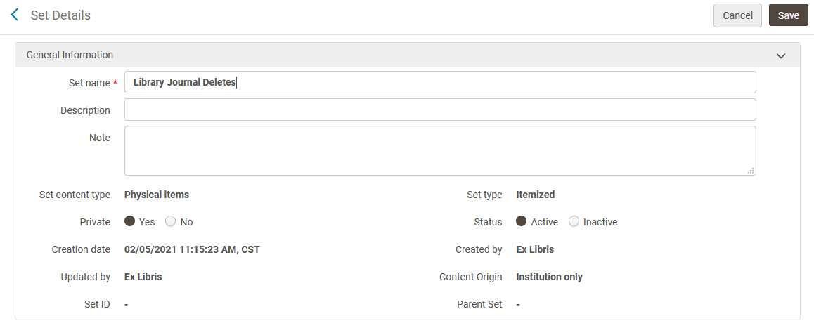
    - Alternatively, a spreadsheet of item barcodes can be uploaded to Alma, and added to a record set.
      - In the spreadsheet, cell A1 should contain the word barcode. Then scan or type the barcodes to be deleted into the spreadsheet.
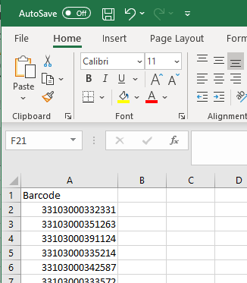

      - In the Alma menu select Admin | Manage Jobs and Sets | Manage Sets

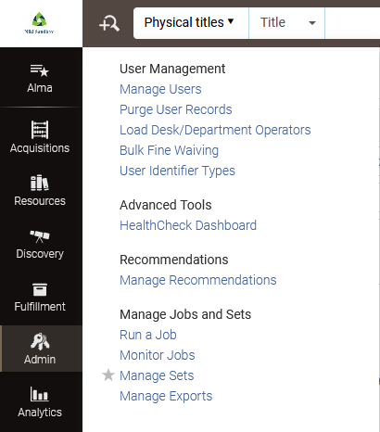

      - Select Add Set | Itemized

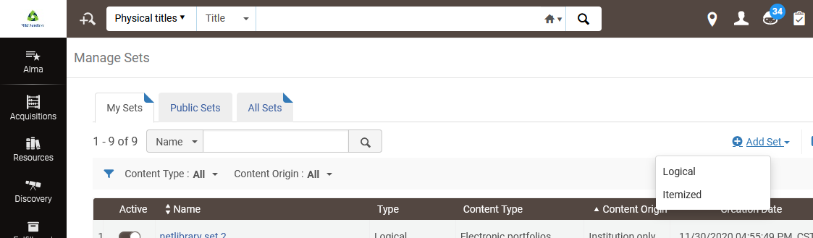

      - Enter a name for the set. If desired, add a description or notes. Change the Set Content Type to Physical Items. In the Add contents from File to set select From File and use the envelop icon to locate the file on your computer and upload it. Click Save to continue.

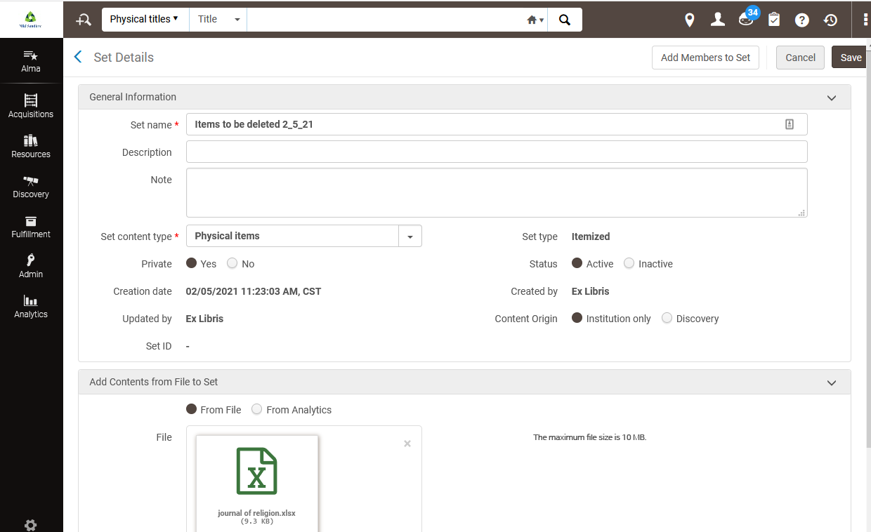

  - Delete the items in the record set. **NOTE: deleting items in bulk will not provide a list of OCLC numbers for deletion on that interface.
    - On the Alma menu select Admin | Manage Jobs and Sets | Run a Job

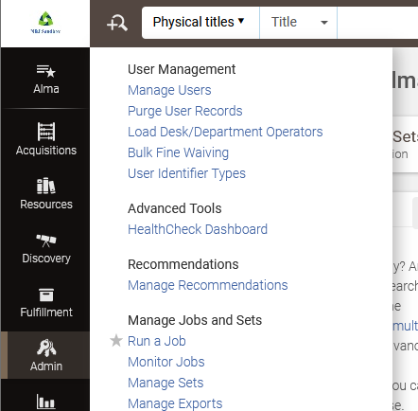

    - Select Withdraw Items and click Next.

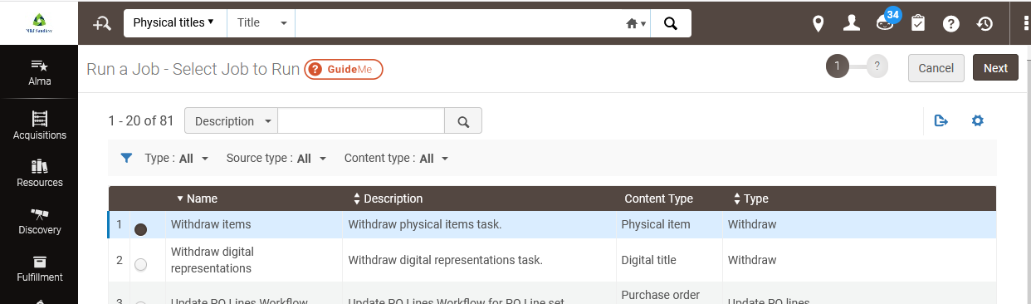

    - Select the record set you created and click Next.

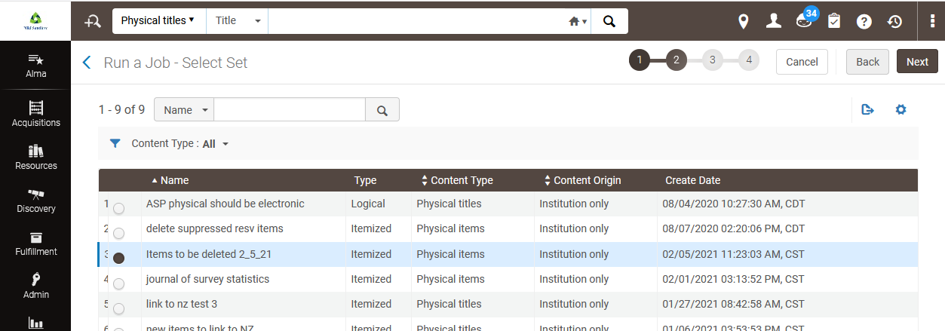

    - Determine how you wish to handle holdings where the last item is being deleted. The holding/bib can be left as is, the holding can be deleted as well as the bib if it is the last item attached, holding/bib can be suppressed if it is the last item or the holding can be deleted and bib suppressed if it is the last item attached. **NOTE: The job results does not provide a list of OCLC or any other record numbers. If you chose to delete the bibs and it is the last holding, the record will no longer be in Alma. You can also determine other settings such as whether or not to delete items that have requests or work orders. Click Next.

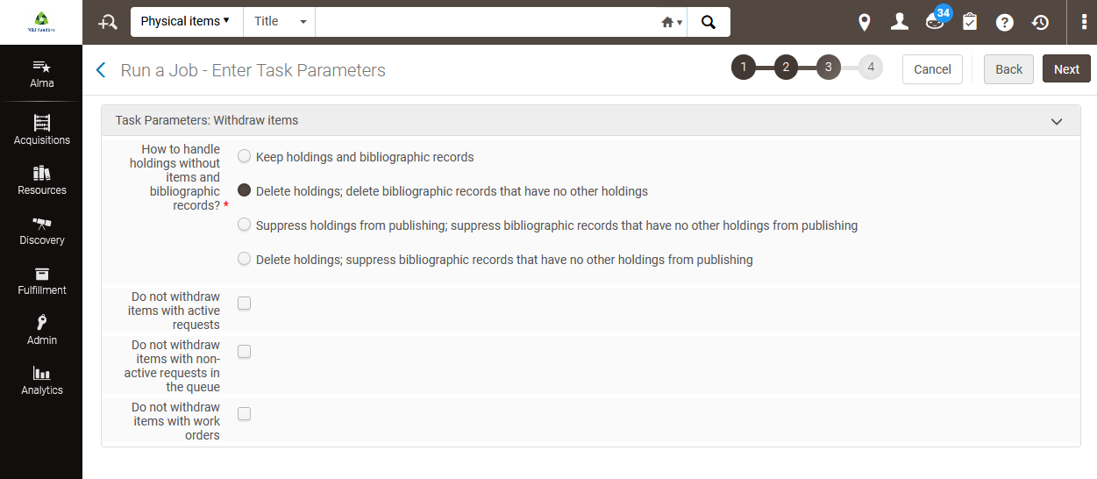

    - A summary of the job choices is presented. Click Submit to run the job.
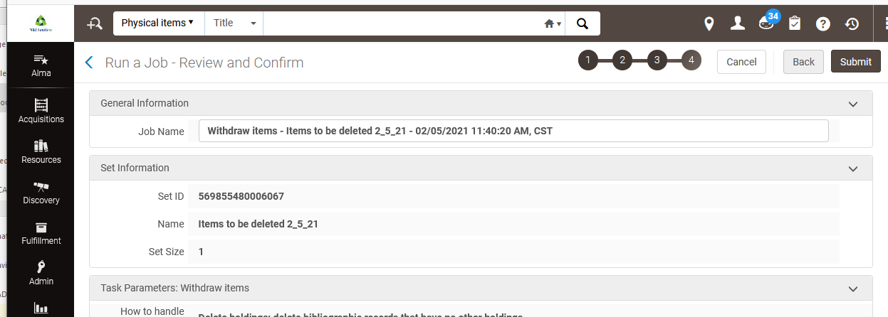
    - You are presented with the Monitor Jobs page. When the job has completed, go to the History tab to retrieve the results. Click the ellipse button next to the job name and select report.
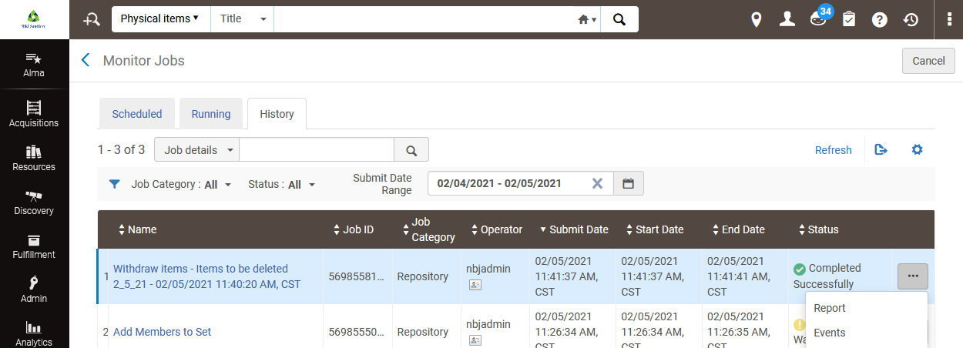

    - The report displays giving a count of items that were withdrawn, as well as other associated counts.
