# Correct the wrong book cover from appearing in the PAC

The book cover image in the PAC is wrong:



This is usually caused by the ISBN for a different book being in the bibliographic record.

Bring up the record in the client or Leap to see the ISBNs in the record, the ISBNs are in the 020 field:

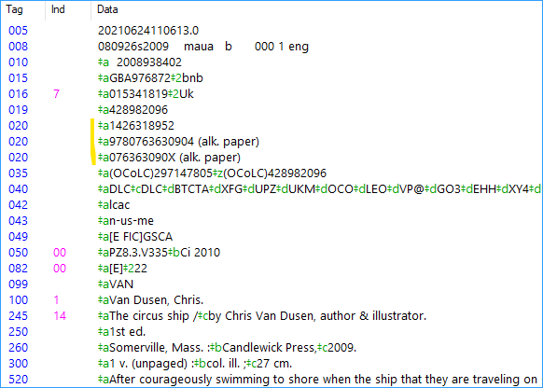

You can use Google to check to see if the ISBN is correct:



This ISBN is the incorrect one:



Now that you have identified the problem, you can edit your bibliographic record. Change the tag from 020 $a to 020 $z which indicates the ISBN is incorrect. Then save the record.

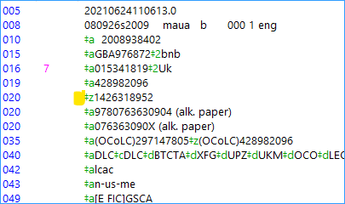

Now the correct image appears for the book:



Part 2: If all the ISBNs in the record are correct, the problem needs to be reported to Syndetics. Explain the problem and include a link to the record in the PAC.

[syndeticscorrections@proquest.com](mailto:syndeticscorrections@proquest.com)