What to do when the OCLC import did not bring in your record

Open Metadata editor by clicking on the Metadata Editor icon on the left side of the screen:

Click the Search & Browse menu and select Search Resources.
Make sure it is searching WorldCat. Type your search in the appropriate box. Here is an example searching by OCLC number. The form calls the OCLC number “System Number.” Click Search.
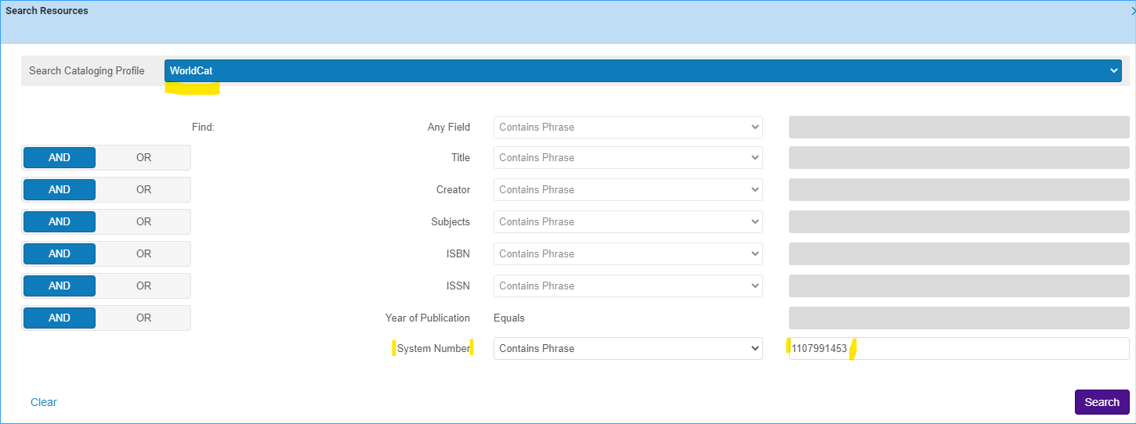
When the correct record appears, click Import.
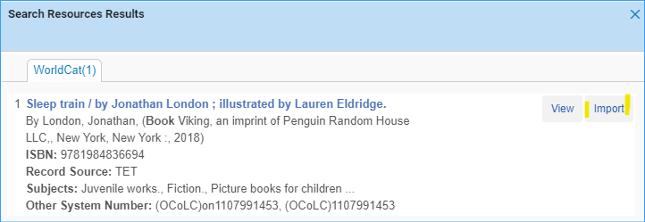
Now the record appears in the Metadata Editor, and you can proceed with your usual processes of adding inventory to it.
