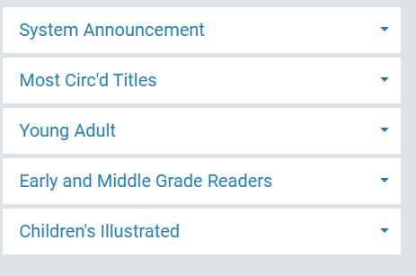
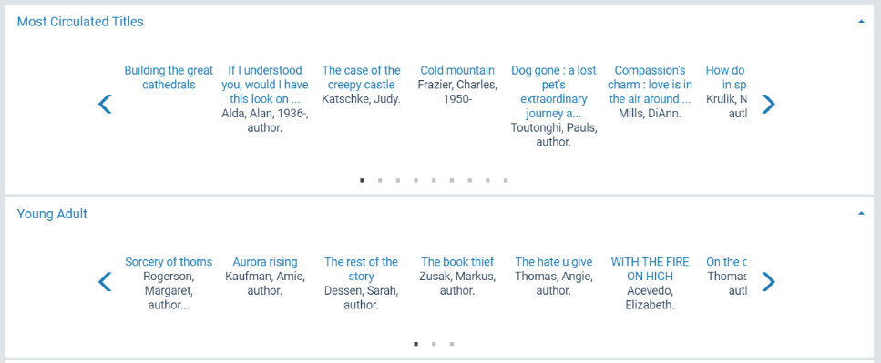
Web Parts and Carousels

In addition to basic functionality of Polaris, libraries can also enhance their catalog discovery display by adding a number of “lists” to the display that can appear along the left or right side of the landing page, below the search bar on the landing page as carousels, or below the facets of the search results page (and a few other, less obvious places).
Here are the default options:

- Children’s Illustrated
- Early and Middle Grade Readers
- Hardcover Fiction
- Hardcover Non-fiction
- Make a Donation
- Mass Market
- Most Circ’d Authors
- Most Circ’d Subjects
- Most Circ’d Titles
- New Titles (links to lists of your libraries new books/videos/etc.)
- On-Order Items
- Trade Paperback Fiction
- Trade Paperback Non-Fiction
- Young Adult

Custom Web Parts
In addition to the pre-defined defaults that come with the system, we can also add ‘custom’ lists as well. This can be used for links to pages on your library’s website, announcements/messages, or any other information that you would like to have show up for patrons to access. Below are some examples. 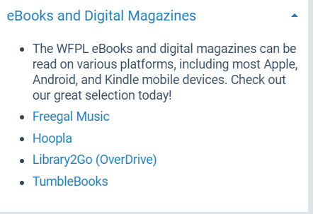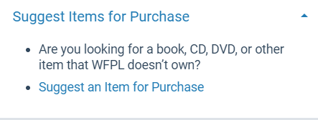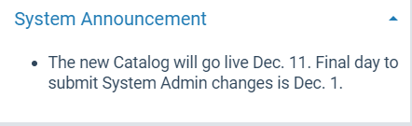
List the area (Portal, Search Results, etc.) and what you would like to see and in what order and we can add/create these as soon as possible.

