Polaris Client Reports
Tips for Using ‘Canned’ Reports

Notes and tips to keep in mind when running notices in Leap and the Polaris Client, as well as various canned reports in the Polaris Client.

- Notices
Notices can be run from either the Leap Interface or the Polaris Client Interface. All notices that are sent via email are done so automatically. Only print notices are addressed by the Utilities in these two interfaces.

- Notices in Leap
In order to review print notices in Leap, in the upper right select Utilities | Print Notices.
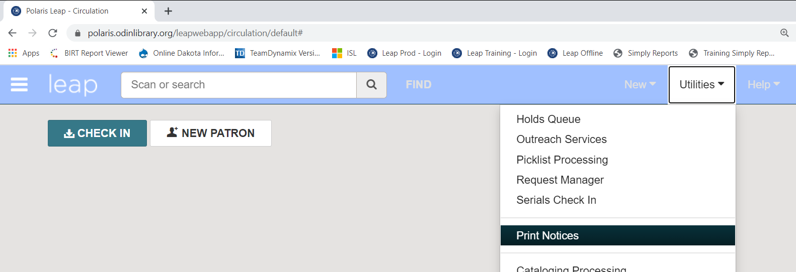

Various notice options are displayed. Select Overdues to retrieve overdues notices.
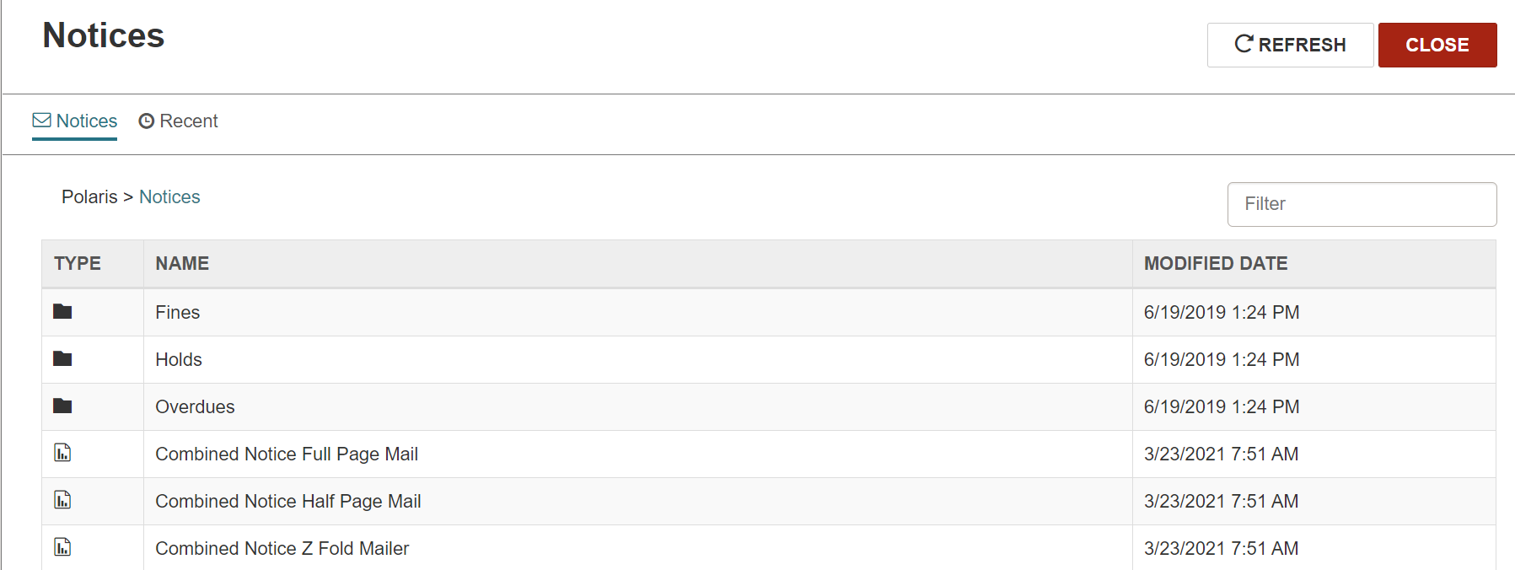
Different notice format types are displayed. It is always recommended to select the ‘Z Fold Mailer’ option for notices. Note: there is a separate file for Billing vs. Overdues.
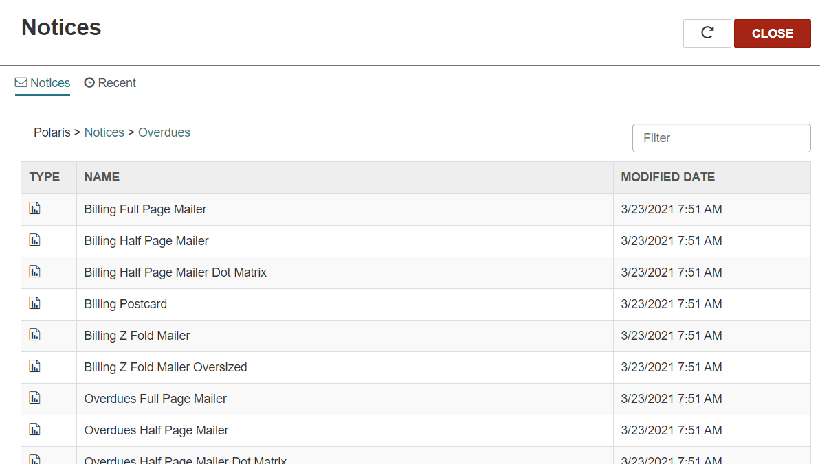

After Selecting either Billing or Overdues Z Fold Mailer, you are prompted to select your library from the list of organizations. Once your library is selected, click Submit Report.
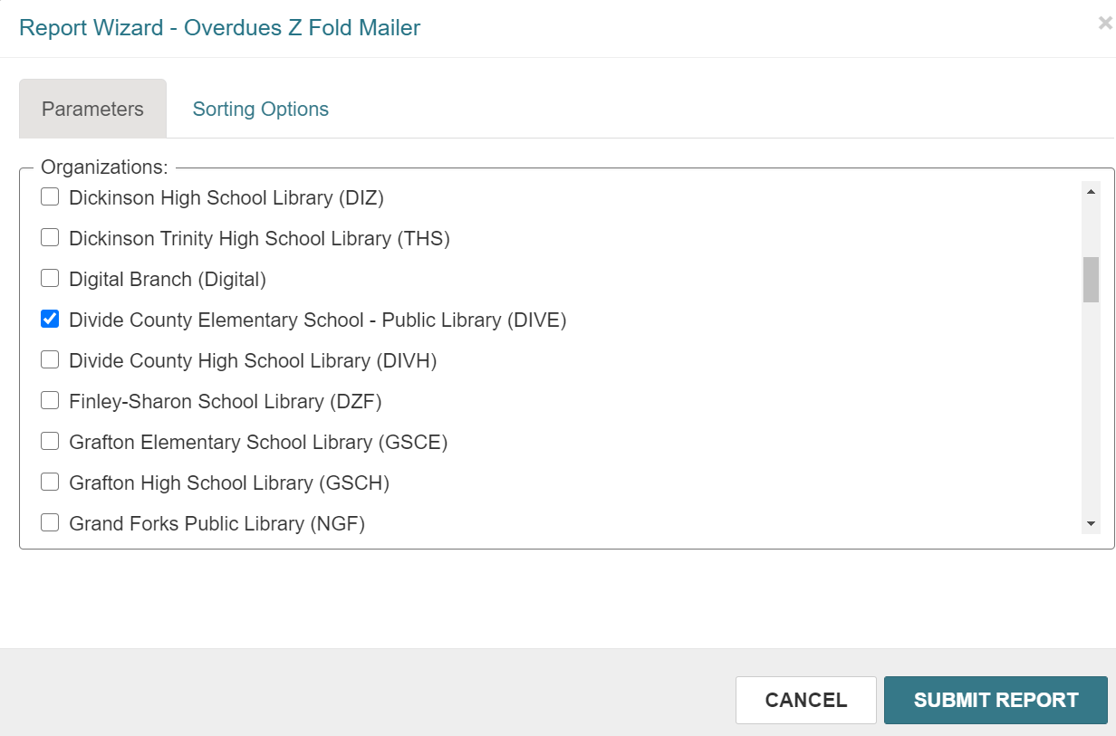

A separate window appears that contains the notices. From here, the notices can be reviewed and/or printed. Notification also appears asking if you wish to post to the database. By saying Yes to this prompt, you are indicating that Polaris should note in the patron record and the item record that a notice was sent for the material. You are also effectively clearing the notice(s) from the Notices folder. The overdue notices folders are dynamic, and as material become overdue (or are in line for a second or third reminder) a notice will be generated and put into this folder. If you post to the database, you’re removing the notice from the folder, indicating it’s already been sent/dealt with and it won’t appear the next time notices are generated. If material is returned before a notice is posted to the database, the notice is automatically removed from the overdue folder. If you never post to the databases, each time the overdue notice folder is opened, the same notices will appear, in addition to any new notifications since the last time the folder was opened.
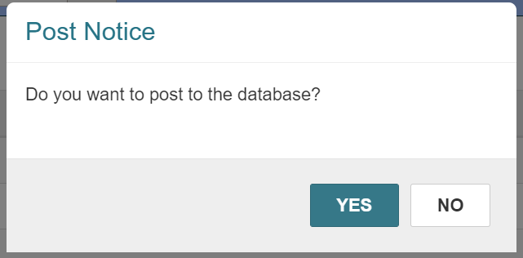

Leap will keep the latest file run for up to 24 hours after it has been generated. NOTE: any newer run of the file will overwrite an older run even if 24 hours hasn’t passed. All files are cleared after 24 hours of running. To access these files, click on the Recent tab of the notices page.
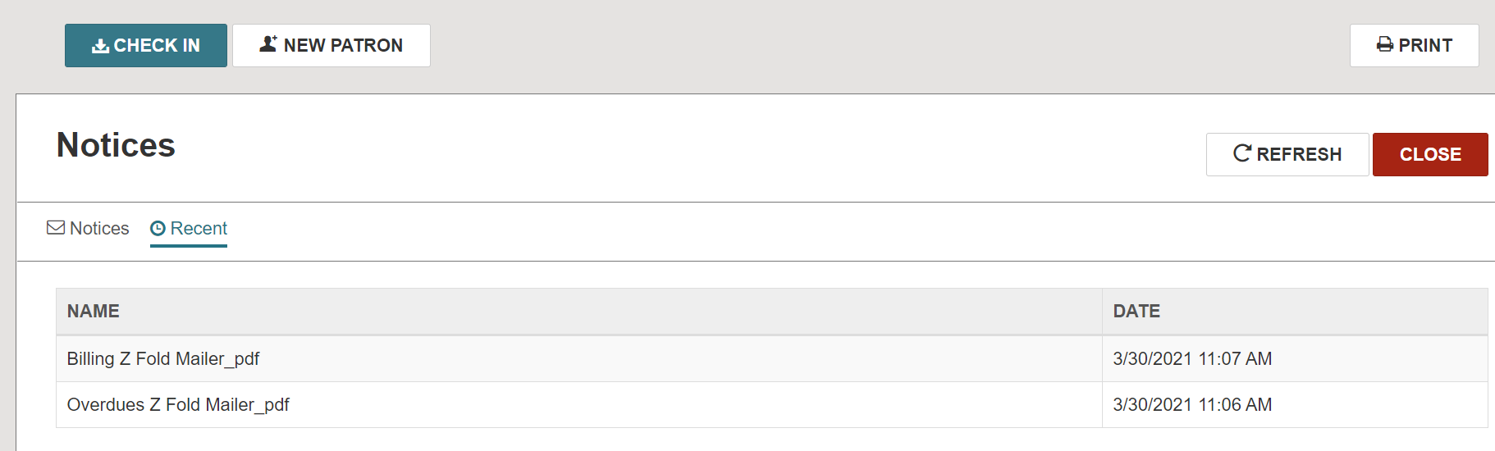

- Notices in the Client
In order to review print notices in the Client, on the menu bar select Utilities | Reports and Notices.
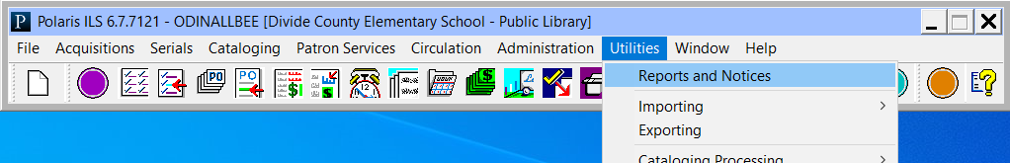

Select the Notices Folder
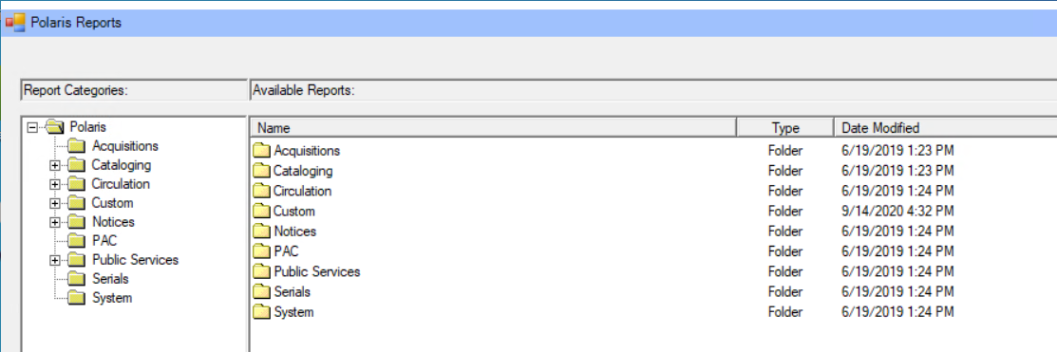

Select the Overdues Folder
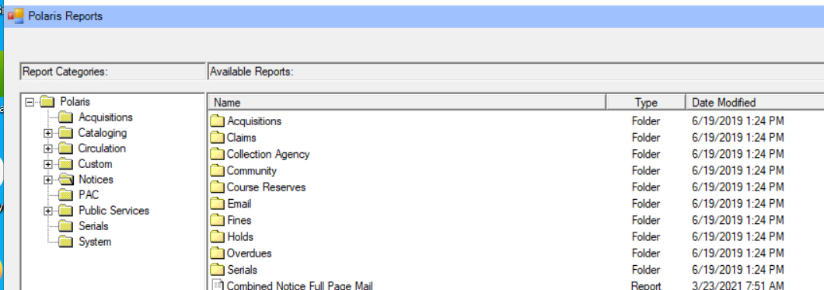

Different notice format types are displayed. It is always recommended to select the ‘Z Fold Mailer’ option for notices. Note: there is a separate file for Billing vs. Overdues.
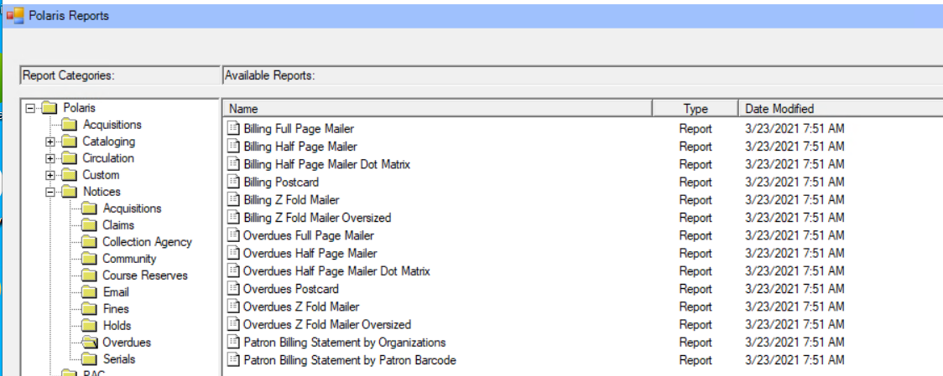

After Selecting either Billing or Overdues Z Fold Mailer, you are prompted to select your library from the list of organizations. Once your library is selected, click Submit.
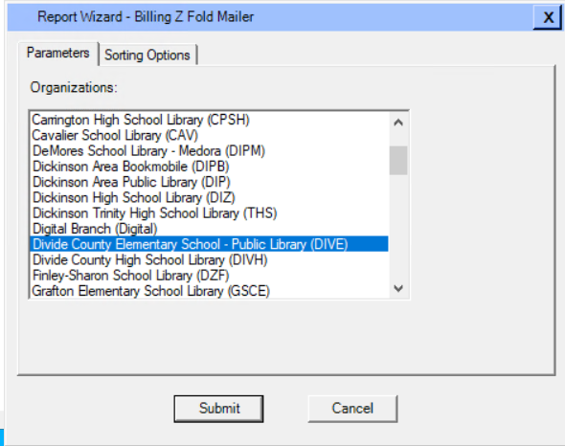

A PDF appears that contains the notices. From here, the notices can be reviewed and/or printed. Notification also appears asking if you wish to post to the database. By saying Yes to this prompt, you are indicating that Polaris should note in the patron record and the item record that a notice was sent for the material. You are also effectively clearing the notice(s) from the Notices folder. The overdue notices folders are dynamic, and as material become overdue (or are in line for a second or third reminder) a notice will be generated and put into this folder. If you post to the database, you’re removing the notice from the folder, indicating it’s already been sent/dealt with and it won’t appear the next time notices are generated. If material is returned before a notice is posted to the database, the notice is automatically removed from the overdue folder. If you never post to the databases, each time the overdue notice folder is opened, the same notices will appear, in addition to any new notifications since the last time the folder was opened.

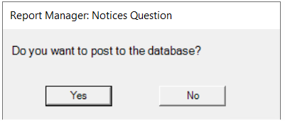

**NOTE: In the client there is no option to retrieve previously run files.

- Canned Reports in the Polaris Client
In order to run reports in the Client, on the menu bar select Utilities | Reports and Notices.
The reports are divided (primarily) by functional areas. NOTE: the custom folder contains reports that have been saved in the Simply Reports interface. They can be run via the client if you wish.

Within each folder there are applicable reports that can be run. Selected the desired report by double clicking on it.
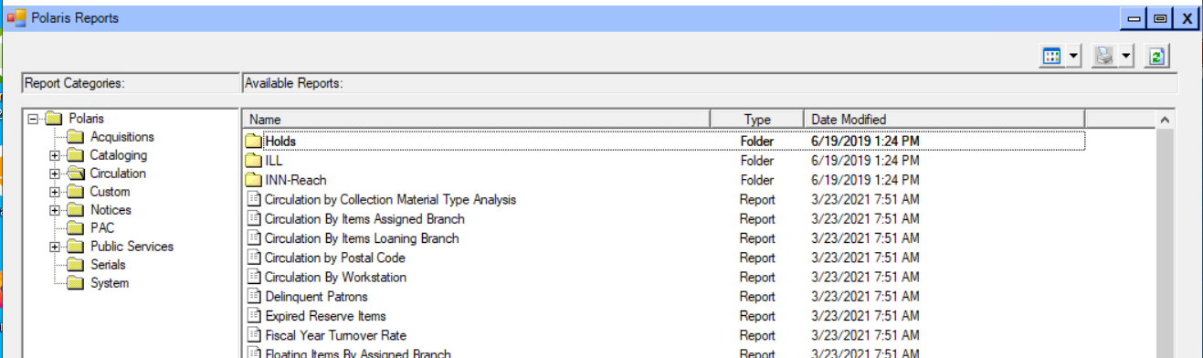

Depending on the report selected, a report workform requiring various information is presented. Typical fields required for running reports are the Organization (select your library), date range (especially when running statistical reports) and call number range (many times when running item reports). After filling out the fields presented, click Submit.

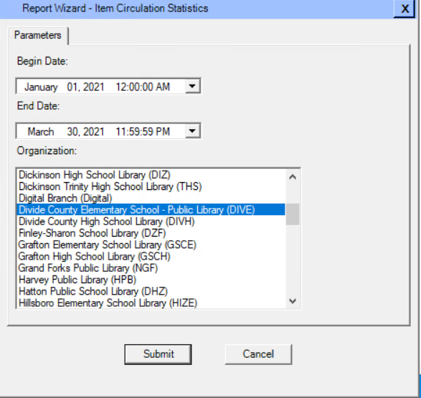

A PDF of the report is displayed. Working with the report output requires an extra layer of consideration, as we connect to the Client remotely, so our computers are not immediately recognized as the machine that is running the client. Tips for saving and printing reports are listed in the next section of this document.

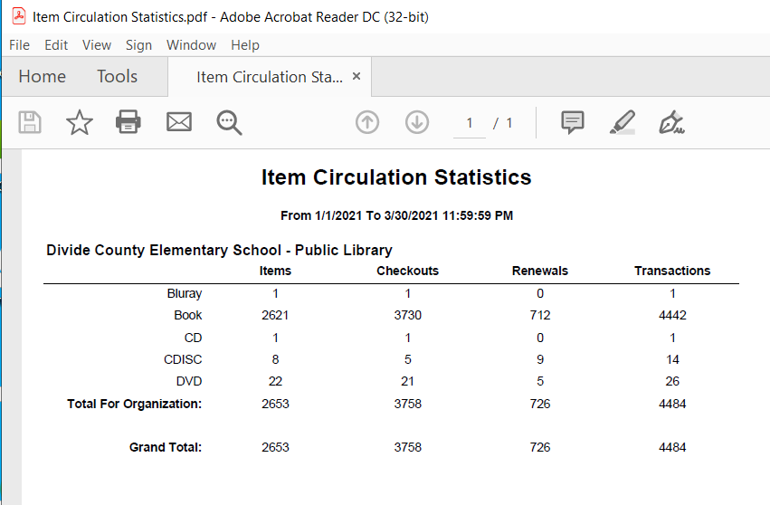

- Miscellaneous tips

- Saving the report.
The report can be saved to your computer by going to File | Save As
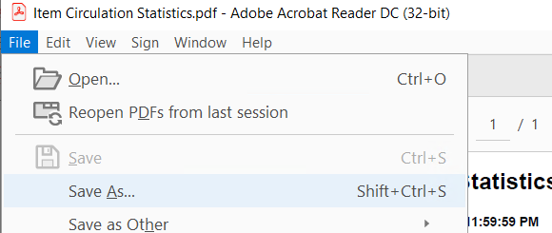
The Save As dialog box automatically defaults to the path for the machine running the remote app, not your computer. Use the left column options to navigate to the C: drive on your computer, where you can then save your file.
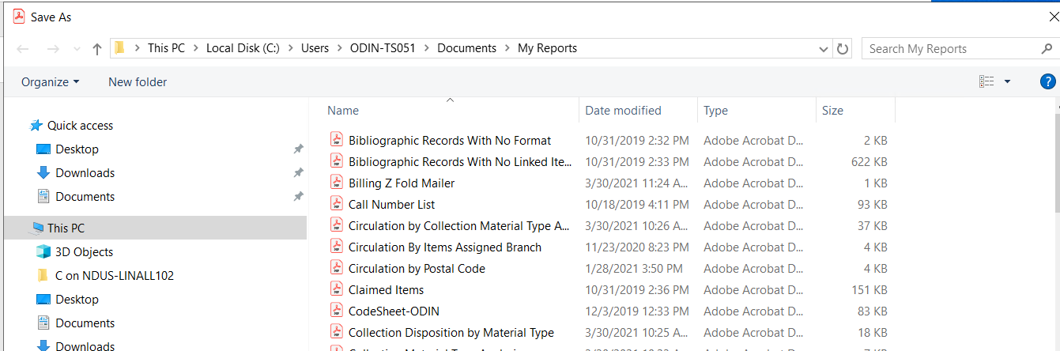
- Printing the report
The report can be printed from the client without being saved. In order to do so, you must installed something called a Screwdriver App so your printer will appear as an option when Print is selected from the PDF.

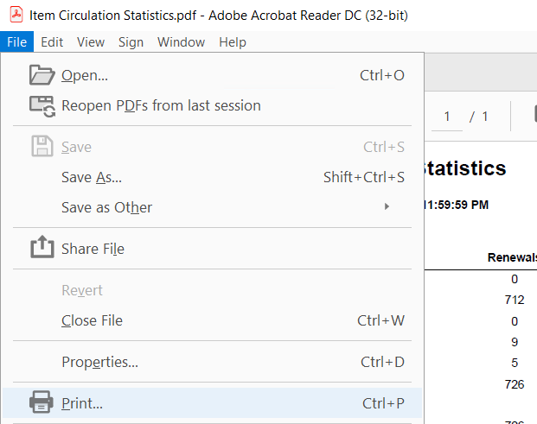
Instructions for installing the Screwdrivers App can be found on the ODIN website on the Polaris Remote App page (http://www.odin.nodak.edu/polaris/remote-app). You must be logged into the ODIN website to view this page. A link to the Screwdrivers download page as well as installation instructions can be found on this page.
- Help.
To see help for any of the client canned reports, go to Help | Polaris Topics.
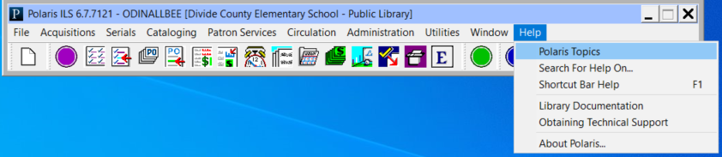

A new window will open. Go to the Index tab and type reports. In the left column, expand the reports section and you’ll see categories for different functional areas.
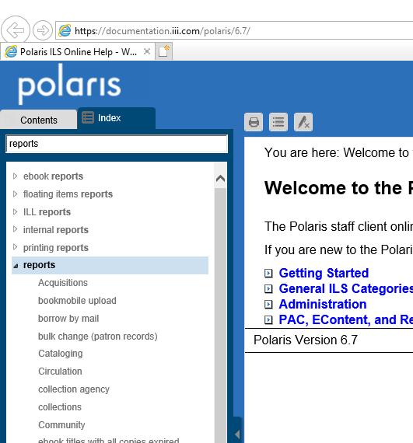

By clicking on one of the areas – such as Circulations – you’ll see a listing of all the Circulation reports, with a brief description of the reports.

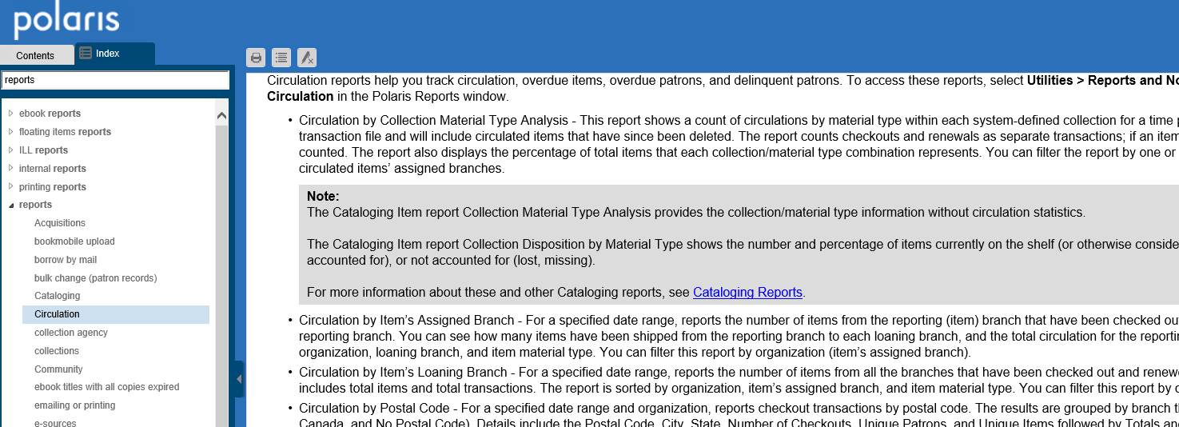

The Help entries can be particularly beneficial in determining what output to expect in various reports. For example, in the Item Statistics report there are categories that list checkouts, renewals and transactions, however the category column doesn’t have a heading. By going to Help, the category designations are list as Material Types (as opposed to collections or another breakdown).

- Scheduling.
Canned reports can be scheduled to run on a periodic basis, with the results emailed to the user. It is extremely important to note, though, that the reports cannot be scheduled with relative dates. If the report requires a date range, that date range is static, and cannot be entered as ‘previous month’ or ‘previous 30 days.’ For this reason, it is not beneficial to schedule the majority of canned reports. There are a few reports, though, that do not require a date range to run – in those cases, scheduling is an option.

