ODIN – POLARIS
LEAP OVERVIEW

The Polaris LEAP interface allows users to work with the library system via a web browser. All circulation and hold functionality is available, as well as several cataloging and serials functions. This document is intended as an outline of logging in and out of LEAP, an overview of the screen layout, and searching within the interface.
- Logging in and out of LEAP.
The url for the LEAP webapp in Production is https://polaris.odinlibrary.org/leapwebapp/ which will display a login page to the application. LEAP will work with all browsers, but Chrome and Firefox are preferred.
On the login page, enter username and password credentials, and press enter or click Sign In. When entering the username, preface it with the domain of ODIN\. For example: ODIN\LIBUSER.
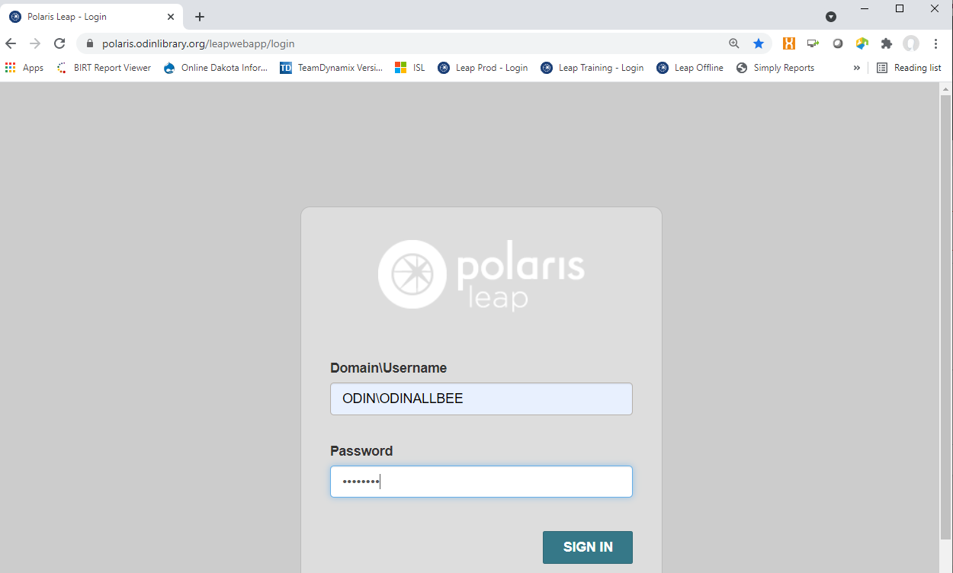

A secondary login screen displays. Based on your username, the Branch field should default to your library. If it does not or if you are part of a multi-branch library, use the drop-down menu to select your library from the list. In the Workstation field, use the drop-down menu to select your workstation ID from the menu. Press enter or click Continue.
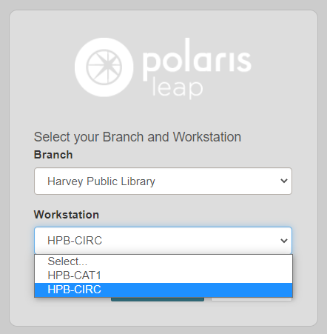

The system will display an indicator of what database is being accessed – either Production or Training. Click Continue to complete the login.
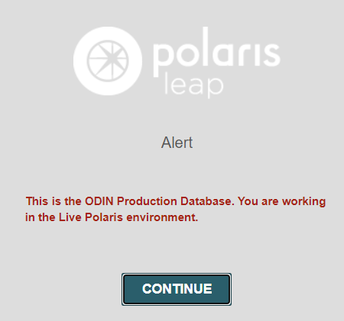

The LEAP interface is displayed.
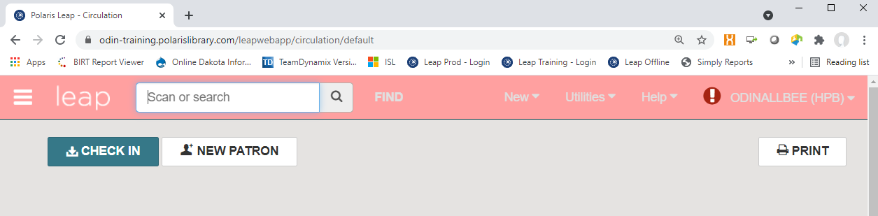

To log out of leap, use the drop-down menu in the upper right of the screen next to the username, and select Logout. The browser session can then be closed.
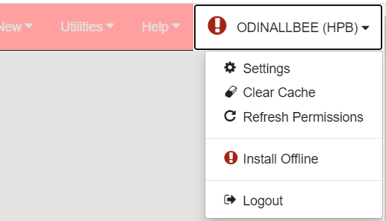

- LEAP Screen Layout
The upper left corner of the screen displays an icon commonly referred to as a ‘hamburger.’ Through this icon, you can gain quick access to any open records in Polaris using the Current tab, including an option to close all open records. Records used during the session that have been closed can be accessed using the Recent tab. System defaults allow for up to two records per type (bibliographic, item or patron record).
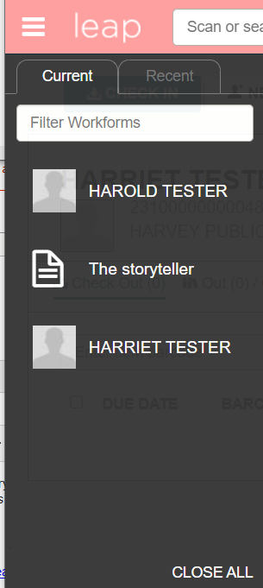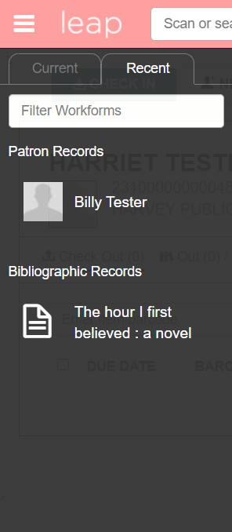
Next to the hamburger icon and branding of ‘leap’ is search functionality. The search box provides a quick search option for bibliographic and patron records. FIND takes the user to the search tool. Searching will be discussed in section 3 of this document.

There are two action buttons available – CHECK IN and NEW PATRON.
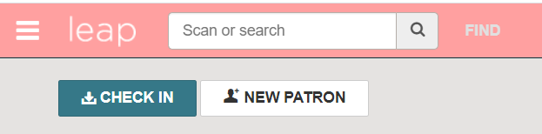

Clicking the CHECK IN button takes you to the check in screen.
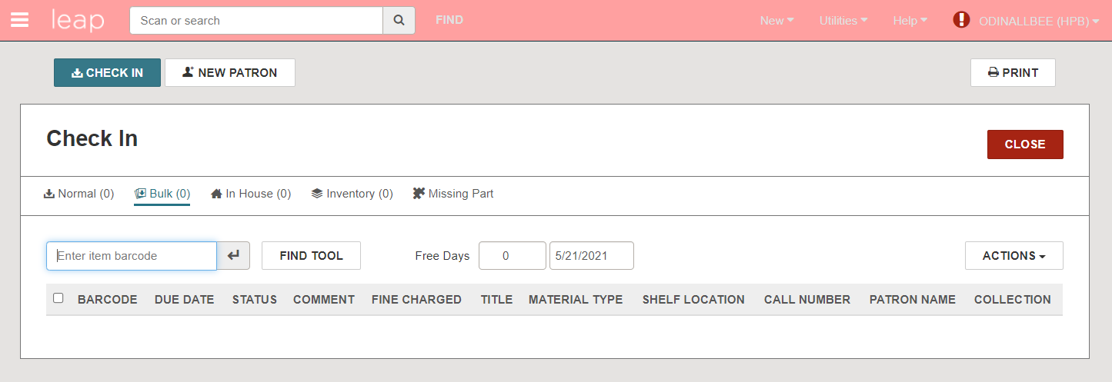

Clicking the NEW PATRON button takes you to the patron registration form.
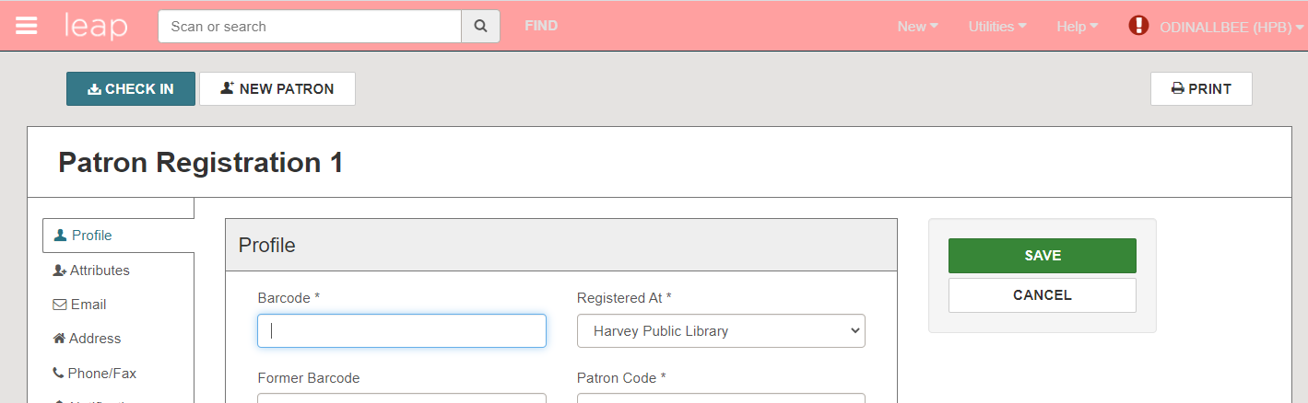
The ‘New’ drop-down menu allows for the creation of a new Patron Record or new Record Set. Functionality for both will be addressed in separate documents.
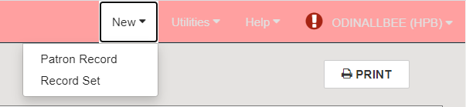

The Utilities drop down menu allows as a gateway for several different tasks including those related to holds, serials, printing and record sets. Functionality for each will be addressed in separate documents.
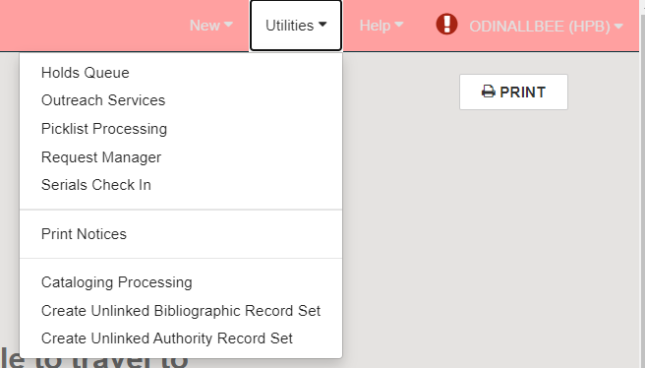

The Help drop down provides links to online help, keyboard shortcuts, and information about the version of Leap.
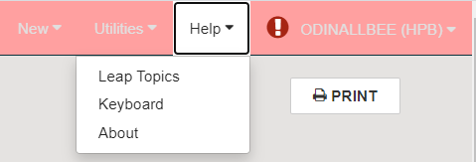

Clicking Leap Topics from the Help drop down opens online help for the Leap interface. You can view a table of contents, index, or search for a specific help topic.
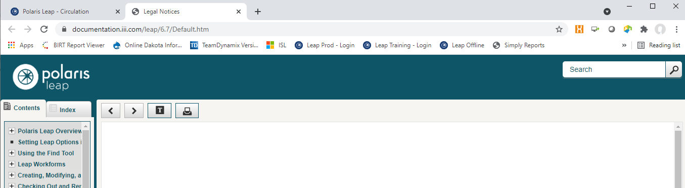
The drop-down menu associated with the logged in user contains options for settings, clearing cache, refreshing permissions, installing the offline option and logging out.
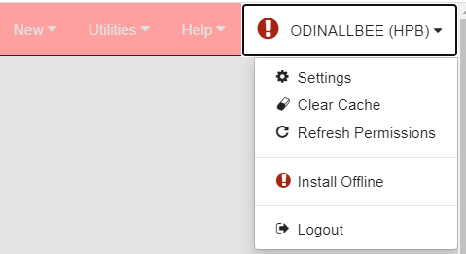

The settings option allows you to configure how Leap displays and acts when logged into as this user. The settings are divided into three sections – Print Options, Special Loan Options and Workform User Defaults. These settings will be discussed with the functionality they pertain to.
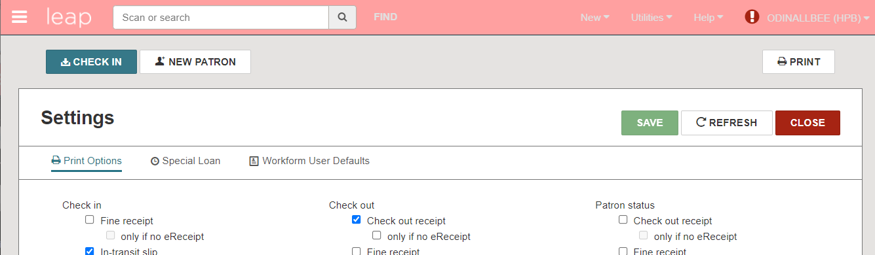

- Searching
Next to the hamburger icon and branding of ‘leap’ is search functionality. The search box provides a quick search option for bibliographic and patron records. The FIND button opens the Leap find tool which allows for additional search options.

Enter search terms in the quick search box for retrieval of patron or bib records. The system will offer suggestions to auto-complete the search looking for options for both patron and bibliographic records. The default searches being used are a keyword phrase search for both patrons and bibliographic records. This default in the quick-search box cannot be changed.
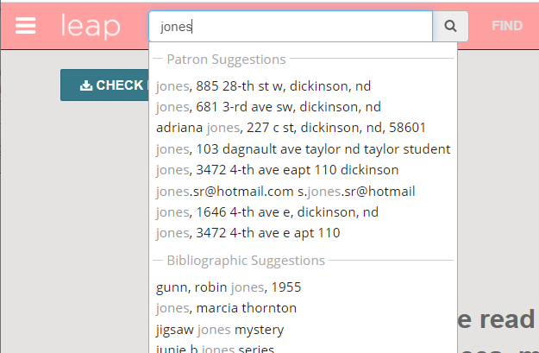

If your search retrieved results for both patron and bibliographic records, you will be prompted to select which set you wish to view.
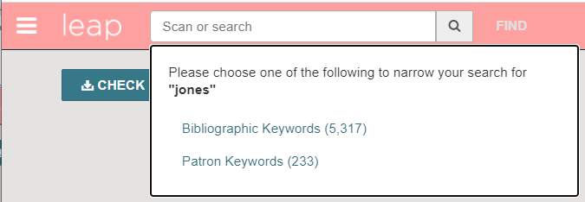
Once you select which set you wish to view, you are dropped into the find tool where you see a list of results. **NOTE: if you retrieve one result (such as in the case of a barcode search) you are immediately taken to the record, and the find toolbox is not displayed.
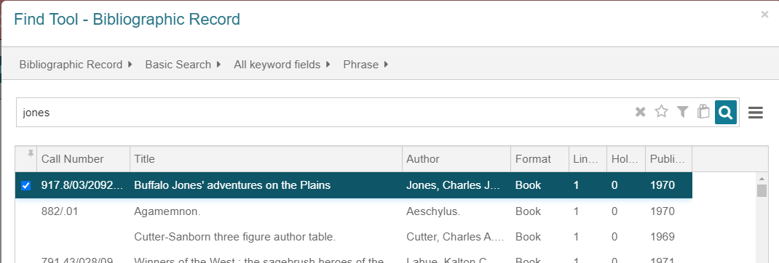

Alternatively, you can click on ‘Find’ and conduct your search via the Find Tool instead of beginning with the quick search box.

The find tool allows for searching of several different types of records – bibliographic, item, and patron to name a few.
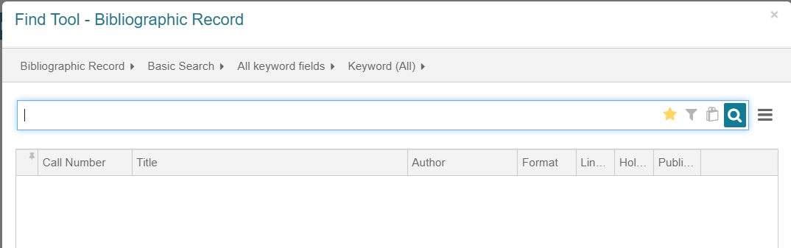

To select which type of search to conduct, click on the words in the search path at the top of the box. Depending on which type of record is selected, the other search path terms will change.
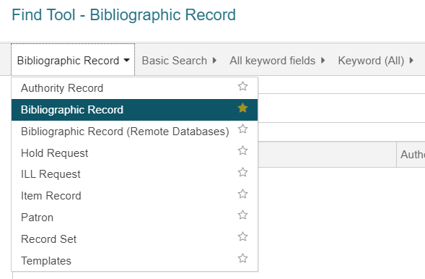

NOTE: each record type is followed by a star. The record type next to the star in yellow is the default search type presented when the Find button is clicked. Click the star next to any of record types to make that the type of search defaulted to when Find is clicked. You’ll be asked to confirm the change to the default search.
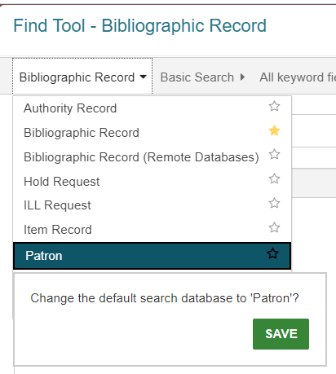

Once the type of search is selected, other terms in the search path can be selected in the same manner – click the search term – such as Name (Last, First Middle) – and you’ll see a menu of search filters that can be used.
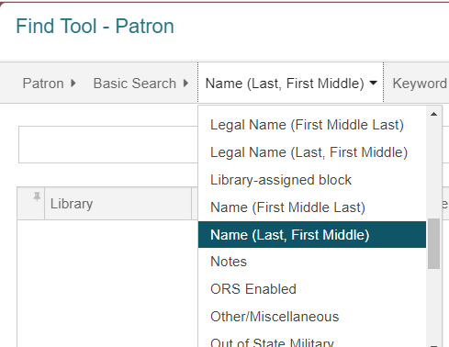

Tip: a default search string can be set up for each search type. After determining which defaults you’d like to use for a record type, click on the star icon at the end of the search box. This turns the star gold and saves the search settings associated with the record type, and any time that record type is selected in the search box, the default settings will display.
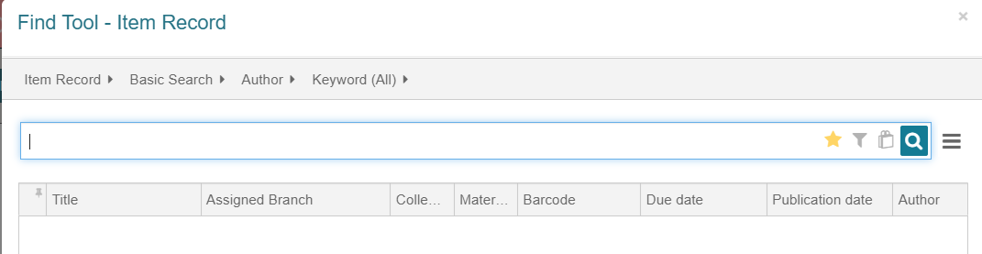

Enter search terms into the search box. As you begin typing your terms, the system will offer autofill suggestions. Select a suggestion, or press enter/click the search button once you’ve typed your terms.
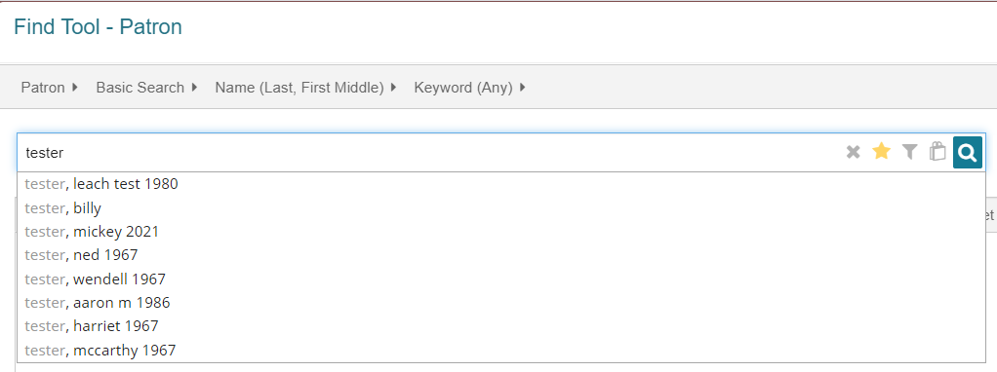
In the results list, double click on the desired entry, or highlight it and click OPEN to go to the record.
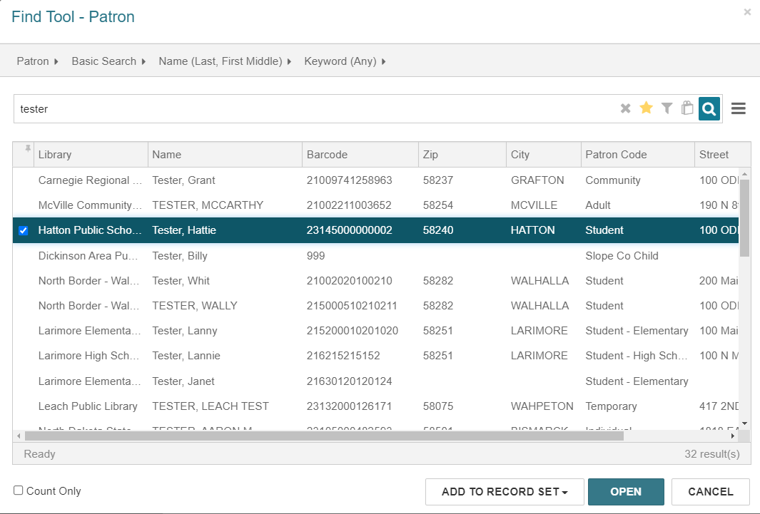

The filter can be used to add limiters to the search.
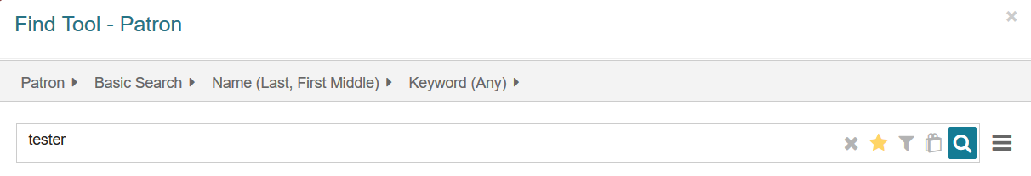
When the filter button is clicked, you’re presented with the option to add conditions to the search.
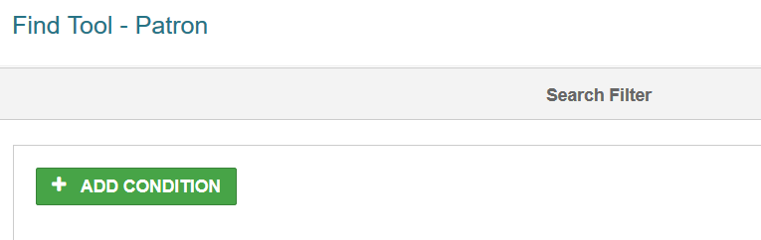

After clicking ADD CONDITION, a drop-down list of potential options can be accessed.
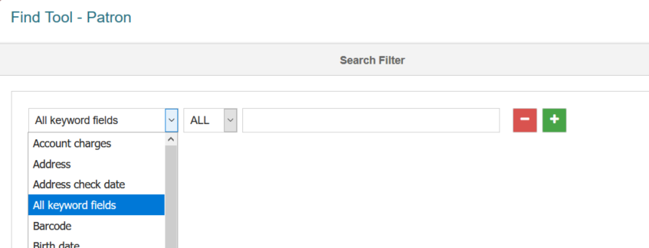
Depending on the condition selected, you will be presented with options that match the condition, or a free-text box where you can type the limiter. In this example, the Patron’s Registered Library was selected as a condition, and a list of libraries is presented to select from. After entering or selecting the limiting text, click the green plus button to add another condition, or click Apply at the bottom of the screen.
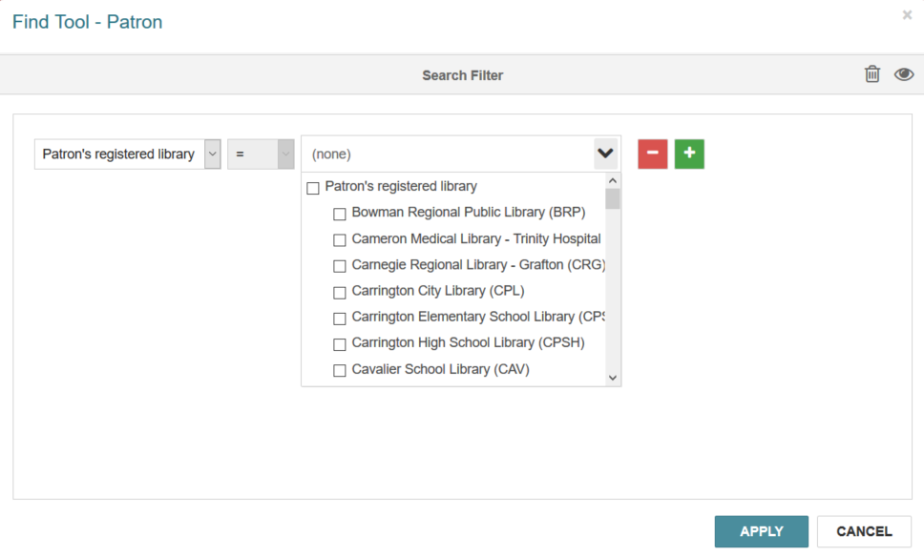
The condition selected is applied to the search, and will remain in place for further searches, but only until the search box is closed. Note, the filter button is green when there are conditions in place.
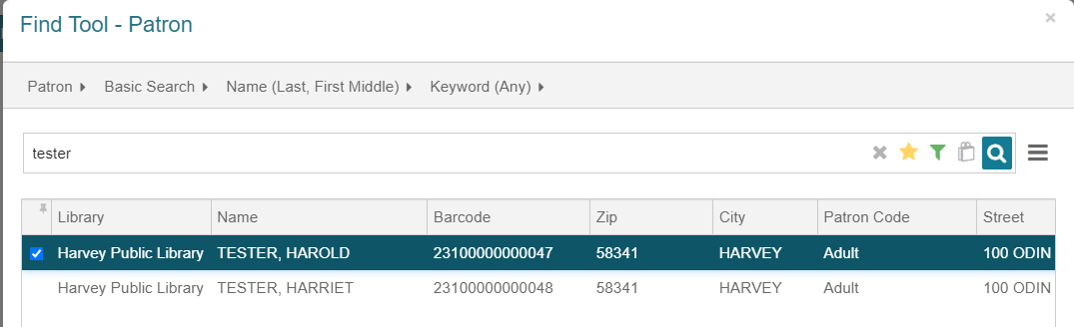
Lastly, at the far right of the search screen is a hamburger button. When clicked, there are options to set column settings, go to the search filter discussed above, or set record set options (which will be discussed in another document).
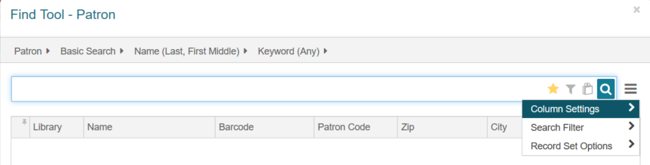
The column settings allow you to determine how the results screen entries will display and is sensitive to which type of record is being searched. Because my Find Tool was set to Patron, we see options for displaying columns when retrieving patron records.
In the left column, the display fields can be checked or unchecked to display. Additionally, when highlighting a display field, the MOVE UP / MOVE DOWN buttons can be used to determine what position the element should be displayed in the list. The right side of the screen contains additional information about the highlighted element on the left. In the example, Barcode is highlight on the left. On the right side of the screen, we see it’s in display position #3, the name of the field, if it is visible, and the width of the column.
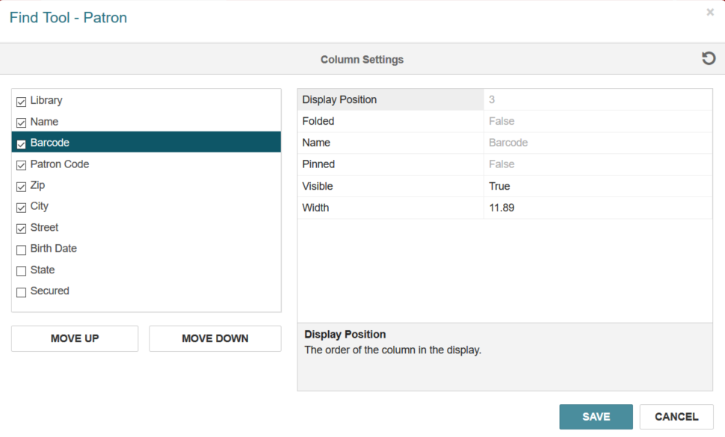
**TIP: it may be beneficial to put the Library first (or toward the front) in the display. Because all databases (patron, bibliographic, item, etc.) are much more integrated in Polaris, having the library name prominent in the results list may make it easier to select the records pertinent to your library.

