ODIN – POLARIS
Simply Reports – Creating a Shelf List

Via the Simply Reports interface, Polaris can be used to create a shelf list report of materials in a collection that can be used as a basis of comparison to what is on the shelf. Alternatively, users may wish to use the inventory functionality in Polaris. Instructions for utilizing the inventory functionality is covered in another document.
To create a shelf list report, first log into the Simply Reports interface at https://polaris.odinlibrary.org/simplyreports . Leap credentials should be used to access Simply Reports. It is recommended to include the domain (ODIN\) preceding the user name.

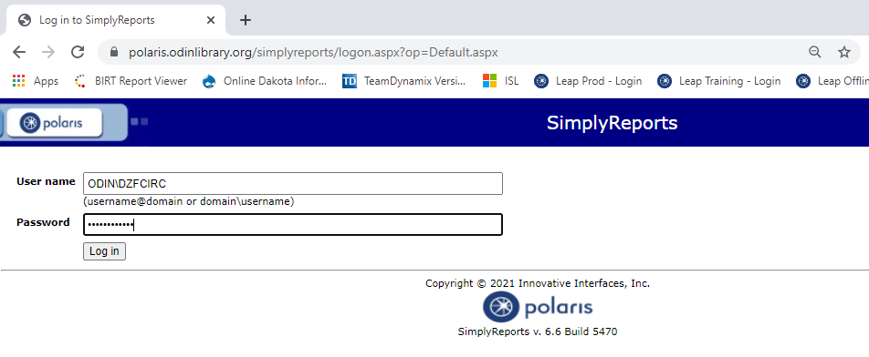

To create a shelf list report, select the Items | Item List Reports from the top menu. The screen can be broken into three sections – 1. the output section where you select the fields to include on the report, 2. the settings section where the defaults can typically be left as is, and 3. the filters section where you select the criteria for the items that should appear on the report.
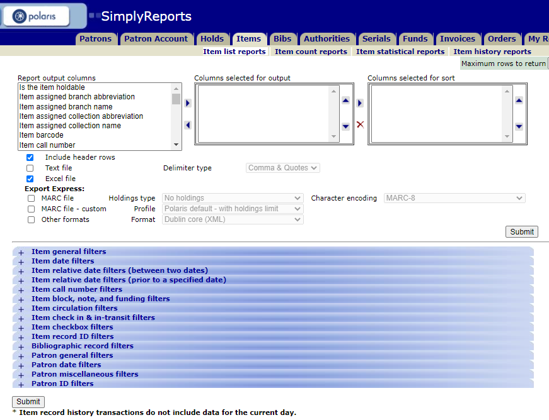
This Photo by Unknown Author is licensed under CC BY-SA
This Photo by Unknown Author is licensed under CC BY-SA
This Photo by Unknown Author is licensed under CC BY-SA

- In the output section, select the information that should appear on the shelf list report. Highlight the output column in the first section and move it to the second section using the right arrow. Common output columns for this report include the item barcode, item call number, item assigned collection, item circ status, MARC author and MARC title. Feel free to include any additional columns that you’d like to see on the report.
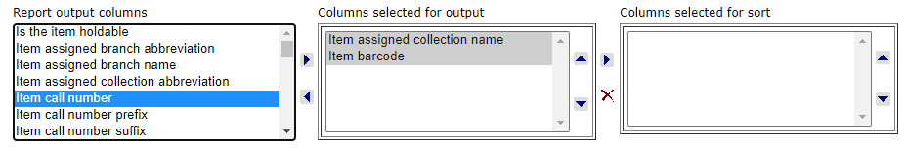
In column 2, you can rearrange the order of the columns using the up and down arrows. Additionally, you can select a column in which to sort the report by highlighting it in the second column and using the arrow to move it to the third column, column selected for sort.
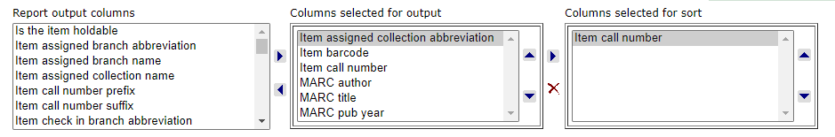
- The settings section typically should be left at the defaults. There is opportunity to create special formats for exporting, but these are not usually necessary for most reports. **NOTE: there is a submit button in the section (as well as at the bottom of the screen) when you’re ready to submit the parameters for your report.
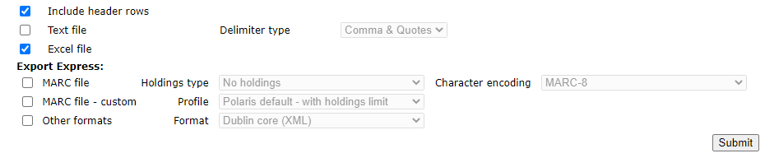
- Lastly, the filters section allows you to select the criteria for the items that will appear on the report. The following filters ALL LOCATED IN THE ITEM GENERAL FILTERS SECTION should be used for a shelf list report:
- In the Item General Filters section, check the box next to Library quick pick and highlight your library from the list.
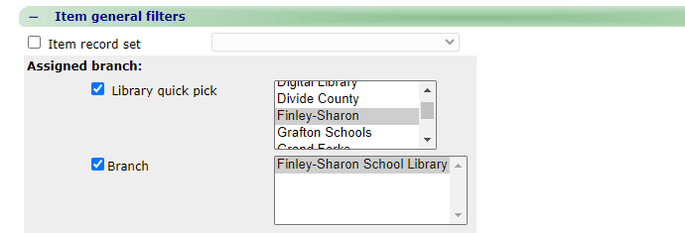
If you are part of a multiple branch library, also highlight your specific library in the branch section. By default, all branches will be highlighted:
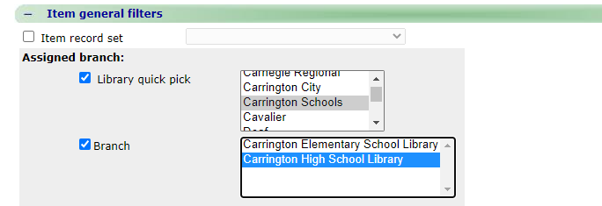
- Check the box next to Collection and highlight the collections in the list.
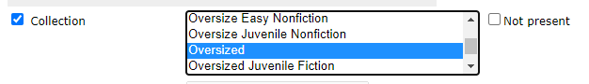

- Check the box next to Record status and highlight Final in the list.
Click Submit from either the bottom of the settings section or the bottom of the filters section.

Results open in a new tab in your browser. Up to 1000 records are listed.
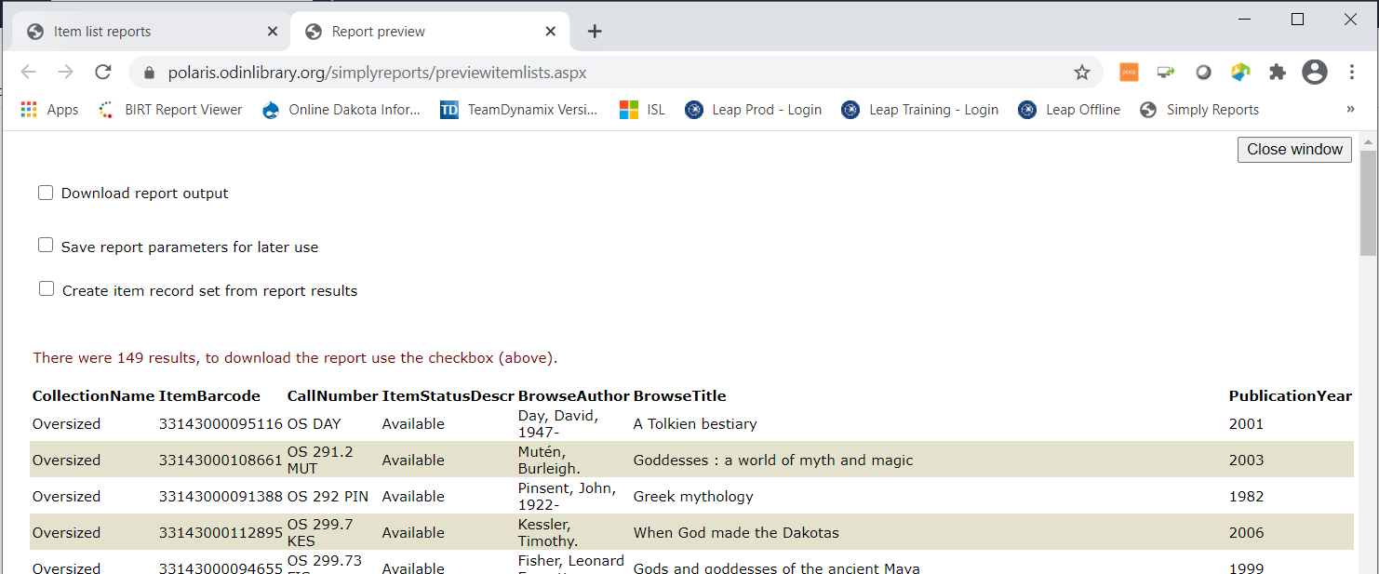

The results can be downloaded into a file in order to be saved or printed. At the top of the screen, click on the box next to Download report output. A download icon will appear. Click on the download icon to download the report.
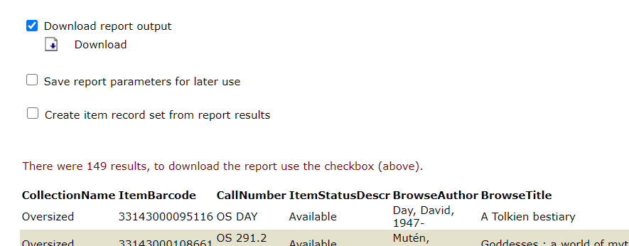

Depending on your browser, you may see the file appear in the lower tray of the window

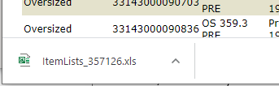

When you click on the file, you will likely be prompted with a warning that the file extension is different than Excel. Click yes to continue.
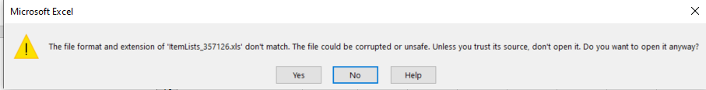

The file opens in Excel. Here you can use normal Excel tools to alter your display, such as widening columns or changing the barcode field to a number format.
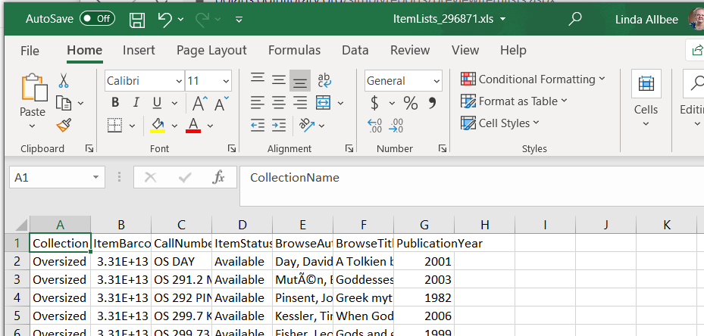

Lastly, if you wish to save the file, note that Windows will likely default the saved file to a txt file. You’ll want to use the Save as type dropdown to select Excel.

