ODIN Work Day 2021 – Electronic Portfolios Clean Up
What we are going to do here is collect a group of electronic portfolios, create a local electronic collection, and add our portfolios to it. Then we are going to link it to the community zone.
- Find the electronic portfolios by keyword searching the URL, and “is standalone” equals Yes.
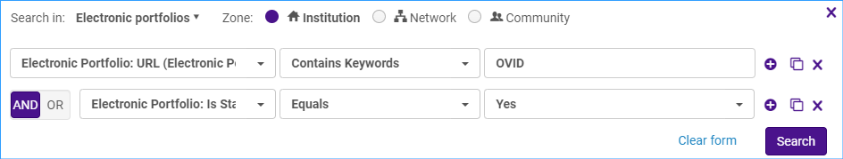
Save the portfolios as a set by clicking Save Query.
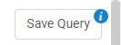
Give the set a name and click Save.
- Next, we are going to create a local electronic collection. Click on Resources > Add Local Electronic Collection
Give the local electronic collection a name, select the collection type and service type.
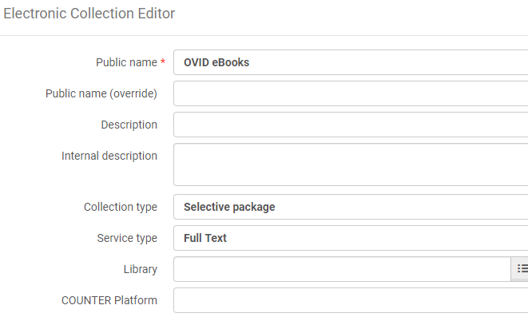
Save and continue.
The electronic service editor page comes up. Make sure the service activation status is set to available.
Click on the Linking tab. Make sure Proxy enabled is set to yes, and select the proxy.
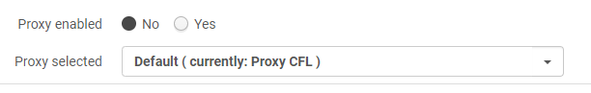
Click on the Portfolios tab. Click on the Add link and select Add from Set.
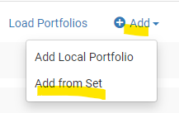
Select the set of portfolios and click Submit.
You will see the portfolios have been added to the collection:
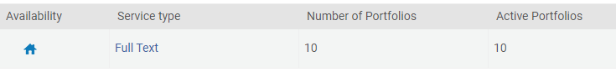
Click Save to save the service and click save again to save the electronic collection.
Here is our new local electronic collection:
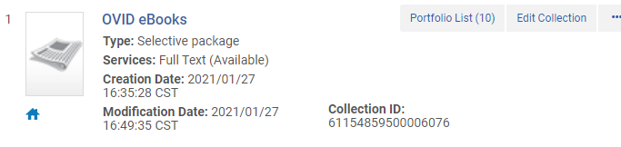
- Next run a job on the set of portfolios to remove the proxy information from the URLS.
Click Admin > Run a Job.
Select “Change electronic portfolio information.” Click Next.
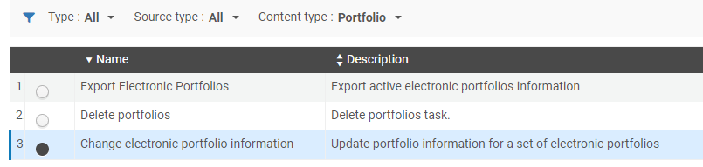
Select your set of portfolios- you can use the same one you used to add portfolios to the collection. Click Next.
Find the line: Delete or replace url’s prefix, and type in the proxy information you want to remove in the box. Leave the With box blank. Click Next.
On the next screen you can review your job settings. Click Submit.
To verify your changes, you can find your electronic collection:
Click on the Portfolio list and click Edit Portfolio to see if the proxy information has been removed. This is what you want because the proxy is set up at the service level in the collection.
- Optional link the collection to the Community Zone.
Click the row action menu and select “Link to community.”
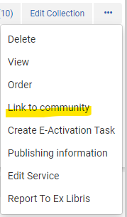
Under the Community information section, search for the electronic collection name of the collection you want to link to.
When you find the collection, click on it and it is inserted into the field along with the Type and interface name.
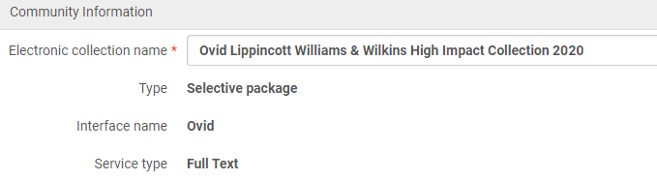
The next section provides an option to use community zone records for our portfolios. We will say yes for this example.
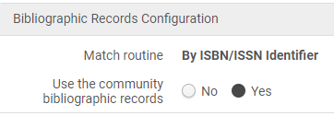
Click Link. You will receive a confirmation warning reminding you of the actions that will happen. Click Confirm. This starts a job to link the collection and portfolios to the CZ.
Now the collection and its portfolios are linked to the CZ.
