Local Electronic Collections and Setting up Proxy Information

- Create a Local Electronic Collection.
  - Create a local electronic collection. Resources > Add Local Electronic Collection.
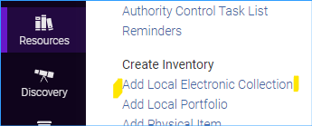
  - Give the local electronic collection a name and set the collection type and service type. Click Save and continue.
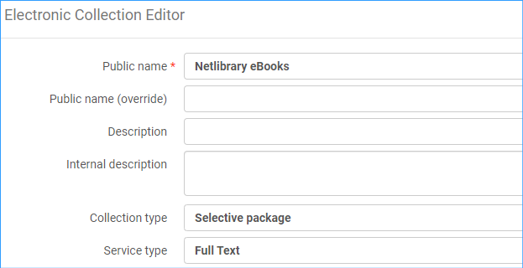
  - Change service activation to Available.
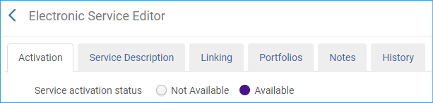
  - Click the next tab Service Description. It should say Full Text.
  - Click the Linking tab. Fill this tab in according to your collection. If the links must be proxied as for Netlibrary you would put that information here: Proxy enabled: Yes and Select your proxy from the drop-down box.
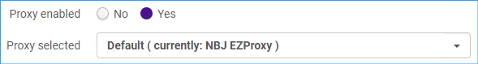
  - Click Save and Save again.
  - Note: if you missed setting up the service when you created a local electronic collection, you can get to it easily by searching for the collection and using the row action menu:
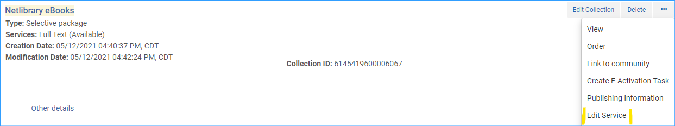
As above, the proxy information is under the linking tab. Proxy information should be stored in the service, not at the portfolio level.
- Create a set of portfolios to add to the local electronic collection.
  - Search your institution for Electronic portfolios | Electronic Portfolio: URL |Contains keywords | part of the url you are searching for AND then add the line Is Standalone | Equals | Yes. *It is very important to include the line “Is Standalone Equals Yes” because you do not want to take actions on portfolios that are already set up in another collection.
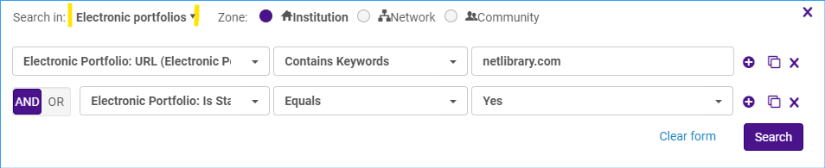
  - Save your query as a set.
  - Give your set of portfolios a name and save it.
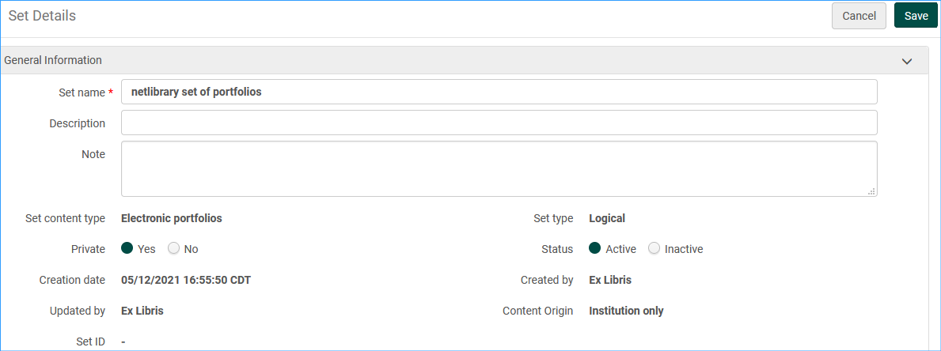
- Add the set of portfolios to the local electronic collection.
  - Search for your electronic collection. For example, Electronic collection | Electronic collection name| Netlibrary
  - Click the row action menu for the electronic collection and click Edit Service.
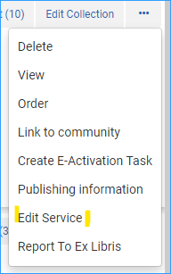
  - Click on the Portfolios tab. Then click +Add and Add from Set.
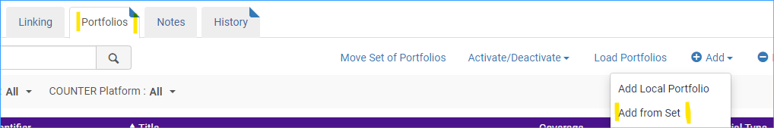
  - Select the set of portfolios from the list and click Submit.
  - You will receive a message asking you to confirm this process, click Confirm.
- Editing portfolio URLs to remove proxy information.
  - Create a set of portfolios to update. Conduct a search for all the portfolios in a collection and save the query. For example:
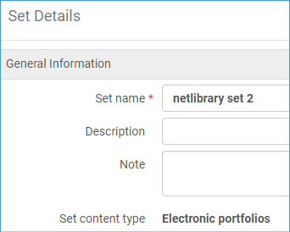
  - Admin > Run a Job.
  - We have set up our library’s proxy information in the Service of the electronic collection. So, we will delete the proxy information from the URLs. Select the job “Change electronic portfolio information.” Click Next.
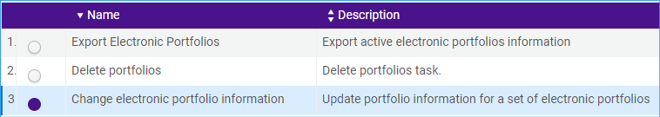
  - Select the set of portfolios:
  - Click Next. Check the line “Delete or replace url’s prefix” type in the proxy prefix in the box and leave the “with” box blank. Click Next.
  - You will see a confirmation page showing what will be done. Click Submit. You will see a confirmation message. Click Confirm. The job runs.
  - View the portfolios in Discovery and check that they work.

