CDI – Setting CDI Attributes

If the setting you want to change is coming from an electronic collection in the network zone, please submit an ODIN Help Desk ticket.

CDI – How does it work?
- When you activate an electronic collection in Alma, it is automatically activated in CDI
- There is a publishing mechanism that published the library's electronic holdings to CDI
Active portfolios include identifiers and coverage which CDI will match to relevant content and marks that content as "Available Online"
Active collections that are "database" type includes collection CDI ID (DBID) which CDI will match all the database content in CDI as "Available Online"
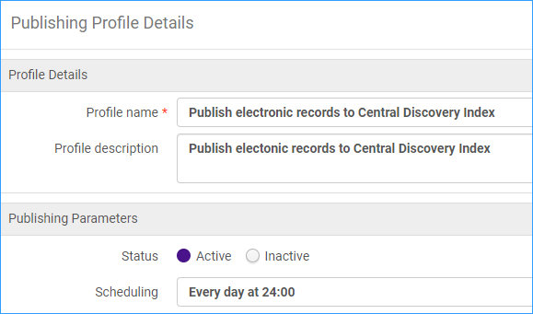

By publishing of all activated resources to CDI keeps CDI up to date. It "knows" what should be available online in Primo VE.

- When searching the Central Discovery Index, often labeled as "Articles" in Primo VE, the search defaults to full text only:
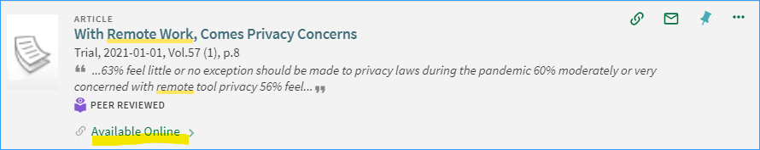
- To see results for both full-text and citations that do not have full-text, click "Expand My Results" check box:
Note: Publishing to CDI includes date coverage as well as embargoes.

CDI Attributes
There are four CDI attributes:
- CDI Search activation status
- Do not show as Full Text available in CDI even if active in Alma
- CDI Only Full Text Activation
- We subscribe to only some titles in this collection
*CDI attributes can be set up differently by institution by using “Available For” groups

- CDI Search activation- this is done automatically when you activate an electronic collection in Alma.
Once an electronic collection is activated in Alma, information from its associated portfolios is published to CDI and they appear as "Available Online" in Primo VE.
- Do not show as Full Text available in CDI even if active in Alma

For use when the collection is active in Alma, and you do not want content from CDI marked as "Available Online."
This option is available in the CDI tab of the electronic collection. This option is available for local collections, not just community zone collections. Your content will be available in Primo, but it will not be marked as available online in CDI.

- CDI Only Full Text Activation

For use when your collection is inactive in Alma, you have the option to mark it as "Available Online" only in CDI. This is only for collections that are defined as "Full text linking in CDI: Link in record.”
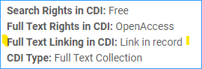

On the CDI tab of the electronic collection:
*Note: This option is only available for collections that have a link in the record, this way the collection in CDI has direct access to the full text. When you have an inactive collection in Alma with linking through the link resolver the result would be dead links from CDI.
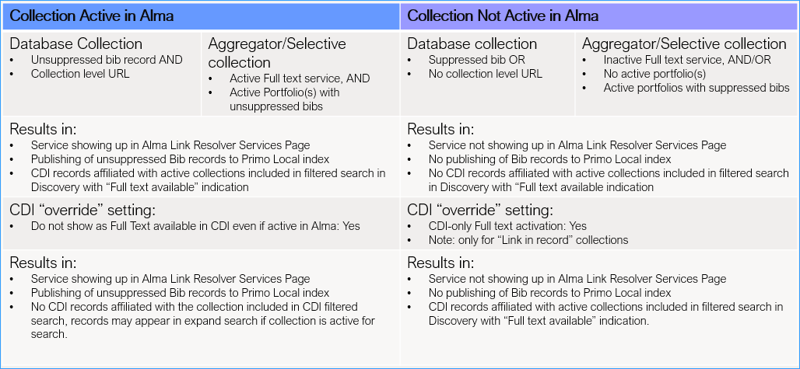
Figure 1 Shows results of using attributes 2 and 3

- We subscribe to only some titles in this collection = No
- This setting is available for any collection that is available for CDI search activation. It is not available for database collections because they do not have portfolios.
- If set to Yes, CDI will match its content with the active portfolios
- If set to No, CDI will set all content of the collection to “full text available” without matching to individual portfolios.
- For Link in Record type of collections where the institution subscribes to the whole collection, use the “No” setting. This will ensure the whole collection will be flagged as full text available.
- For Link Resolver type of collections, use the “Yes” setting, especially in case there are partial activations in Alma, where not all portfolios are active. Setting this option to “No” will increase the chance of having linking problems in CDI.
When you would change this setting: You have the option to mark the entire collection content as "Available Online" in CDI regardless of whether the library has access to only a subset of the collection. This setting would be used if you believe that CDI has access to more content than your electronic collection has. This is only for collections that are defined as "Link in record."

Ex Libris has set the default for Link in Record type collections to “No” and Link Resolver type collections to “Yes” so in general you should not have to change this setting.
Best Practice: ODIN does not recommend changing this setting unless your library subscribes to just part of the collection, and it is Link in record, it is okay to change to “Yes.”

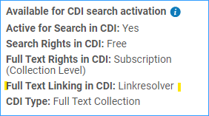
Figure 2 Collection uses Link Resolver
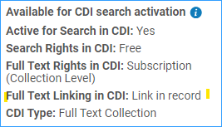
Figure 3 Collection uses Link in Record
Links in Merged CDI Records
When content in CDI is available from a couple of collections that have different linking methods, CDI will merge the records and prefer the "link in record" over the link resolver (unless it is open access).
- Linking via link resolver (OpenURL linking) provides the library with various configuration options for the display of services – display logic rules, sort order, direct linking. Where possible, Primo will add a platform-specific document ID to the Open URL to allow the link resolver to link to full text instead of using metadata to create the link. Collections that use this method include primary publishers and collections that contain mainstream material such as articles and books that are available on more than one platform.
- Link in record – will show a single link to the full text. This method of linking is used by collections that contain material unique to that platform or the link is difficult or impossible to create using the link resolver.
"Direct Links" - the term direct link is used to indicate that a document ID of the original platform is used to link to the full text, rather than a link created from metadata. When both types of links are available for a resource, Alma gives preference to direct links because they are more accurate. (This setting is configurable here: Configuration Menu > Fulfillment > Discovery Interface Display Logic > Online Services Order)

Link prioritization in the merged record- it you have access to several platforms that provide access to the same material the records are merged, and prioritization rules are applied to determine which link is displayed. (Note: merged records can be created from records in a collection that you may not subscribe to.)
1) All records in a merged group are coming from collections using the link resolver. In this case the priority and order of links is set by the library using the configuration mentioned above.

2) All records in a merged group are coming from collections using the link in record. Typically link in record materials are unique to one collection, and therefore that link will be used. If there happen to be multiple links to several platforms, the system will give priority to collections with the most reliable link, which is a direct link.

3) One or more of the records in a merged group is coming from a collection using the link resolver and others are from collections using link in record.
- If the library does not have access to the collection using link in record, the merged record will use the link resolver.
- If the library does have access to the collection using the link in record, the merged record will use the link in record. However, if the link in record collection is Open Access, then the OpenURL link will be given precedence.

Duplicate eBooks in CDI Results

Duplicates occur in a blended search scope ("Everything search") when bibliographic records are published to your local Primo VE and the full text portfolios for the same books are published to CDI.

CDI data and Alma data cannot be deduplicated with one another.

Options:
- Suppress the ebook records from being published to CDI
In the electronic collection, under the CDI tab, select Do not show as Full Text available in CDI even if active.
In this case, you have the electronic collection active in Alma and you do not want the available eBooks to show from CDI.
- The benefit of this is using your local bibliographic records.
- The disadvantage of this is this setting will also turn off access to book chapters and other book content. Note the resource types in the CDI tab:

- Suppress the bibliographic records to be published to your local Primo and then,
in the electronic collection, under the CDI tab, select CDI-only Full text activation

This method is only available for collections with "Link in record" in CDI.

Managing CDI attributes in the NZ with “Available For” settings

- Active for search in CDI for a specific Institution
The electronic collection is available as full text for the entire network, we want:
- CDI as full text for everyone
- “Available for search in CDI” (“Expand my Results”) only for a single library
This is set in the group settings part of the CDI tab. Prior to adding group settings it looks like this (CDI search activation not set.)
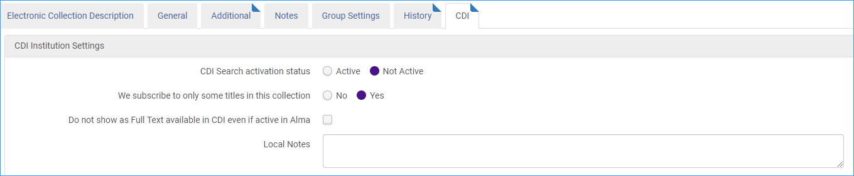
Group setting workform:
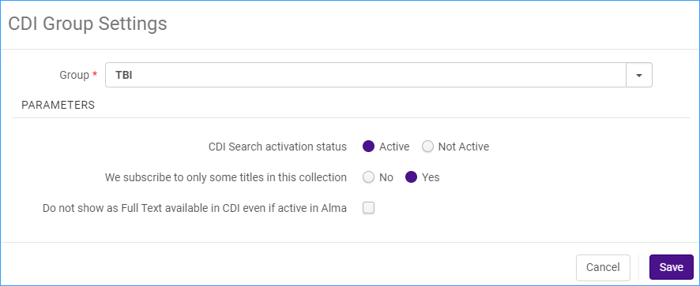
Group setting found at bottom of the screen:
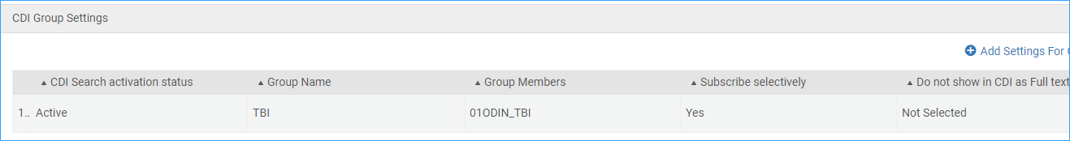
Save the collection.

Description of the CDI settings on the record:
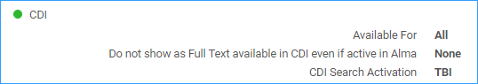
All institutions will be able to search for full text, but only TBI can expand the search for records without full text.

- Do not show as Full Text available in CDI even if active in Alma for a specific institution
The electronic collection is available for all institutions, we want:
- The full text from CDI not to appear for a single library
Note- This attribute, “Do not show as Full Text available in CDI even if active in Alma” and the Alma full text activation must be aligned either at the groups or for all. If you want to use this attribute for just one institution, then you must use group settings for the full text.
This collection is set up for all institutions for full text using the group settings:
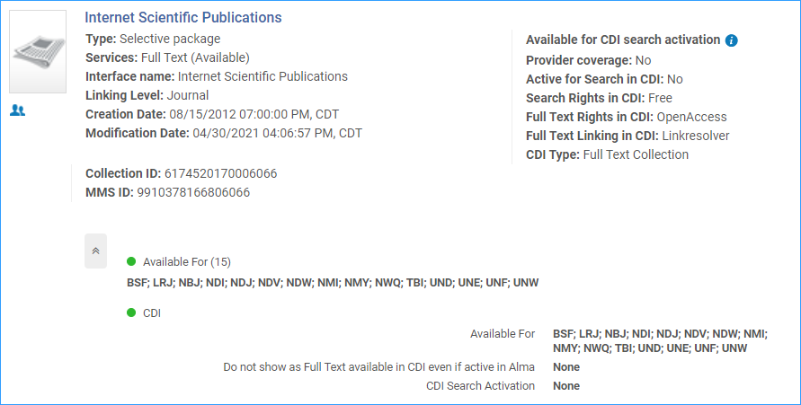
Now we go to the CDI tab to set up a separate group setting for “Do not show as Full Text available in CDI even if active in Alma” and not “Available for Search in CDI.”
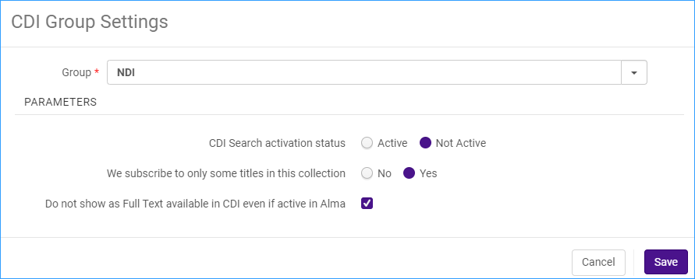

We have selected CDI Search Activation for UNE:
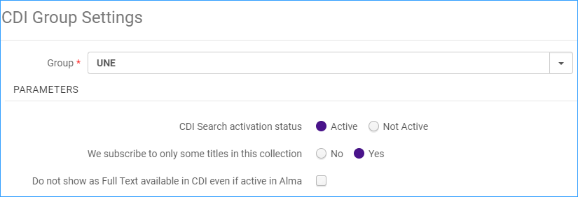

Here are the resulting group settings:

And here is what they look like summarized in the collection description:
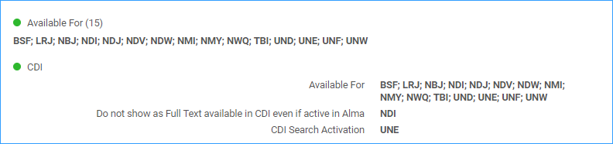
Full text is available for all 15, NDI will not get CDI full text, and UNE can do expanded search in Primo VE.

Also: a video demo of these settings: Troubleshooting Content and Activation Issues with Alma

Scenario: You subscribe to an electronic collection that has full text. You want to use the full text from CDI rather than Alma. The collection does not give you this option, why not?

