Alma Resource Management
Basic Cataloging

This document will discuss basic steps of cataloging material in Alma, including adding holdings and items.
Alma is divided into three silos - or three zones -- the community zone, the network zone and the institution zone. For resource management, the community zone is a repository of records that have been contributed to the alma community by a variety of vendors and other resources. The network zone can be likened to ODIN's union catalog -- it's a repository of records, that our consortia shares. When a library obtains an item, they 'hang' their holdings off this shared, network record. Lastly, the institution zone contains records unique to the library, that aren't shared among all ODIN Alma libraries, such as brief acquisitions records or reserve items. The institution zone also includes local extensions – or local fields – libraries wish to have reflected in Network Zone records. This will be described later in the document.
Typically, most all bibliographic records used will be contributed to the Network zone, and all libraries will be able to attach their holdings to the same bibliographic record. Material can be added to Alma using two different workflows:
- If after searching the network zone, no record exists that matches your material, catalog the record in OCLC as per usual. There is no need to export the record, simply update your holdings. Once a record is updated, OCLC will place the record in a special ODIN file. This file is loaded into Alma once a day, and the records are added to the Network Zone. Once the record is in the Network Zone, you can add your library holding(s) and item(s) to it. The file from OCLC is downloaded once a day, in the morning.
- If after searching the Network Zone a matching record is found, you may decide to add your library holding(s) and item(s) immediately. You will still need to update your holdings in OCLC, but there is no need to wait a day after updating holdings in OCLC. If you do wish to update in OCLC and wait the day, that is fine – it is your choice.

- Locating bibliographic record.

- Searching in the Network Zone, locate the bibliographic record that matches the material you are adding to your collection.
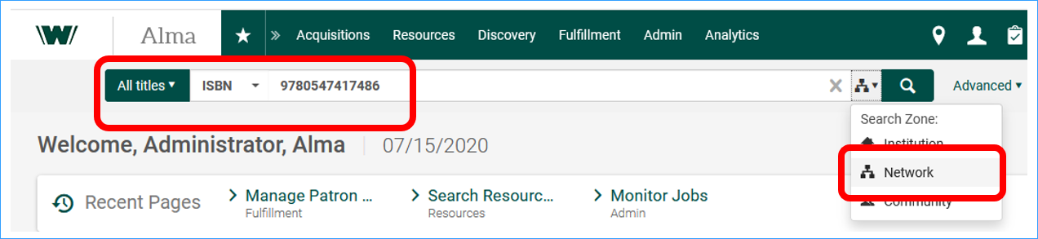
- Once you locate the record that matches the material you are adding to the catalog, you can edit the record to add any needed local fields. Click Edit Record to open the Metadata Editor.
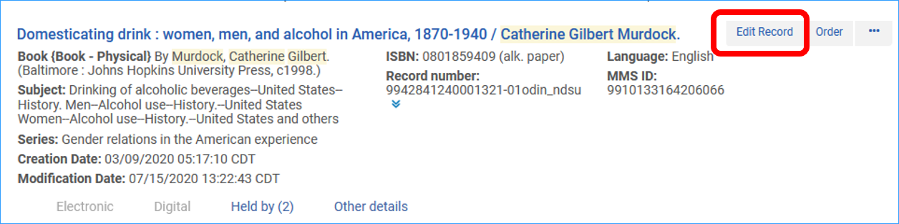
- The bibliographic record displays in the metadata editor. The Network Record is a record that is shared by all ODIN Alma libraries, and the fields cannot be edited. The exception, however, is you have the ability to add local extensions to the record. Local extensions are predesignated local fields that are unique to your institution’s view of the record. These extensions include various note fields, prices and others. A full list of fields considered as local extensions can be found on the ODIN website.
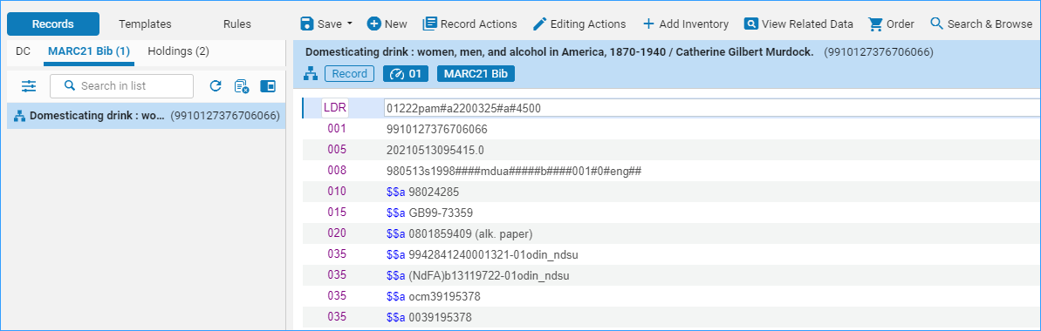
- To add a local extension to a record, click Editing Actions | Add Local Extension.
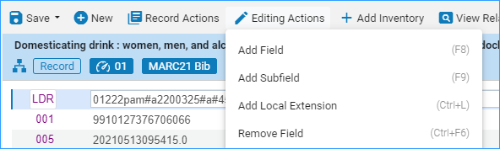
- Alma presents you with an empty field. Enter the tag, indicators and any text needed. Note when you add the extension, Alma puts a house or institution zone icon next to the field.
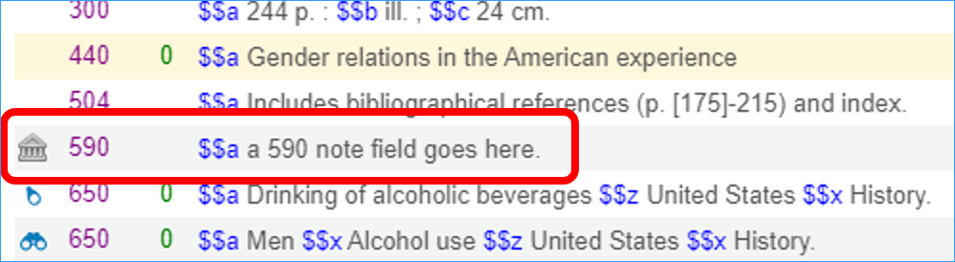

- When you’ve finished working with the record, save it. Either use the save short-cut icon, click File | Save Record, or the short-cut keys Ctrl+S.
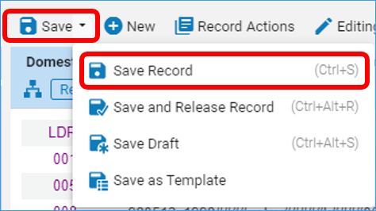

- Alerts display in the lower portion of the screen. Those alerts in yellow are ‘soft’ alerts and do not need to be fixed before saving the record. Any alerts in red are ‘hard’ alerts and must be fixed before the record can be saved. Click the double arrows to see the alerts.
- Adding holdings

- Once the bibliographic record has been located and/or updated if needed, add your library’s holdings to the record. The holding is very similar to the holding record in Aleph in that it contains collection and call number information. To add holdings, click the Add Inventory menu or use the short-cut key Ctrl+Alt+H.
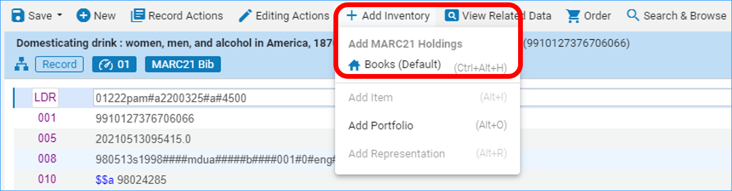

- The holding record opens on the right side of the screen.
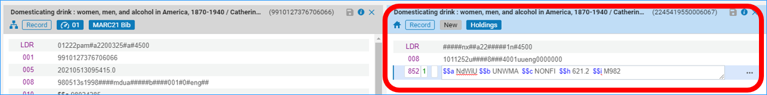

- The 852 is present, and information can be typed into the field, including indicators and information in the subfields.

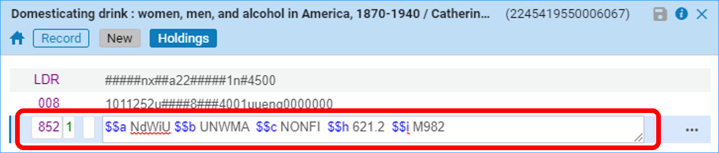

Alternatively, with the 852 field highlighted, press Ctrl+F, or click on the row actions menu and select Open Form editor. This opens a workform that can be used to edit the field. It offers drop-down menus to make it easier to work with the library and collection subfields. Additionally, it presents all available subfields making it more convenient to add call number or other information as needed.

Tip: If your library uses Library of Congress classification, the LC call number can be automatically inserted into the 852 field by inserting 0 as the first indicator, and clicking Alt-U.
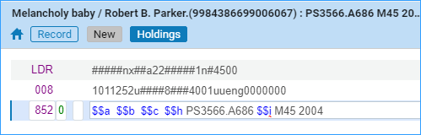
After Alt-U the call number is in the field, and you only need to fill in library and collection codes- $a, $b, $c.

- When you’ve finished working with the holding record, save it. Either use the save short-cut icon, click Save | Save Record, or the short-cut keys Ctrl+S.

- Adding Items

- Once the holding record has been saved, add your library’s items (inventory) to the record. To add an item, click the Add Inventory menu or use the short-cut key Ctrl+I.
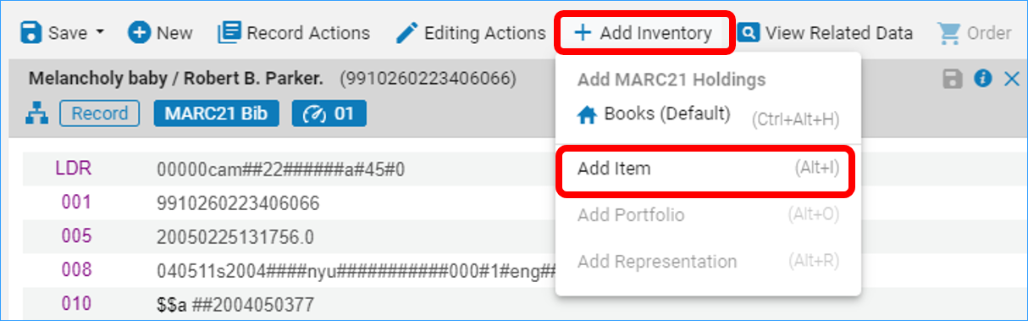

- Alma opens the physical item editor, and you can fill in the fields to add an item record.
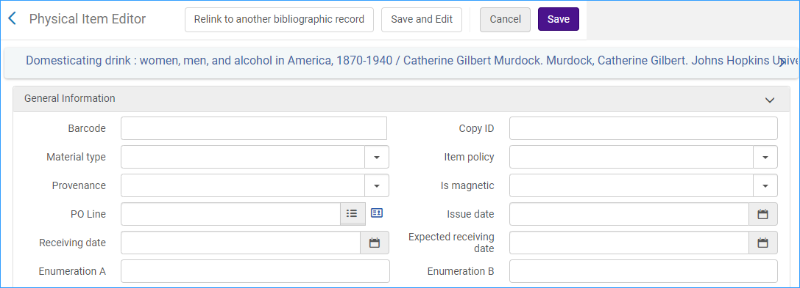

- General Information
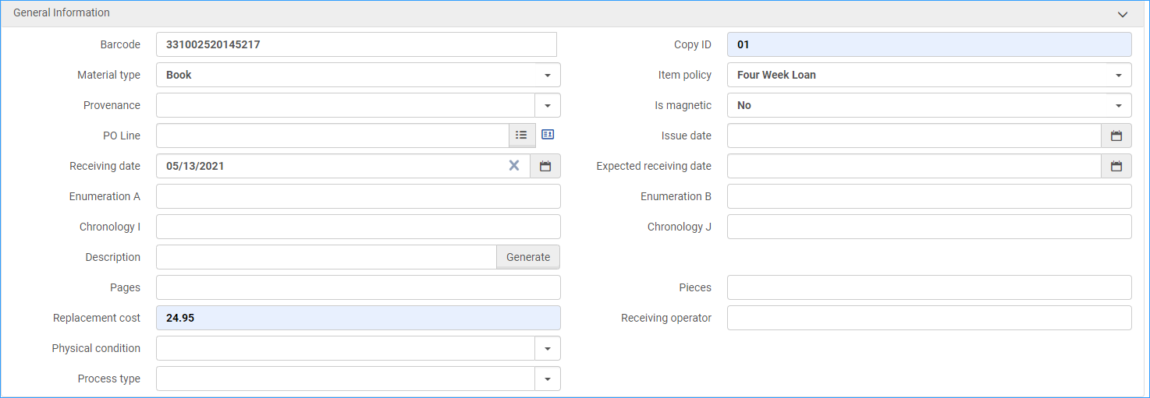

- Barcode – REQUIRED - enter the barcode of the item
- Copy ID – Enter the copy ID if desired
- Material Type – REQUIRED – enter the type of material, such as book, DVD, etc.
- Item policy – Enter the item policy that corresponds to the material. If this field is left blank, Alma will use the default line in your library’s TOU table to dictate circulation rules.
- Provenance –
- Is Magnetic – Enter if the item is magnetic (default set to N)
- POL Line – Populated if using acquisitions
- Issue date – Populated if using acquisitions
- Enumeration A/B – Enter if there is any enumeration information
- Chronology I/J – Enter if there is any chronology information
- Description – Enter description field if necessary, or use Generate button to generate a description from the enum/chron fields.
- Pages/Pieces – Enter additional description information if necessary.
- Replacement Cost – Enter the replacement cost if desired. If entered, Alma will use this amount when sending lost material notices to patrons.
- Receiving operator – Populated if using acquisitions
- Physical Condition – Enter information if desired.
- Process type – Enter information if desired.

- Inventory information. Some inventory information is populated automatically during the inventory process. You may wish to enter other inventory information such as Inventory Number.

- Location Information. Location information is pulled from the holding record.
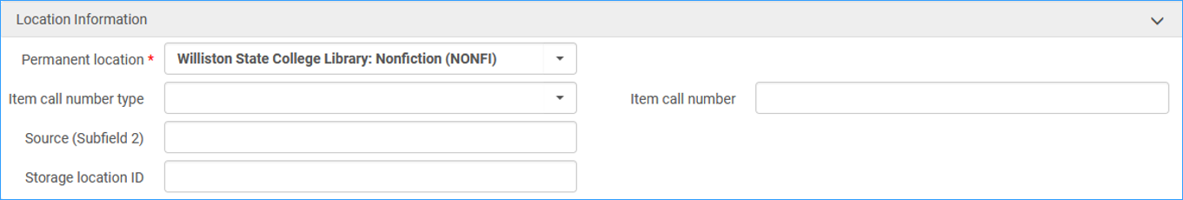
- Permanent location: This information is pulled directly from the holding record.
- Item call number type/Item call number – This information resides in the holding record and does not have to be included in the item record.
- Source – Enter information if desired
- Storage location ID – Enter information if desired

- Temporary Location Information. This section should be used if moving an item to a location temporarily, such as to a display or to the reserve shelf.
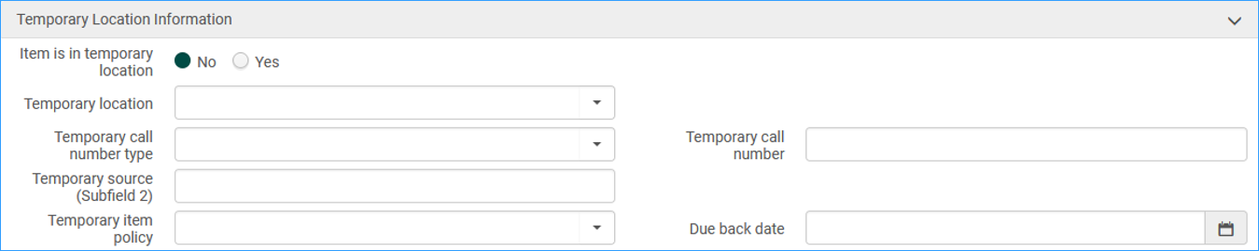
- Item is in a temporary location – check the YES button if the material is going to be in a temporary location.
- Temporary location – use the drop-down menu to select the temporary location.
- Temporary Call number type/call number – Enter the temporary call number type and temporary call number.
- Temporary Source – Enter the temporary source
- Temporary Item policy – Enter the temporary item policy that should be used when circulating the material.
- Due back date
**Note: once the material goes back to its permanent location, the Item is in temporary location button will be set to No, and all fields will default back to their previous values.

- When the item workform is complete, click Save and Edit to save and stay on the record, or click Save to save and return to the metadata editor. Save and Edit is very useful if you have notes or enumeration/chronology that you need to enter on other tabs of the item record.
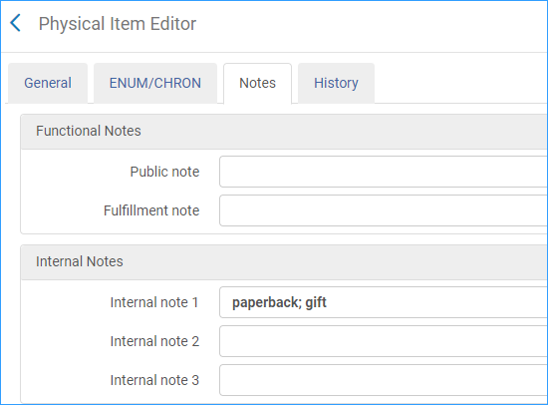
- Once you have saved the item record, the cataloging is complete.

