How to delete portfolios from an electronic collection using an Excel spreadsheet
Example: Portfolios are activated in the Network Zone, and you want to delete duplicates from your Institution Zone.
This procedure requires you to have your Institution Zone portfolios in an electronic collection.
First create a spreadsheet of the portfolios from the NZ collection:
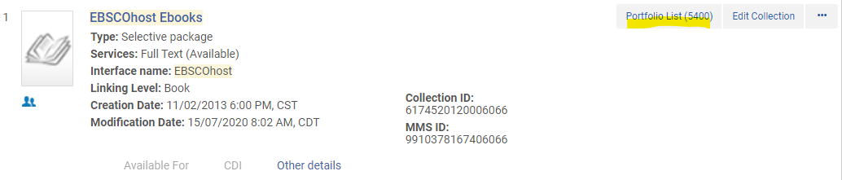
Click on the Portfolio List.
Then click on the Export List icon:
Select Extended Export
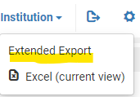
Since the file is big, it will run a job. Find the job from the Admin menu, Manage Jobs.
Click on the row action menu, and click on Report, then click on the report link:
Then click the row action menu and click on Download to download the file.
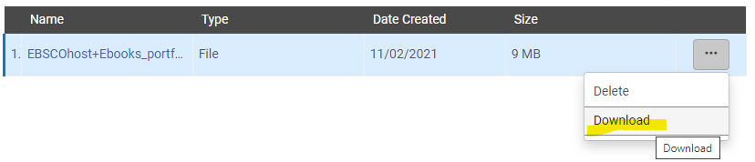
This is what the report looks like:
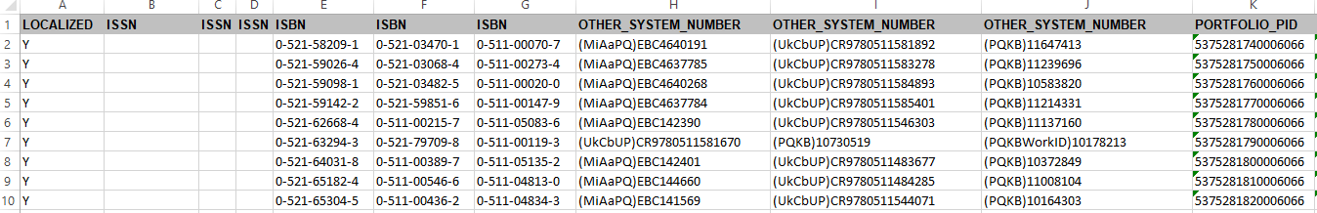
Next, find the electronic collection in your Institution Zone in Alma.
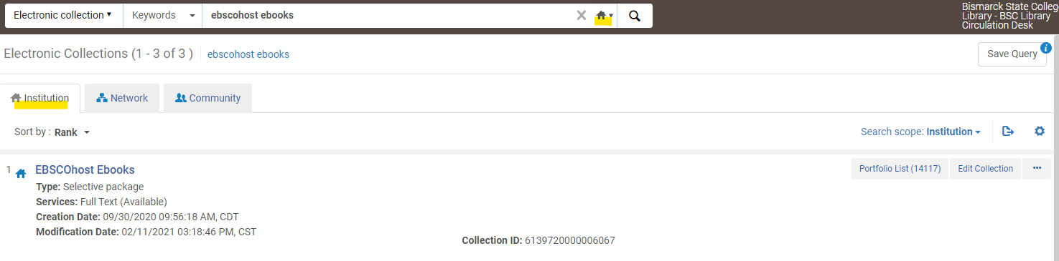
On the row actions menu, select Edit Service.
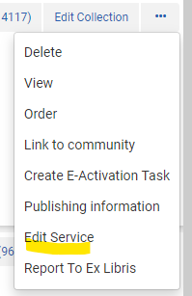
Select the Portfolios tab and click on Load Portfolios.

- Make sure “Institution” is selected and upload the spreadsheet.
- Select “Incremental” (This is important because deleting operates differently when you select Complete).
- Choose “Delete,” and for bibliographic handling select “Delete bibliographic records.”
- I am deleting a small number of portfolios, so I chose “Validate online” if you are deleting a large number choose “Validate offline.”
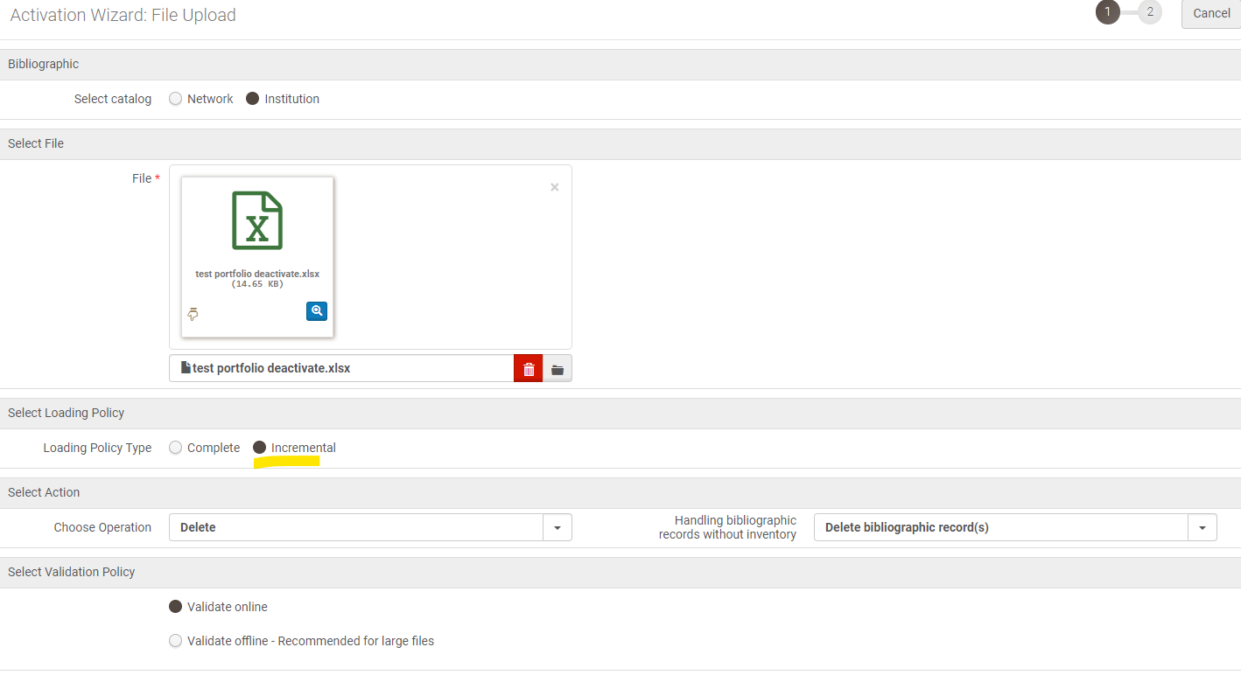
Click Next.
Review this page if there are errors download the spreadsheet with errors so you can work on them later.
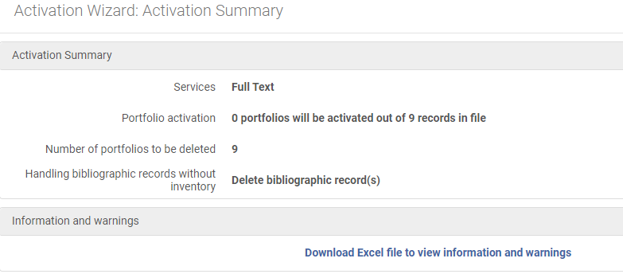
Click Load. This kicks off a job.
Under Admin menu, Monitor Jobs, find your job. Once it is finished running, review the report:
