- Question E2a: Library’s online Public Access Catalog (PAC) address
https://polaris.odinlibrary.org/polaris/default.aspx?ctx=N.1033.0.0.1 where N after the ctx= is the organization number assigned to your library at the time of migration.
To find the ctx number for your library, go your initial search page that contains your library logo. Look at the URL for the number that follows ctx=:
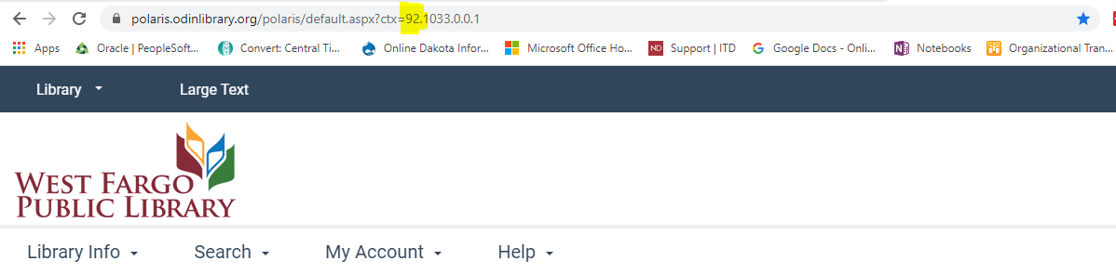

- Questions 7.1 (print materials), 7.6 (physical audio), 7.11 (physical video), and 7.15 (all other): Physical Material counts
**NOTE: Depending on your cataloging procedures, if you catalog electronic books (7.2/7.4), audio (7.7/7.9) and video (7.12/7.13) into Polaris, this report will help to garner those numbers as well. Otherwise, electronic media numbers will need to be obtained via the specific vendors where the media is purchased.
In Simply Reports, go to the Items tab and the Items count reports subfolder.
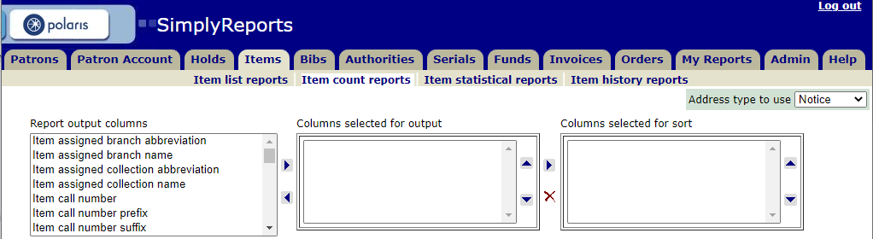
Suggested criteria:
- Columns selected for output: Item owning organization name and Item material type
- Columns selected for sort: Item material type
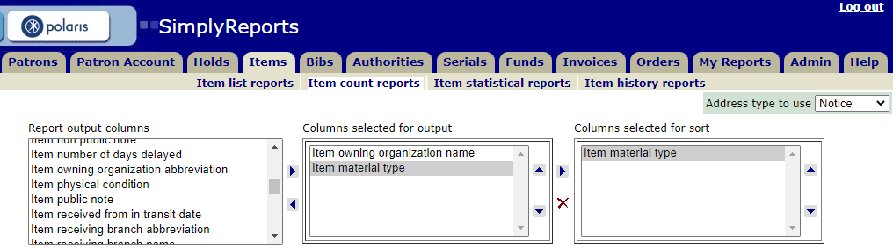

Next expand the Item general filters section and choose your Assigned branch:
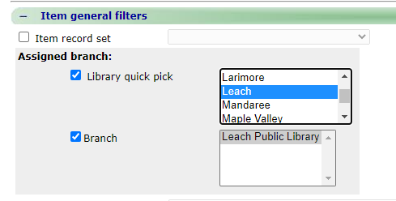

Finally set Item date filter for Creation date ending with the last day of the reporting period.
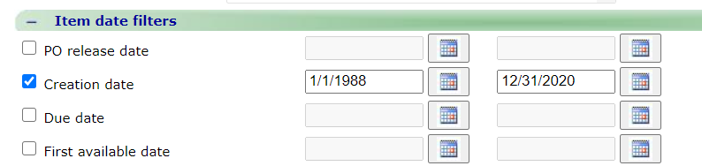

No other filters should be needed. Click SUBMIT and the report will run. The report output window will open and you will have the options to download report and/or save report parameters for later use. Example of the output for Leach Public Library. 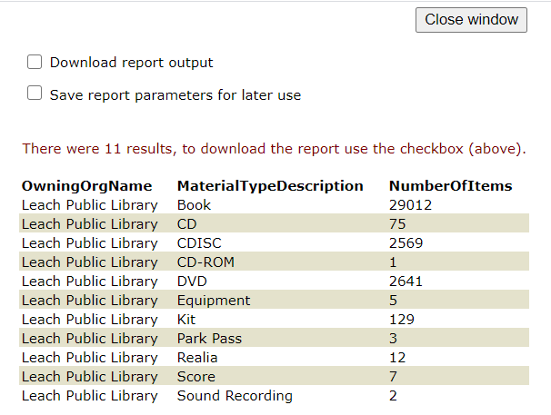
This report should provide information needed for your material type breakdown.

Results:
Determine which material types correspond to the categories (print volumes, e-books, physical video etc.) and add together their corresponding volumes to obtain count. NOTE: In some cases, you may be provided with counts for electronic material within the survey. Use the Polaris statistics to supplement these counts where necessary.

As an example, if you had BOOK, LARGE PRINT, and MANUSCRIPT/ARCHIVE item count would be combined to obtain the print volumes; CASSETTE, CD, CDISC and SOUND RECORDING would be combined to obtain physical sound; etc. Depending on the library collection, different material types may display in this report.

- Question 7.16 (total): Material counts
Total of fields 7.1 + 7.2 + 7.3 + 7.4 + 7.6 + 7.7 + 7.8 + 7.9 + 7.11 + 7.12 + 7.13 + 7.15

- Questions 10.3: Number of registered users

In Simply Reports, go to the Patrons tab and the Patron count reports subfolder.

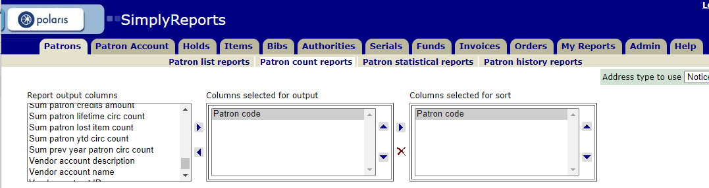

In the Patron general filters, select your Patron Branch: 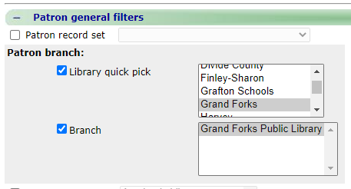

Under Patron date filters, Expiration date should be Jan 1 of survey year through 12/31/2099 to catch all your unexpired patrons.

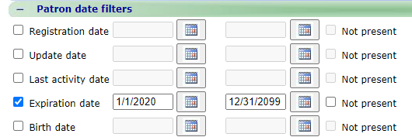

Submit to run the report. Example of output is:
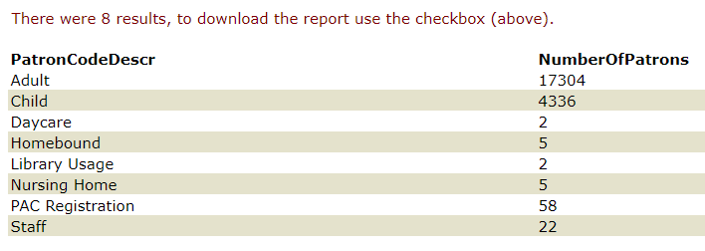
Results:
This will give you a breakdown of the different patron codes. If you want just the total number of current patrons, alter the first criteria to only include the branch name:
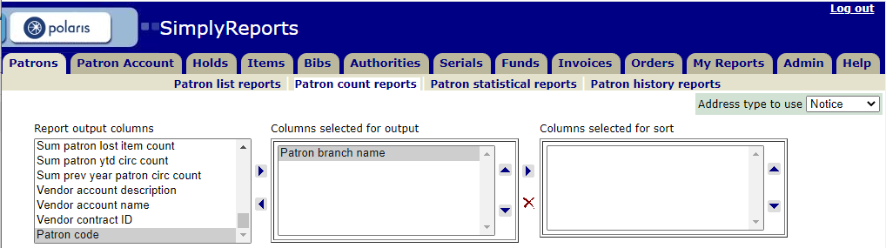
And you will get a report like this:
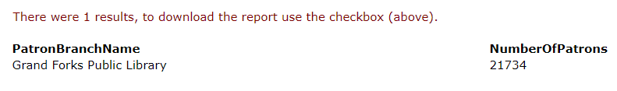

- Questions 10.6 (total physical item circulation), 10.5 (children’s item circulation),: Annual circulation
In Simply Reports, go to the Items tab and the Items count reports subfolder.
Suggested criteria:
- Columns selected for output: Item assigned collection name, Sum prev year circ count, Sum prev year inhouse use count
- Columns selected for sort: Item assigned collection name
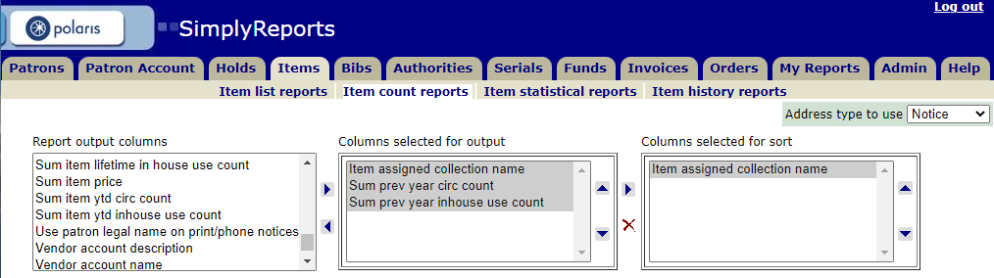

Next expand the Item general filters section and choose your Assigned branch:

Submit to run the report. This is an example of the report:
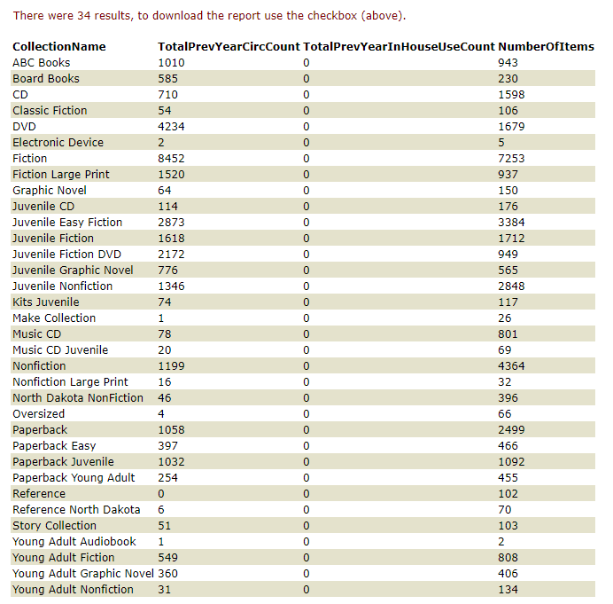
Results:
When answering question 10.6, to obtain the total circulations for the children’s materials, determine which collections are considered ‘Childrens’ collections, and add the TotalPrevYearCircCount column values. In the above example, this might include ABC Books, Board Books, all collections that contain Juvenile and maybe the Paperback Easy.
When answering question 10.5, total all values in the TotalPrevYearCircCount columns.

- Question E1a: Choose from the drop-down the name of the automation system used by the library to aid in cataloging and circulation of its materials.
Polaris

- Question 10.14: Number of items loaned to other libraries AND Question 10.15: Number of items borrowed from other libraries

We will use the same report from SimplyReports to get statistics for both categories.

In Simply Reports, go to the Items tab and the Item statistical reports subfolder.

Suggested criteria:
- Statistical categories: Check out
- Available subcategories: Item assigned branch
- Report type: General summary

Report focus:
- Run report by transacting organization only
- Library quick pick – highlight ALL libraries

Date range: for this report we can use the start through the end of the calendar year

See screenshot on next page -

**** Note: Statistical Reports can use tremendous amounts of system resources. They are usually not run during online hours if large amounts of data are being processed. The report below should not negatively impact system performance with a limited Date Range. The box for Run report now must be checked prior to hitting Submit.

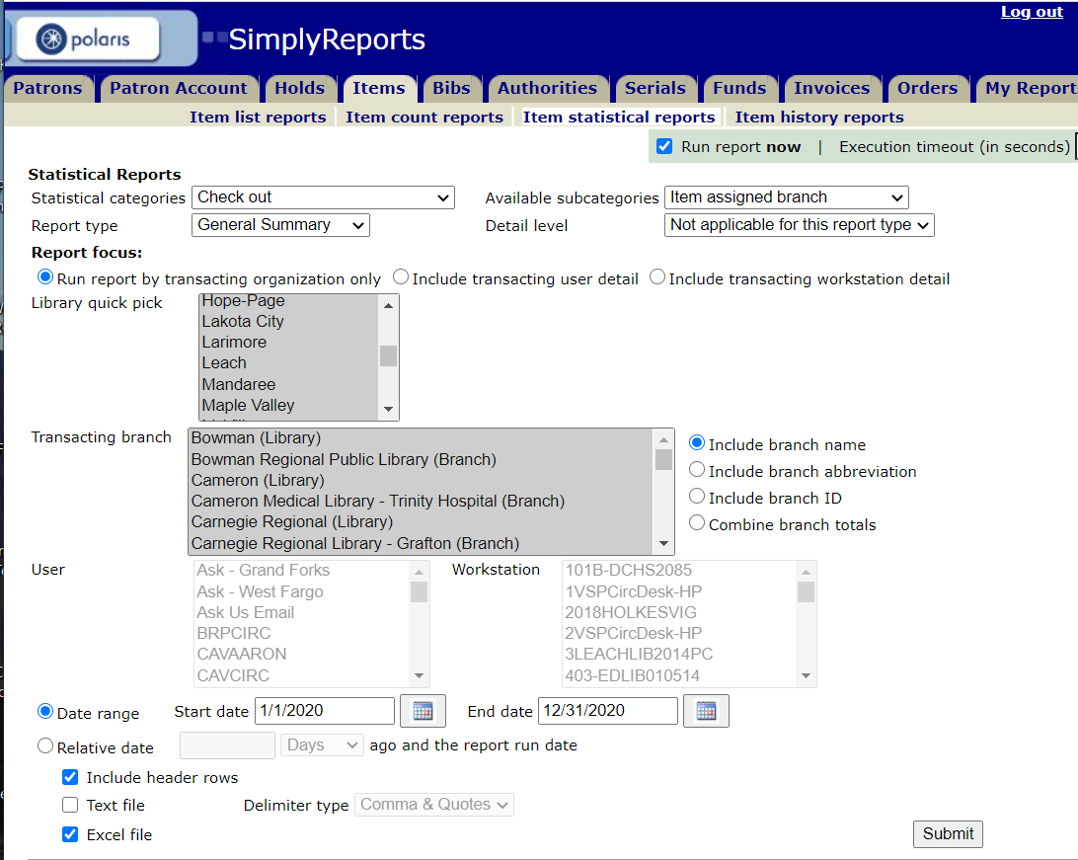

Snippet of results is below. You will want to Download the report since it will be used for this question and the next.
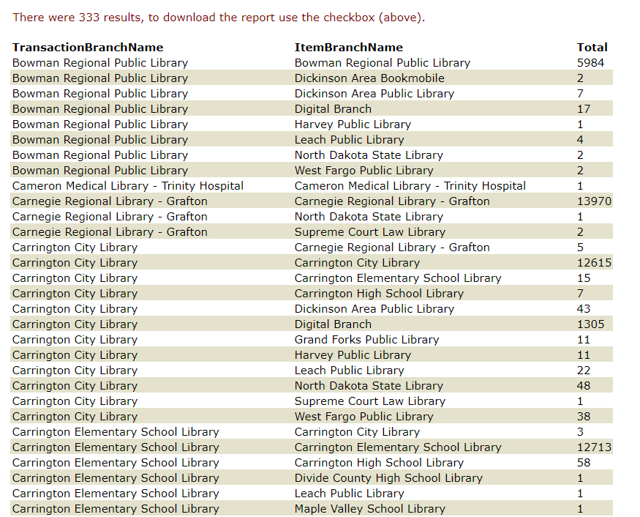

Find your library in the TransactionBranchName column. For this example, Bowman would look at this section:
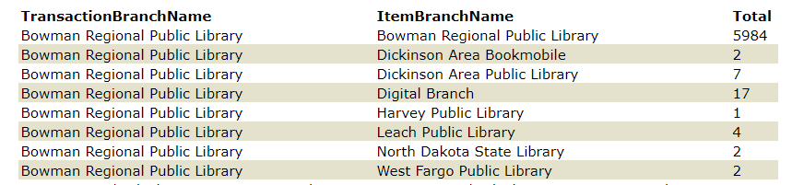

The number of items from other libraries loaned through Bowman is the total all TransactionBranchName = Bowman Regional Public Library lines except where ItemBranchName = Bowman Regional Public Library and Digital Branch. This gives you 18 items belonging to other libraries and checked out through Bowman Regional Public Library. This is for Question 10.15
Results:
Remember to manually add any items that were borrowed on ILL via other sources (OCLC, manual, etc.) to this total.
For items from your library loaned to other libraries (Question 10.14)
Open the downloaded report from above in Excel and sort by ItemBranchName.

Find your library name in the ItemBranchName column.
For this example, Bowman would look at this section:
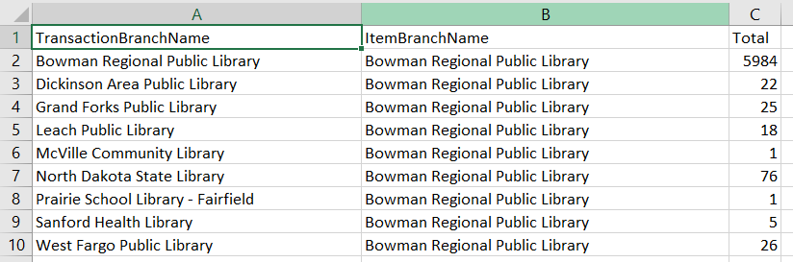

Total the values from all TransactionBranchName libraries except your own. This will represent items from your library checked out through the transacting branch name (loaned through ILL). Above example, Bowman Regional Public Library would be 174.

Results:
Remember to manually add any items that were loaned on ILL via other sources (OCLC, manual, etc.) to this total.

