Finding Bibliographic Records Without Holding or Item Records or Portfolios

Click the magnifying glass to open the form to conduct an Advanced Search.
Make sure you are searching for All titles in your Institution Zone, and search Has Inventory Equals No.
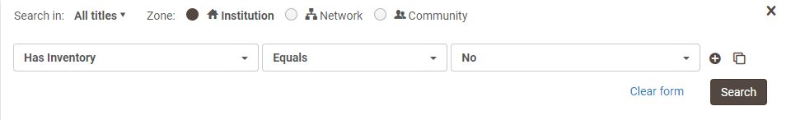
This will bring up bibliographic records that do not have holding or item records, or portfolios.
Example:
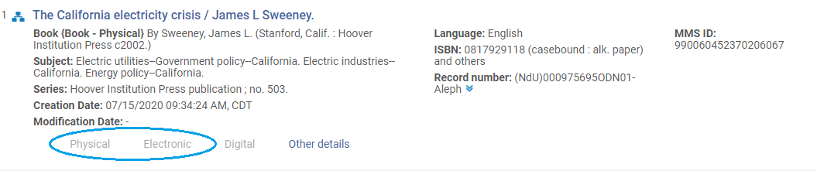

Finding Holdings Records Without Item Records

Using the advanced search, search for Physical Titles in your Institution Zone, and search Has Items Equals No.
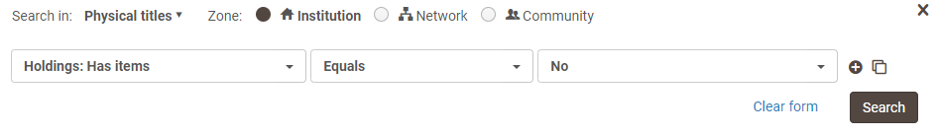
Example:
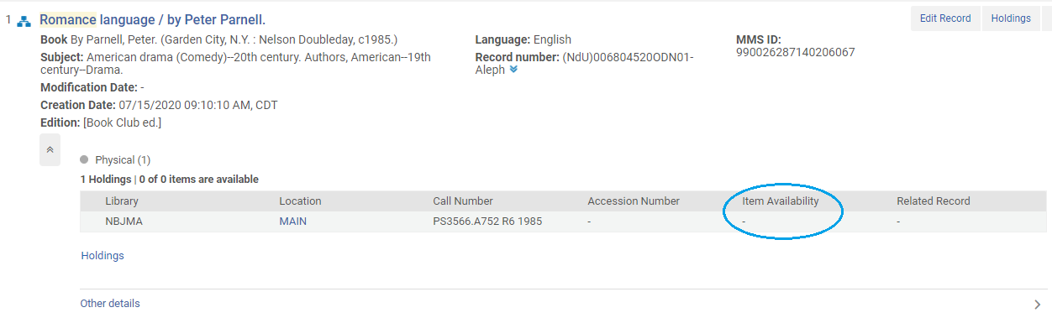
There are no items on this record.

